Canadian Natural Resources Limited

GENERAL PRESSURE VESSEL INFORMATION Job # 10.110194
District: Fort St. John BC. |  |  |  |  | Skid No.
Facility: Inga Unit# 3 Compressor Station |  |  |  |  | Location (LSD): b-82-J / 94-A-12
Tank Name / Equipment Number: Glycol Contactor

Orientation: Vertical
Status: In Service |  |  |  |  | Regulatory Inspection
PRESSURE VESSEL NAMEPLATE DATA
“A" or “G” or “S” (Sask.) or BC Registration Number.  A0483169 |  |  |  |  |  | CRN Number  P-7788.21
Vessel serial number: 7773 |  |  |  |  |  | Size: 24 in x 30 ft approx.
Shell thickness: 28.6 mm |  |  |  |  |  | Shell material: SA-516-70N
Head thickness: 26.9 mm |  |  |  |  |  | Head material: SA-516-70N
Tube wall thickness: |  |  |  |  |  | Tube material:
Tube diameter: |  |  |  |  |  | Tube length:
Channel thickness: |  |  |  |  |  | Channel material:
MAWP | Shell: 9928 kPa |  |  |  |  | MAWP |  | Shell:
 | Tubes: |  |  |  |  |  |  | Tubes:
Design Temp. | Shell: 54°C |  |  |  |  | Design Temp. |  | Shell:
 | Tubes: |  |  |  |  |  |  | Tubes:
X-ray: RT - 1 |  |  |  |  |  | Heat treatment: Yes
Code parameters: ASME VIII Div I |  |  |  |  |  | Joint efficiency (if on nameplate):
Manufacturer: Natco Canada Ltd. |  |  |  |  |  | Year built : 2002
Corrosion allowance: 3.2 mm |  |  |  |  |  | Manway: No

PRESSURE SAFETY VALVE NAMEPLATE DATA
PSV Tag # | Manufacture | Model # |  | Serial # |  |  | Set Pressure  (kPa) |  | Capacity  (scfm) | Service  Date
None | Taylor | 82H11671312 |  | 27533-126 |  |  | 9928 |  | 22382 | 06/2008
CRN # | Service By | Block Valve |  | Location |  |  | Size |  | Code Stamp
0G1316.2C | Tyco | No |  | Lower Shell |  |  | 2 in x 2 in |  | UV/NB

SERVICE CONDTIONS-INDICATE ALL THAT APPLY
Sweet | Sour X |  | Oil |  |  |  |  | Gas X |  | Water X
Amine | LPG |  | Condensate |  |  |  |  | Air |  | Glycol X
Other (Describe):

Inspection Interval ________________________________________PSV Service Interval_________________________________

(Determined by MIC in conjunction with Chief Inspector following guidelines of CNRL’s Owner-User Inspection Program)
Reports reviewed and accepted by:

Mechanical Integrity Coordinator________________________________________________Date__________________________

Fill out all forms as completely as possible. All information is important! Use back of sheets to record additional information or sketch if required.

Copy of report to be filed by MIC at site, and copy sent to Chief Inspector.

External Inspection Items | G | F | P | N/A | Comments
Insulation Verify sealed around manways, nozzles, no damage present, and there is no egress of moisture. |  |  |  | X | Vessel is not insulated.
External Condition Assess paint condition, areas peeling, record any corrosion, damage, etc (record location, size and depth of corrosion or damage) | X |  |  |  | Paint is in good overall condition – Peeling to less than 1% no visibly exposed metal as best effort no pitting detected – no previous corrosion.
Leakage Record any leakage at flanges, threaded joints, weep holes on repads, etc. | X |  |  |  | No leaks observed.
Saddle/skirt Assess condition of paint, fire protection, and concrete. Look for corrosion, buckling, dents, etc. Look at vessel surface area near supports. Verify no signs of leakage at attachment to vessel and attachment welds are acceptable. Ground wire attached? | X |  |  |  | Skirt: Firmly bolted to skid floor – no buckling or dents.  No corrosion at attachment welds to vessel – no leaks.  Ground wire attached to skid.
Anchor Bolts Hammer tap to ensure secure. Look for cracking in treads or signs of deformation. | X |  |  |  | Skirt firmly bolted to skid frame.  No signs of deformation.
Concrete foundation Check for cracks, spalling, etc. |  |  |  | X | None.
Ladder / Platform Describe general condition, ensure support is secure to vessel, and describe any hazards. |  |  |  | X | None.
Nozzle Assess paint, look for leakage, and ensure stud threads are fully engaged. Record any damage, deflection, etc. Are nozzles gusseted? | X |  |  |  | Stud threads are fully engaged to nuts – no short bolts.  No leaks observed.  No damage or deflections.  Nozzles are not gusseted.
Gauges Ensure gauges are visible, working, no leakage, and suitable for range of MAWP/ Temp. | X |  |  |  | Gauges are visible, working, and suitable for range of MAWP/Pressure.  Pressure gauge: 0 to 10000 Kpa / 4500 Kpa @ gauge.  Temperature gauge: -5 to 50 deg C / 25 deg C @ gauge.
External Piping Ensure pipe is well supported. All clamps, supports, shoes, etc. in place. Look for evidence of structural overload, deflection, etc. Paint condition, external corrosion? | X |  |  |  | Well supported, no deflection – all clamps in place.  Paint mostly intact – small areas of exposed metal – surface corrosion to same area – no pitting.
Valving Ensure no leaks are visible. Valves are properly supported and chained if necessary. | X |  |  |  | No leaks found.  Valves are properly supported.
PSV Ensure PSV is set at pressure at or below that of vessel. | X |  |  |  | Located on inlet piping – Set below the vessels MAWP.  Discharge piping is the same size as the outlet to PSV.  No block valve present.  Seal intact. PSV vents to flare.
NDE methods Was UT/ MPI done on vessel  (MI coordinator to review results) | X |  |  |  | Ultrasonic thickness survey carried out-no metal thickness detected below nominal minus corrosion allowance.
Recommendations or corrective actions : Vessel is Fit for Service or describe corrective actions required)
(MIC to review corrective actions with Operations, discuss with Chief Inspector where necessary, and get remedial action implemented)
Recommendations: 1. No recommendations at this time.
Summary: This vessel is in good over all condition, visual external and ultrasonic thickness survey carried out-no metal thickness detected below nominal minus corrosion allowance.
Vessel is fit for service.

Inspected By: Joseph Holdstock Date: April 17, 2011.

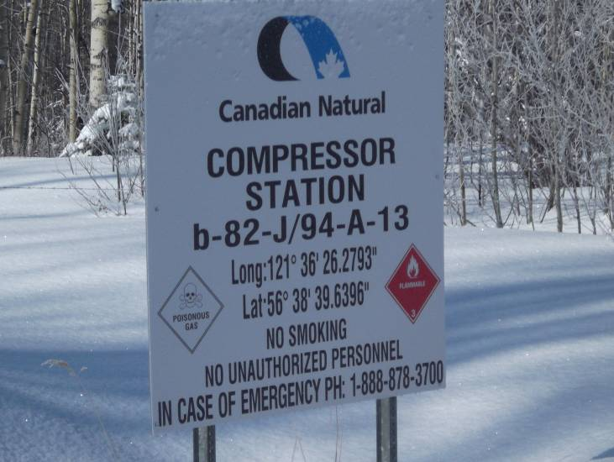 | 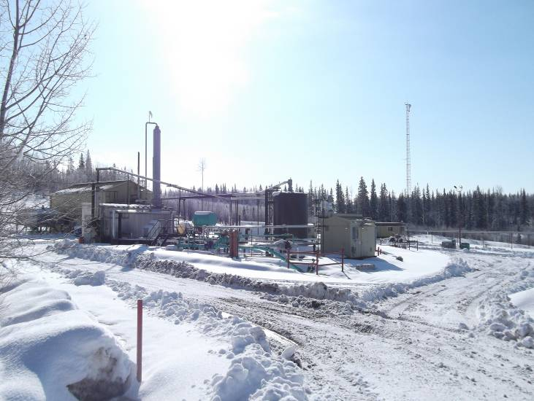
LSD Location | Site overview
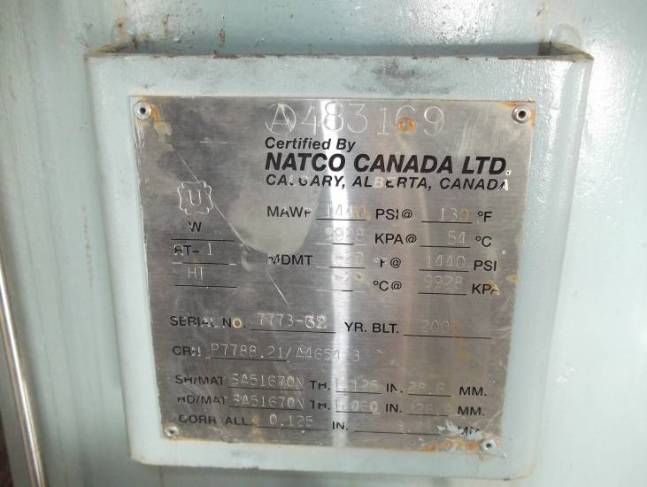 | 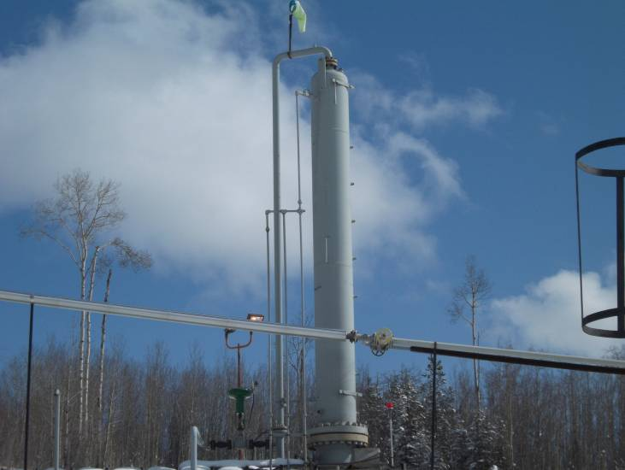
Data plate | Vessel overview
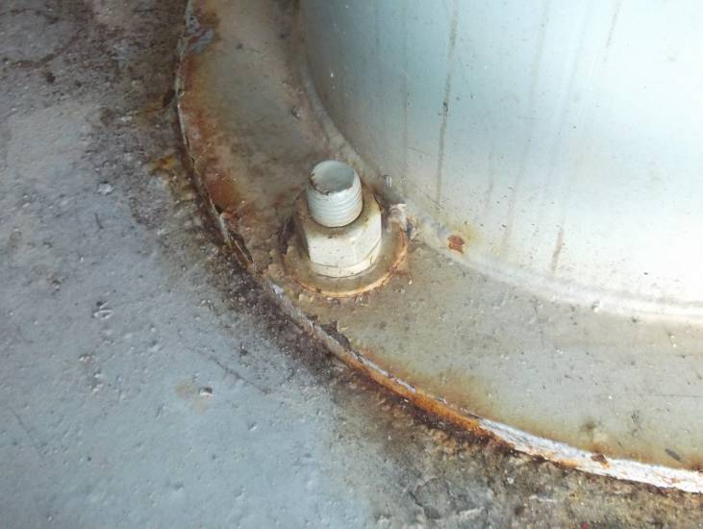 | 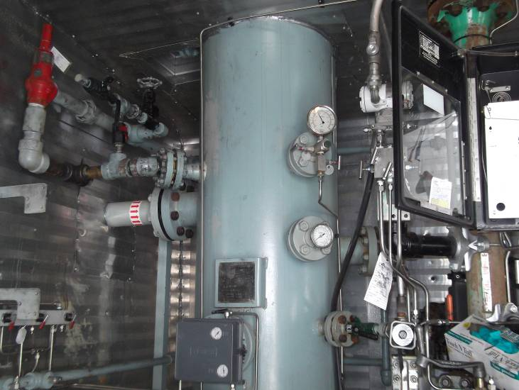
Base anchored securely | Lower shell overview
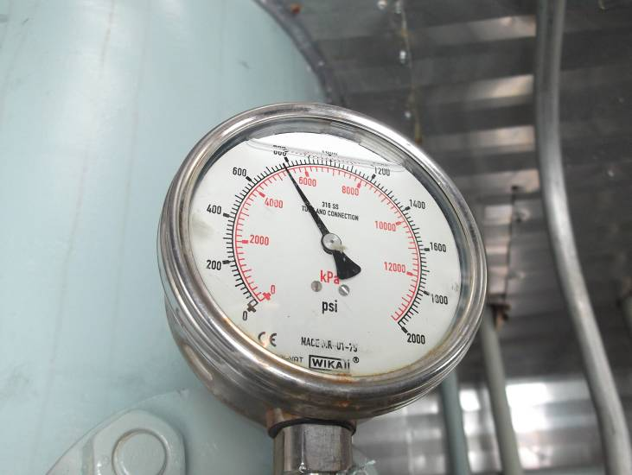 | 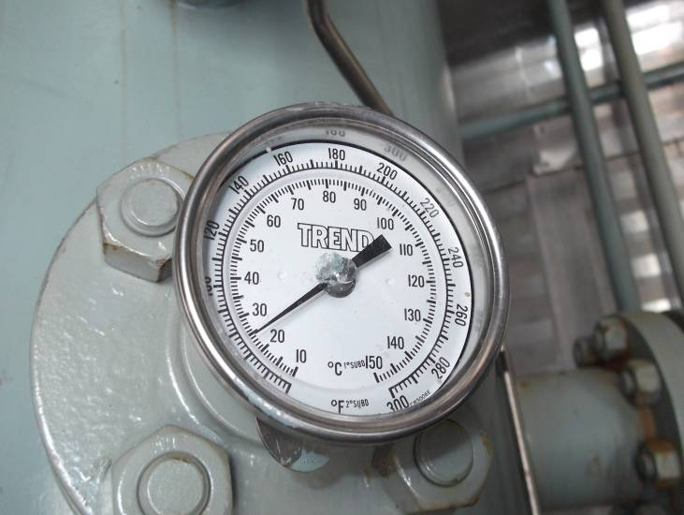
Pressure gauge | Temperature gauge
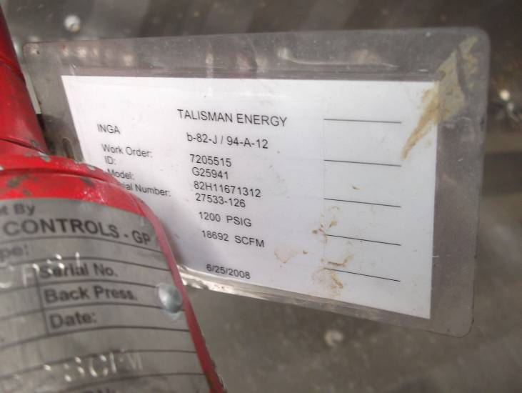 | 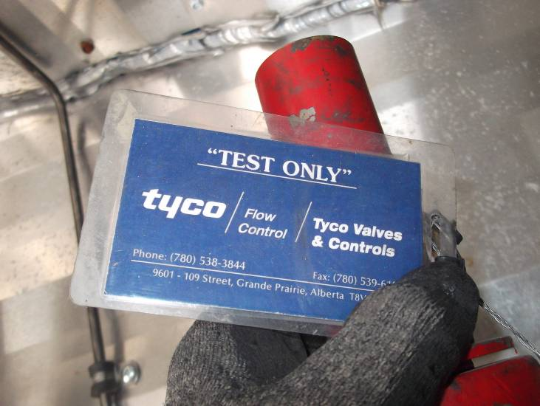
PSV service tag | PSV service tag
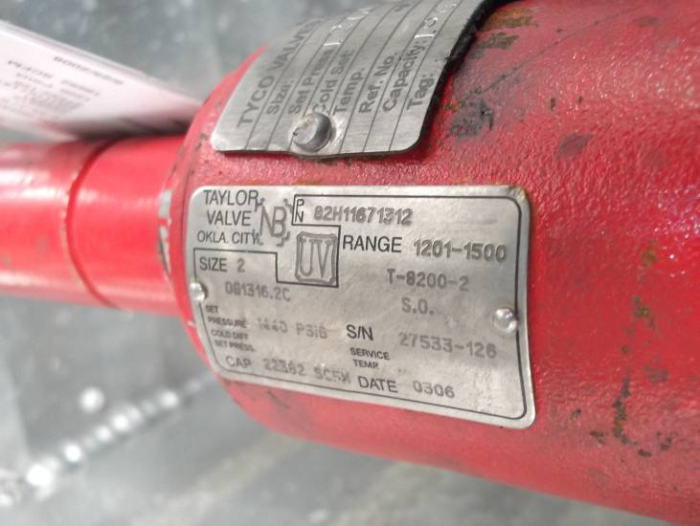
PSV Data plate

