 Pressure Equipment Integrity
Version 1.0 released April 2008

GENERAL INSPECTION FORM
District: Northern Plains |  |  |  |  | Skid No. : 15330
Facility: Fire Bird Oil Battery |  |  |  |  | Location (LSD) Surface: 14-01-98-08-W6M
Vessel Name & Equipment Number: Test Separator
Orientation: Horizontal or Vertical |  |  |  |  | Location (LSD) Downhole:
Status: In Service or Out of Service (blinded / fully isolated) |  |  |  |  | Commissioning Inspection or Regulatory Inspection
PRESSURE VESSEL NAMEPLATE DATA
“A" or “G” or “S” (Sask.) or BC Registration Number.  A0516951 |  |  |  |  |  | CRN Number  R-8469.21
Vessel serial number:  HS-12472 |  |  |  |  |  | Size (diameter x length- estimate if necessary):  60 in X 20 ft S/S
Shell thickness: 51.1 mm |  |  |  |  |  | Shell material: SA-516-70N
Head thickness: 48.5 mm |  |  |  |  |  | Head material: SA-516-70N
Tube wall thickness: |  |  |  |  |  | Tube material:
Tube diameter: |  |  |  |  |  | Tube length:
Channel thickness: |  |  |  |  |  | Channel material:
MAWP | Shell: 1440 Psi |  |  |  |  | Operating pressure | Shell:
 | Tubes: |  |  |  |  |  | Tubes:
Design Temp. | Shell: 127 F |  |  |  |  | Operating temperature | Shell:
 | Tubes: |  |  |  |  |  | Tubes:
X-ray: RT-1 |  |  |  |  |  | Heat treatment? Yes
Code parameters: |  |  |  |  |  | Joint efficiency (if on nameplate):
Manufacturer: Larsen & D’Amico |  |  |  |  |  | Year built: 2004
Corrosion allowance: 4.7 mm |  |  |  |  |  | Manway? Yes 20 in #600

PRESSURE SAFETY VALVE NAMEPLATE DATA
Tag Number(s) | Set Pressure | CRN # | Manufacturer/ Model / Serial / Code Stamp |  |  |  |  | Capacity (Scfm) | Size (Inlet x Outlet) | Set Date  (mm/dd/yyyy)
Shell Side G#  707684 | 9929 kPa | 0G8442.5C | Farris, 26EA13-120, sn-506484-1-A10  UV, NB |  |  |  |  | 160.2 M3/Min | 1” #600 X 2” #150 | 3/2008
Tube Side G#

SERVICE CONDTIONS-INDICATE ALL THAT APPLY
Sweet | Sour |  |  | Oil |  |  | Gas |  |  | Water
Amine | LPG |  |  | Condensate |  |  | Air |  |  | Glycol
Other (Describe):

Inspection Interval ________________________________________PSV Service Interval_________________________________

(Determined by integrity specialist in conjunction with Chief Inspector following guidelines of ConocoPhillips Canada Owner-User Inspection Program)
Reports reviewed and accepted by:

Integrity Specialist________________________________________________________Date_____________________________

Fill out all forms as completely as possible. All information is important! Use back of sheets to record additional information or sketch if required.

Pressure Equipment Integrity Management Program | This document contains proprietary information belonging to ConocoPhillips Canada and must not be wholly or partially reproduced nor disclosed without written prior permission from ConocoPhillips Canada. | Page 1

External Inspection Items | G | F | P | N/A | Comments
Insulation Verify sealed around manways, nozzles, no damage present, and there is no egress of moisture. Are straps secure? |  |  |  | X | Vessel is not insulated.
External Condition Assess paint condition, areas peeling, record any corrosion, damage, distortion etc (record location, size and depth of corrosion or damage) | X |  |  |  | No scratches or peeling of pain external surface. Vessel is suited with a 20” #600 man way closure, davit arm appears to be in good condition with no visible damage.
Leakage Record any leakage at flanges, threaded joints, weep holes on repads, etc. |  |  |  | X | No leaking detected.
Skirt/ Saddle Assess condition of paint, fire protection, concrete. Look for corrosion, buckling, dents, etc. Look at vessel surface area near supports. Verify no signs of leakage at attachment to vessel and attachment welds are acceptable. Is ground wire attached? | X |  |  |  | Saddles are seal welded to shell, weld appears full and complete.  No distortion – no buckles or dents.  Ground attached to saddle.
Anchor Bolts Hammer tap to ensure secure. Look for corrosion, cracking in threads or signs of deformation. | X |  |  |  | In Place and secure
Concrete foundation Check for cracks, spalling, etc. |  |  |  | X
Ladder / Platform Describe general condition, ensure support is secure to vessel, describe any hazards. | X |  |  |  | Ladder and platform to upper shell and PSV access is secure and in place.
Nozzle Assess paint, look for leakage, and ensure stud threads are fully engaged. Record any damage, deflection, etc. Are nozzles gusseted? Inspect gussets for cracking. | X |  |  |  | All nozzles are clean with no visible deflection noted.  Paint condition is good – no exposed metal.
Gauges Ensure gauges are visible, working, no leakage, and suitable for range of MAWP/ Temp. | X |  |  |  | Both temp gauge and pressure gauge are attached and within range for operation.
External Piping Ensure pipe is well supported. All clamps, supports, shoes, etc. in place. Look for evidence of structural overload, deflection, etc. Paint condition, external corrosion? | X |  |  |  | All external piping is well supported with no visible deflection or signs of any leakage present at time of inspection.
Valving Ensure no leaks are visible. Valves are properly supported and chained if necessary. | X |  |  |  | Well supported – no leaks.
PSV Ensure PSV is set at pressure at or below that of vessel. Discharge piping is same size as valve outlet and is properly supported and routed. Are psv seals in place? Ensure no block valves between psv and vessel, or if there are ensure they are locked/sealed open. | X |  |  |  | Located on top shell - set at the vessel MAWP.  Seal intact.  No block valve.  Discharge piping same size as outlet orifice.
NDE methods Was UT/ MPI done on vessel | X |  |  |  | Ultrasonic thickness inspection carried out, no metal thickness detected below nominal minus corrosion allowance.

Other Observations:

Recommendations: No recommendations at this time.
Summary: This vessel is in good condition, visual external and ultrasonic thickness inspection carried out – no metal thickness detected below nominal minus corrosion allowance.

Vessel found to be acceptable and fit for service.

Inspected By: Jerald Zaderey Date: July 28, 2008
(Please Print)

Pressure Equipment Integrity Management Program | This document contains proprietary information belonging to ConocoPhillips Canada and must not be wholly or partially reproduced nor disclosed without written prior permission from ConocoPhillips Canada. | Page 2

Internal Inspection Items | G | F | P | N/A | Comments
Coating Assess coating. Describe area coated, general condition of coating. Look at nozzles, coupling, and areas of most severe corrosion to ensure coating is intact. If coating is in poor condition make decision now if re-coating necessary? If so, when?
Anodes. How many, type, condition. % consumed. Are they being replaced?
Internal Piping Is there any? If so, carbon or stainless steel. Describe condition, dents, corrosion, erosion, etc. Ensure supports are secure and any bolts are suitable for future use.
Trays How many? Type of material. Are valves in place. Check for erosion/ corrosion; wear on tray valve legs. Cleanliness?
Baffles, deflector plates, etc. If present, describe condition. Look closely at welds attached to vessel wall.
Bottom Head Note all corrosion, erosion or mechanical damage. (If vessel is horizontal identify direction of this head)
Top Head Note all corrosion, erosion or mechanical damage. (If vessel is horizontal identify direction of this head)
Shell Sections Record number of shell sections. Record location, size and depth of all erosion, corrosion or mechanical damage. Describe general condition. If any corrosion greater than corrosion allowance is observed in either shell or head, discuss with Chief Inspector before closing vessel.

Demister pad Is it in place? Is it clean? If any corrosion is apparent in vessel, lift pad and check top head for corrosion.

Welds Inspect all welds, including attachment welds. Record all service-related damages and if there is any discuss with Chief Inspector before closing.

Repairs Required. If yes, ensure procedure and copy of AB-40 is on file, and one sent to local ABSA Inspector

NDE Was any NDE done.

Other Observations

Inspected By:___________________________________________________________ Date:________________________________
(Please Print)

Pressure Equipment Integrity Management Program | This document contains proprietary information belonging to ConocoPhillips Canada and must not be wholly or partially reproduced nor disclosed without written prior permission from ConocoPhillips Canada. | Page 3

Photo Table
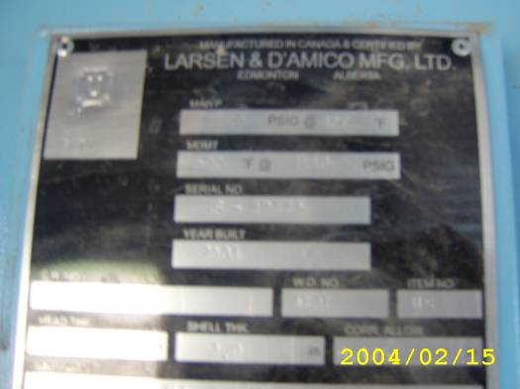  Nameplate | 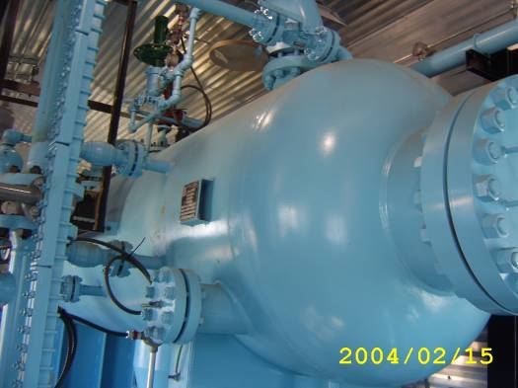  Vessel External Over View
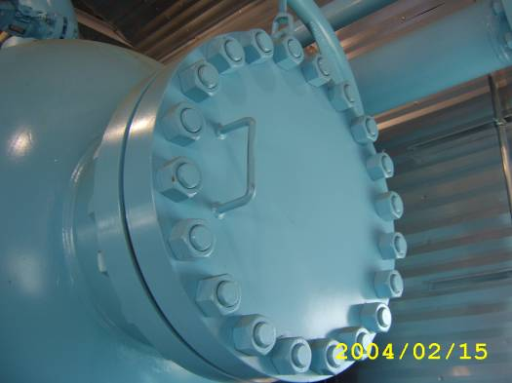
20” #600 Man Way Closure

