Canadian Natural Resources Limited

GENERAL PRESSURE VESSEL INFORMATION
District: Fort St. John, B.C. |  |  |  |  | Skid No.
Facility: Clear Hills Gas Field |  |  |  |  | Location (LSD): 6-15-88-12-W6M
Vessel Name Equipment Number: 3 Phase Separator

Orientation: Vertical
Status: In Service |  |  |  |  | Regulatory Inspection
PRESSURE VESSEL NAMEPLATE DATA
“A” or “G” or “S” (Sask.) or BC Registration Number.  A2815118 |  |  |  |  |  | CRN Number:  K 9067.21
Vessel serial number: 6000A-V02 |  |  |  |  |  | Size: 16in.x 90in.
Shell thickness: 16.67mm |  |  |  |  |  | Shell material: SA 106-B
Head thickness: 15.87mm |  |  |  |  |  | Head material: SA 516-70N
Tube wall thickness: |  |  |  |  |  | Tube material:
Tube diameter: |  |  |  |  |  | Tube length:
Channel thickness: |  |  |  |  |  | Channel material:
Design pressure | Shell: 720 PSI |  |  |  |  | Operating pressure |  | Shell: 0 – 2000 PSI
 | Tubes: |  |  |  |  |  |  | Tubes:
Design Temp. | Shell: 120 Deg. F |  |  |  |  | Operating temperature |  | Shell: -40 – 120 Deg. F
 | Tubes: |  |  |  |  |  |  | Tubes:
X-ray: RT-1 |  |  |  |  |  | Heat treatment: yes
Code parameters: ASME VIII, Div 1 |  |  |  |  |  | Coated: no
Manufacturer: NUSCO |  |  |  |  |  | Year built:1993
Corrosion allowance: 3.2 mm |  |  |  |  |  | Manway: no

PRESSURE SAFETY VALVE NAMEPLATE DATA
PSV Tag # | Manufacture | Model # |  | Serial # |  |  | Set Pressure  (kPa) |  | Capacity  (scfm) |  |  | Service  Date
1619 F | Taylor | T-7900-2 | not stated |  |  |  | 4964 |  | 2992 |  | 01/07
CRN # | Service By | Block Valve | Location |  |  |  | Size |  | Code Stamp
not stated | unified valve | no | upper shell |  |  |  | 2”x 2” |  | UV

SERVICE CONDITIONS-INDICATE ALL THAT APPLY
Sweet X | Sour |  |  | Oil |  |  |  | Gas X |  | Water X
Amine | LPG |  |  | Condensate X |  |  |  | Air |  | Glycol
Other (Describe):

Inspection Interval ________________________________________PSV Service Interval_________________________________

(Determined by MIC in conjunction with Chief Inspector following guidelines of CNRL’s Owner-User Inspection Program)

Reports reviewed and accepted by:

Mechanical Integrity Coordinator________________________________________________Date__________________________

Fill out all forms as completely as possible. All information is important! Use back of sheets to record additional information or sketch if required.

Copy of report to be filed by MIC at site, and copy sent to Chief Inspector

External Inspection Items | G | F | P | N/A | Comments
Insulation Verify sealed around manways, nozzles, no damage present, and there is no egress of moisture. |  |  |  | X | Vessel is not insulated
External Condition Assess paint condition, areas peeling, record any corrosion, damage, etc (record location, size and depth of corrosion or damage) | X |  |  |  | Paint over all in good condition.  Paint peeling 5% of area. Scale corrosion where paint has peeled
Leakage Record any leakage at flanges, threaded joints, weep holes on repads, etc. | X |  |  |  | No leaks are visible
Saddle/Skirt Assess condition of paint, fire protection, concrete. Look for corrosion, buckling, dents, etc. Look at vessel surface area near supports. Verify no signs of leakage at attachment to vessel and attachment welds are acceptable. Ground wire attached? | X |  |  |  | Skirt: Bolted directly to skid floor  No buckling or dents.  No corrosion at attachment welds to vessel.  Skid package is grounded.
Anchor Bolts Hammer tap to ensure secure. Look for cracking in treads or signs of deformation. | X |  |  |  | Anchor bolts are securely fastened to skid floor.  No deformation
Concrete foundation Check for cracks, spalling, etc. |  |  |  | X
Ladder / Platform Describe general condition, ensure support is secure to vessel, describe any hazards. |  |  |  | X
Nozzle Assess paint, look for leakage, and ensure stud threads are fully engaged. Record any damage, deflection, etc. Are nozzles gusseted? | X |  |  |  | Threaded nozzle joints are fully engaged.  No damage or deflections. No leaks observed  Nozzles are not gusseted
Gauges Ensure gauges are visible, working, no leakage, and suitable for range of MAWP/ Temp. | X |  |  |  | Gauge are clear and clean. No leakage.  Suitable for range of MAWP/Temperature of vessel  Temperature gauge -40 – 120 Deg. F/Pressure gauge 0 – 2000 PSI
External Piping Ensure pipe is well supported. All clamps, supports, shoes, etc. in place. Look for evidence of structural overload, deflection, etc. Paint condition, external corrosion? | X |  |  |  | Piping is well supported.  All clamps and supports are in place.  No structural overloads or deflections.  Paint peeling to 30 % of area.
Valving Ensure no leaks are visible. Valves are properly supported and chained if necessary. | X |  |  |  | No leaks are visible.  Valves are properly supported
PSV Ensure PSV is set at pressure at or below that of vessel. | X |  |  |  | Located on upper shell - set at MAWP of vessel.  Seal intact – no block valve.
NDE methods Was UT/ MPI done on vessel  (MI coordinator to review results) | X |  |  |  | Ultrasonic thickness inspection carried out – piping metal thickness detected below nominal minus corrosion allowance. Calculations carried out to ensure sufficient metal exists for safe operation.
Recommendations or corrective actions : Vessel is Fit for Service or describe corrective actions required)
(MIC to review corrective actions with Operations, discuss with Chief Inspector where necessary, and get remedial action implemented)
Recommendations: No recommendations at this time.
Summary: This vessel is in good condition, visual external and ultrasonic thickness inspection carried out - piping metal thickness detected below nominal minus corrosion allowance. Calculations carried out to ensure sufficient metal exists for safe operation.
Vessel is fit for service.

Inspected By: Gerry Avery Date: August 28, 2007

Photo Table

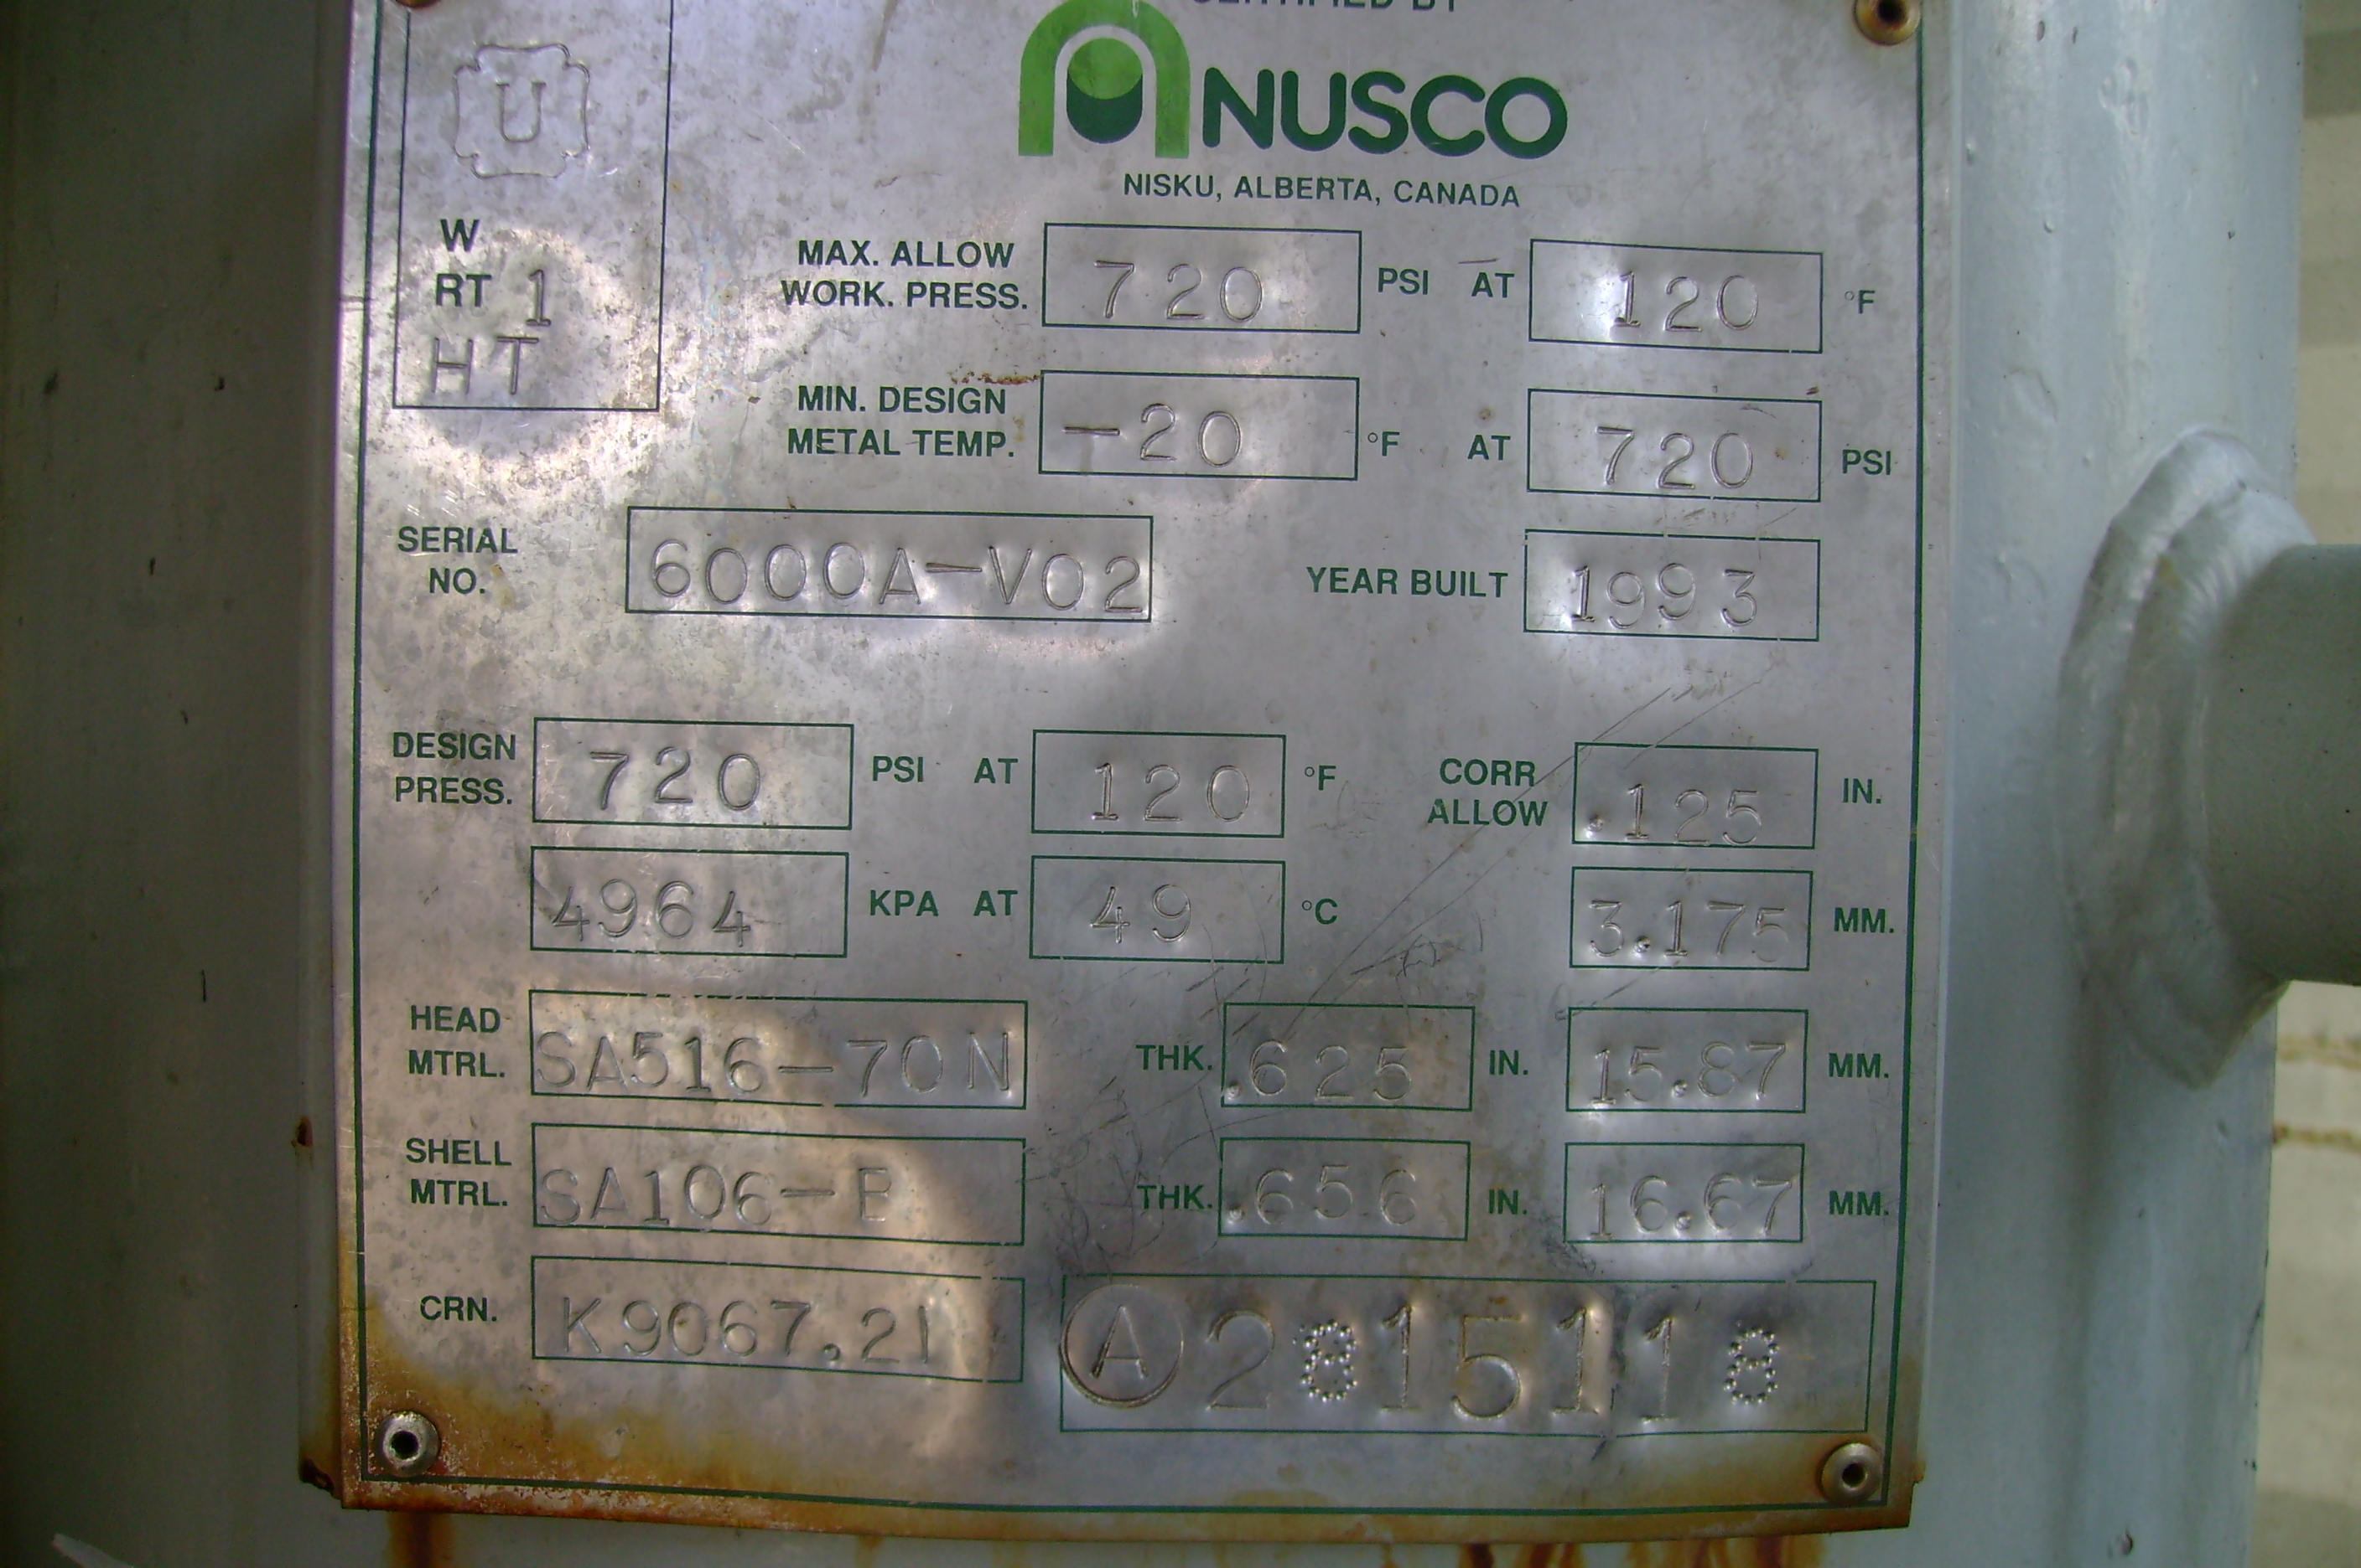 | 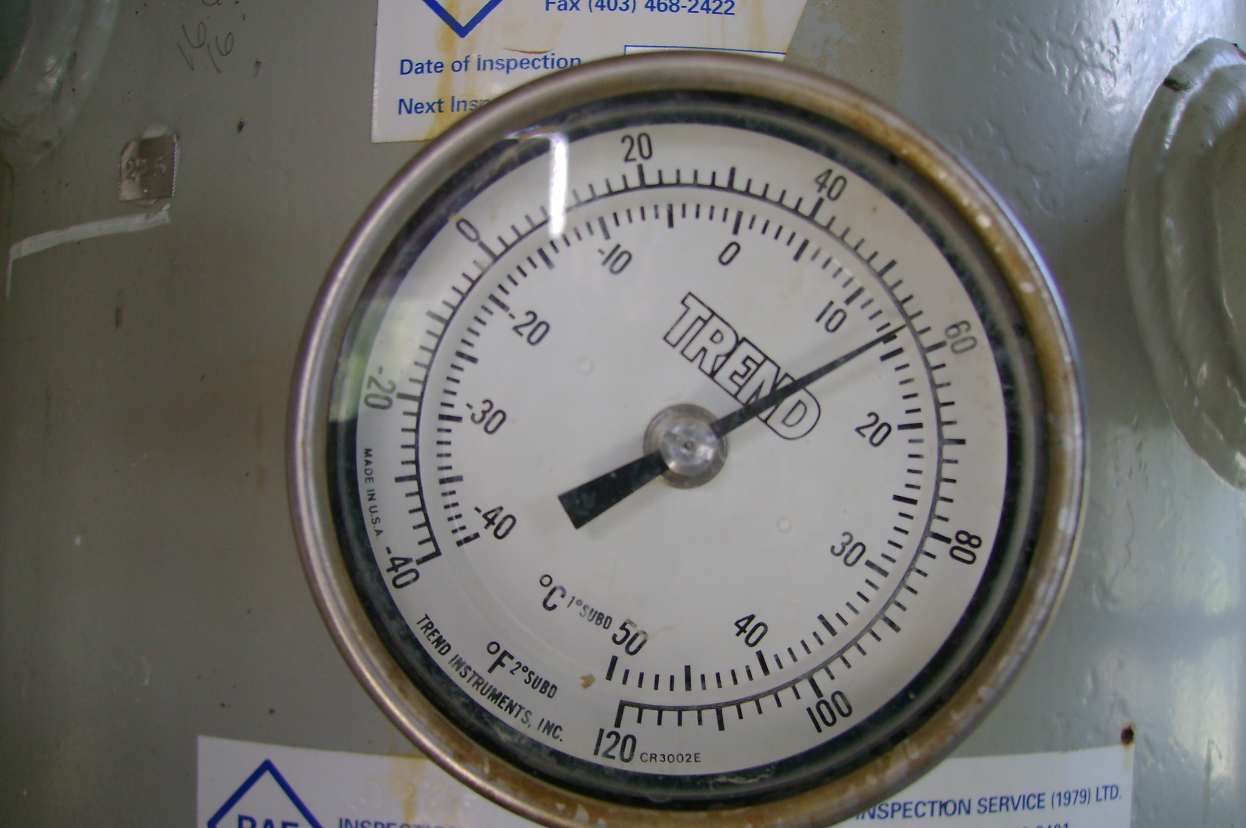
vessel data plate | vessel temperature gauge
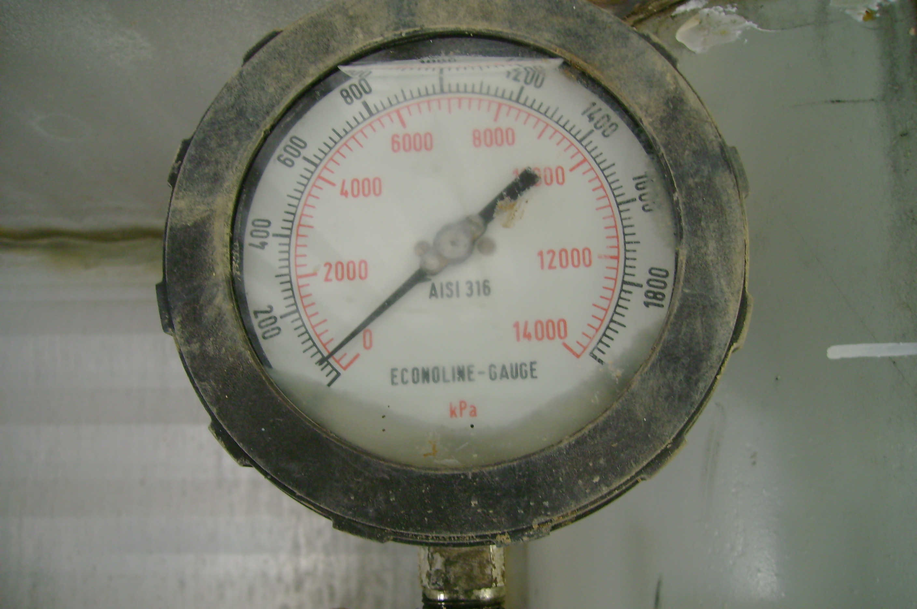 | 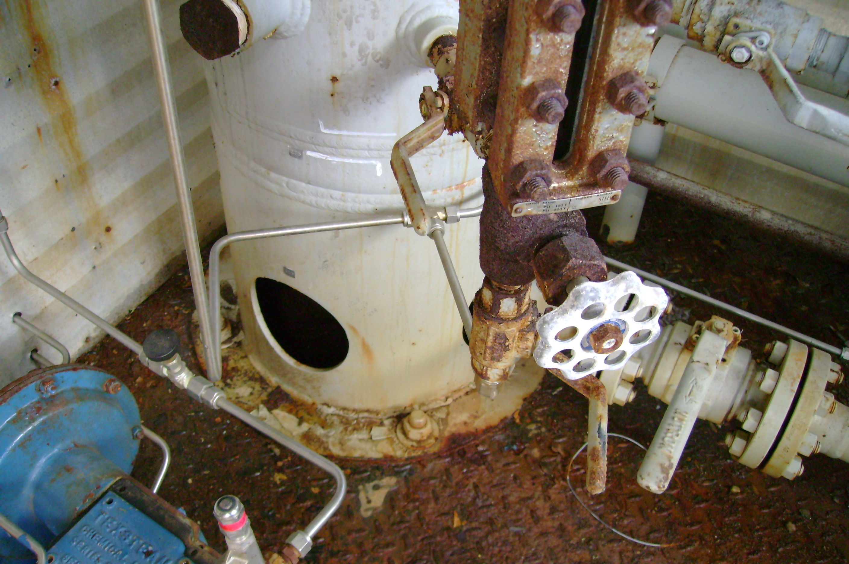
vessel pressure gauge | vessel skirt bolted to skid floor
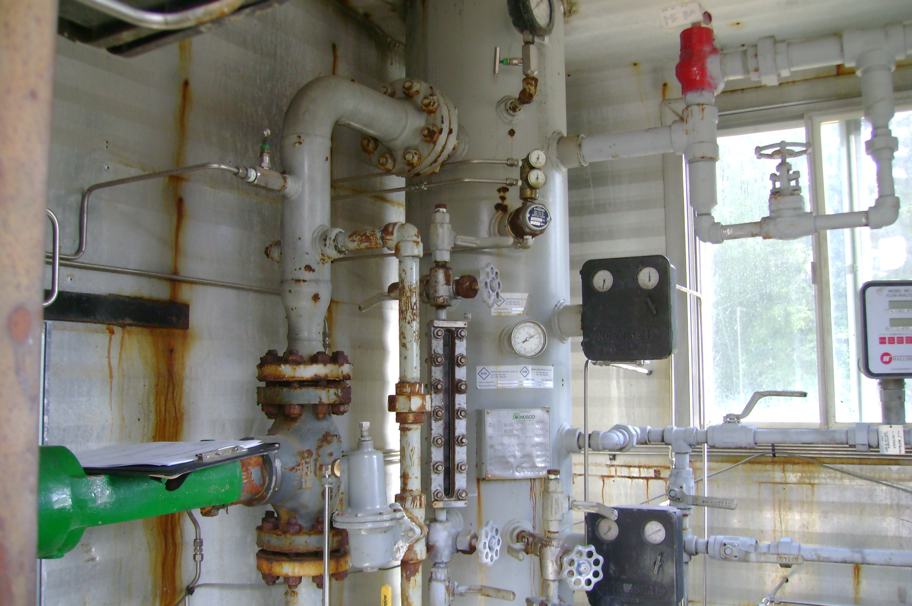
vessel overview

