Canadian Natural Resources Limited

GENERAL PRESSURE VESSEL INFORMATION Job# 05.001889
District: Fort St. John BC. |  |  |  |  | Skid No.
Facility: Elm Compressor Station |  |  |  |  | Location (LSD): d-19-G/94-H-7
Tank Name / Equipment Number: Line Heater

Orientation: Vertical
Status: In Service |  |  |  |  | Regulatory Inspection
PRESSURE VESSEL NAMEPLATE DATA
“A" or “G” or “S” (Sask.) or BC Registration Number.  A 443854 |  |  |  |  |  | CRN Number  L-5411.2
Vessel serial number: PE 5336 |  |  |  |  |  | Size: 36in x 90in
Shell thickness: 9.5mm |  |  |  |  |  | Shell material: A 36
Head thickness: 9.5mm |  |  |  |  |  | Head material: A 36
Tube wall thickness: |  |  |  |  |  | Tube material:
Tube diameter: |  |  |  |  |  | Tube length:
Channel thickness: |  |  |  |  |  | Channel material:
MAWP | Shell: 21547 kPa |  |  |  |  | MAWP |  | Shell:
 | Tubes: |  |  |  |  |  |  | Tubes:
Design Temp. | Shell: 93°C |  |  |  |  | Design Temp. |  | Shell:
 | Tubes: |  |  |  |  |  |  | Tubes:
X-ray: RT-2 |  |  |  |  |  | Heat treatment: Nil
Code parameters: ASME B31.3 |  |  |  |  |  | Joint efficiency (if on nameplate):
Manufacturer: Penfabco Ltd. |  |  |  |  |  | Year built : 1999
Corrosion allowance: 1.6mm |  |  |  |  |  | Manway: No

PRESSURE SAFETY VALVE NAMEPLATE DATA
PSV Tag no. | Manufacture | Model |  | Serial number |  |  | Set Pressure |  | Capacity | Size
8860F | Farris | 26GA12-120 |  | CE43195-1-A10 |  |  | 720 |  | 7081 | 1.5” x 2.5”
Service By | Date | Block Valve |  | CRN number |  |  | Code Stamp |  | Location
Unified | 06/2005 | No |  | N/S |  |  | UV |  | Shell

SERVICE CONDTIONS-INDICATE ALL THAT APPLY
Sweet X | Sour |  | Oil |  |  |  |  | Gas X |  | Water X
Amine | LPG |  | Condensate X |  |  |  |  | Air |  | Glycol
Other (Describe):

Inspection Interval ________________________________________PSV Service Interval_________________________________

(Determined by MIC in conjunction with Chief Inspector following guidelines of CNRL’s Owner-User Inspection Program)

Reports reviewed and accepted by:

Mechanical Integrity Coordinator________________________________________________Date__________________________

Fill out all forms as completely as possible. All information is important! Use back of sheets to record additional information or sketch if required.

Copy of report to be filed by MIC at site, and copy sent to Chief Inspector

External Inspection Items | G | F | P | N/A | Comments
Insulation Verify sealed around manways, nozzles, no damage present, and there is no egress of moisture. | X |  |  |  | Good condition with no torn or damaged sections.
External Condition Assess paint condition, areas peeling, record any corrosion, damage, etc (record location, size and depth of corrosion or damage) | X |  |  |  | Flanges: Paint is in good condition with no areas of thinning or peelings.
Leakage Record any leakage at flanges, threaded joints, weep holes on repads, etc. | X |  |  |  | No leaks observed.
Saddle/skirt Assess condition of paint, fire protection, concrete. Look for corrosion, buckling, dents, etc. Look at vessel surface area near supports. Verify no signs of leakage at attachment to vessel and attachment welds are acceptable. Ground wire attached? | X |  |  |  | Saddle: No buckling or dents.  No corrosion at attachment welds to vessel – no leaks.  Ground wire attached.
Anchor Bolts Hammer tap to ensure secure. Look for cracking in treads or signs of deformation. | X |  |  |  | Tight-studs fully engaged.
Concrete foundation Check for cracks, spalling, etc. |  |  |  | X
Ladder / Platform Describe general condition, ensure support is secure to vessel, describe any hazards. |  |  |  | X
Nozzle Assess paint, look for leakage, and ensure stud threads are fully engaged. Record any damage, deflection, etc. Are nozzles gusseted? | X |  |  |  | Stud thread are fully engaged to nuts  No leaks – no damage or deflections  Nozzles are not gusseted
Gauges Ensure gauges are visible, working, no leakage, and suitable for range of MAWP/ Temp. |  |  |  | X | No gauges.
External Piping Ensure pipe is well supported. All clamps, supports, shoes, etc. in place. Look for evidence of structural overload, deflection, etc. Paint condition, external corrosion? | X |  |  |  | Piping is well supported – all clamps and supports are in place.  No structural overloads or deflections.
Valving Ensure no leaks are visible. Valves are properly supported and chained if necessary. | X |  |  |  | No leaks are visible- valves are supported properly
PSV Ensure PSV is set at pressure at or below that of vessel. | X |  |  |  | Located on inlet separator – set below MAWP of gas coil.  Seal intact.  No block valve between vessel and PSV.
NDE methods Was UT/ MPI done on vessel  (MI coordinator to review results) | X |  |  |  | Ultrasonic thickness inspection carried out, gas coil nozzle metal thickness found below nominal minus corrosion allowance. Calculations performed to ensure sufficient metal exits for safe operation.
Recommendations or corrective actions : Vessel is Fit for Service or describe corrective actions required)
(MIC to review corrective actions with Operations, discuss with Chief Inspector where necessary, and get remedial action implemented)
Recommendations: No recommendations at this time.
Summary: This vessel is in good condition, visual external and ultrasonic thickness inspection carried out – gas coil nozzle metal thickness found below nominal minus corrosion allowance. Calculations performed to ensure sufficient metal exits for safe operation.
Vessel is fit for service.

Inspected By: Keith Kowal Date: June 8, 2008
API 510 # 26812

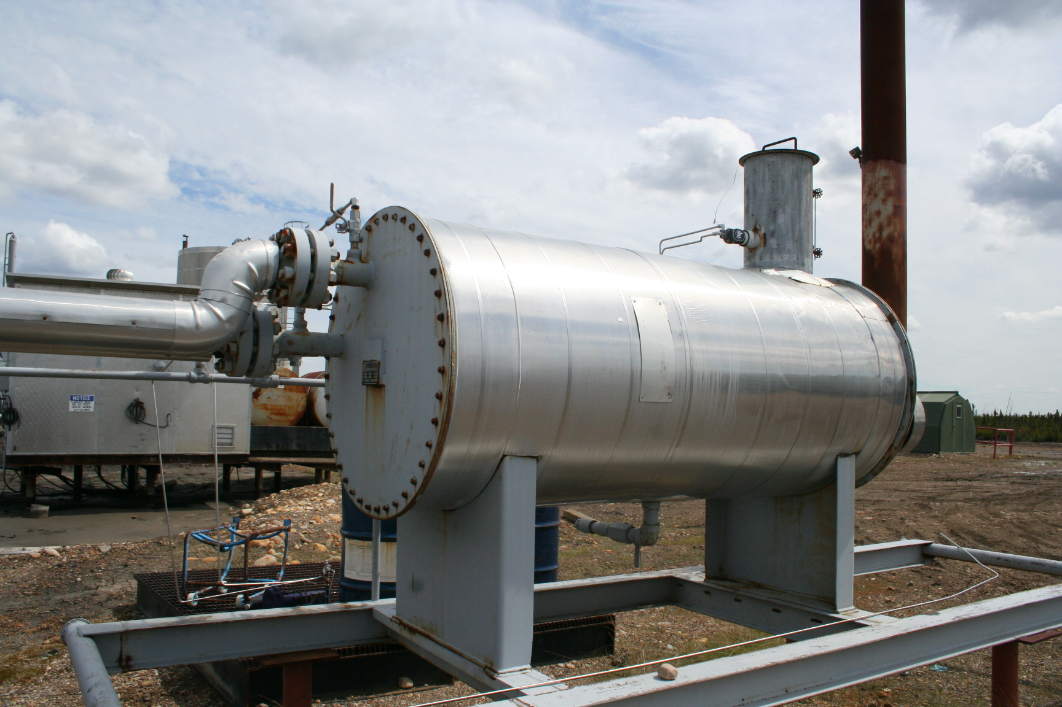 | 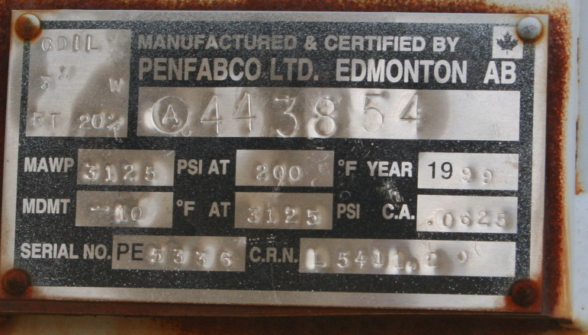
Vessel overview | Data plate

