Canadian Natural Resources Limited

GENERAL PRESSURE VESSEL INFORMATION Job # 05.001508
District: Fort St. John BC. |  |  |  |  | Skid No.
Facility: West Blueberry Battery |  |  |  |  | Location (LSD): 12-29-88-25-W6M
Vessel Name Equipment Number: Flare Knock out Drum

Orientation: Horizontal
Status: In Service |  |  |  |  | Regulatory Inspection
PRESSURE VESSEL NAMEPLATE DATA
“A” or “G” or “S” (Sask.) or BC Registration Number.  C 23408 |  |  |  |  |  | CRN Number:  Non Code
Vessel serial number: 98120-002 |  |  |  |  |  | Size: 36 in. x 10 ft.
Shell thickness: 6.4 mm |  |  |  |  |  | Shell material: SA 36
Head thickness: 6.4 mm |  |  |  |  |  | Head material: SA 36
Tube wall thickness: |  |  |  |  |  | Tube material:
Tube diameter: |  |  |  |  |  | Tube length:
Channel thickness: |  |  |  |  |  | Channel material:
Design pressure | Shell: |  |  |  |  | Operating pressure |  | Shell:
 | Tubes: |  |  |  |  |  |  | Tubes:
Design Temp. | Shell: |  |  |  |  | Operating temperature |  | Shell:
 | Tubes: |  |  |  |  |  |  | Tubes:
X-ray: none |  |  |  |  |  | Heat treatment: no
Code parameters: ASME VIII, Div 1 |  |  |  |  |  | Coated: no
Manufacturer: Black, Sivalls & Bryson |  |  |  |  |  | Year built: 1998
Corrosion allowance: not stated |  |  |  |  |  | Manway: yes

PRESSURE SAFETY VALVE NAMEPLATE DATA
PSV Tag # | Manufacture | Model # |  | Serial # |  |  | Set Pressure  (kPa) |  | Capacity  (scfm) |  |  | Service  Date
CRN # | Service By | Block Valve | Location |  |  |  | Size |  | Code Stamp

SERVICE CONDITIONS-INDICATE ALL THAT APPLY
Sweet | Sour X |  |  | Oil X |  |  |  | Gas X |  | Water X
Amine | LPG |  |  | Condensate X |  |  |  | Air |  | Glycol
Other (Describe):

Inspection Interval ________________________________________PSV Service Interval_________________________________

(Determined by MIC in conjunction with Chief Inspector following guidelines of CNRL’s Owner-User Inspection Program)

Reports reviewed and accepted by:

Mechanical Integrity Coordinator________________________________________________Date__________________________

Fill out all forms as completely as possible. All information is important! Use back of sheets to record additional information or sketch if required.

Copy of report to be filed by MIC at site, and copy sent to Chief Inspector
External Inspection Items | G | F | P | N/A | Comments
Insulation Verify sealed around manways, nozzles, no damage present, and there is no egress of moisture. | X |  |  |  | No damage present- no egress of moisture  Sealed at man way and nozzles
External Condition Assess paint condition, areas peeling, record any corrosion, damage, etc (record location, size and depth of corrosion or damage) | X |  |  |  | Paint in good overall condition – No exposed metal
Leakage Record any leakage at flanges, threaded joints, weep holes on repads, etc. | X |  |  |  | No leaks observed
Saddle/Skirt Assess condition of paint, fire protection, concrete. Look for corrosion, buckling, dents, etc. Look at vessel surface area near supports. Verify no signs of leakage at attachment to vessel and attachment welds are acceptable. Ground wire attached? | X |  |  |  | Saddle: Welded directly to skid frame – no buckling or dents.  No corrosion at attachment welds to vessel – no leaks.  Ground wire attached to skid
Anchor Bolts Hammer tap to ensure secure. Look for cracking in treads or signs of deformation. |  |  |  | X | Saddle welded to skid frame.
Concrete foundation Check for cracks, spalling, etc. |  |  |  | X
Ladder / Platform Describe general condition, ensure support is secure to vessel, describe any hazards. |  |  |  | X
Nozzle Assess paint, look for leakage, and ensure stud threads are fully engaged. Record any damage, deflection, etc. Are nozzles gusseted? | X |  |  |  | Stud threads are fully engaged to nuts – no short bolts.  No leaks observed.  No damage or deflections.  Nozzles are not gusseted
Gauges Ensure gauges are visible, working, no leakage, and suitable for range of MAWP/ Temp. |  |  |  | X | No gauges
External Piping Ensure pipe is well supported. All clamps, supports, shoes, etc. in place. Look for evidence of structural overload, deflection, etc. Paint condition, external corrosion? | X |  |  |  | Piping is well supported – all clamps, supports and shoes are in place.  No structural overloads or deflections.  Piping is insulated no damage present.
Valving Ensure no leaks are visible. Valves are properly supported and chained if necessary. |  |  |  | X | No valves
PSV Ensure PSV is set at pressure at or below that of vessel. |  |  |  | X | No PSV – vent to flare
NDE methods Was UT/ MPI done on vessel  (MI coordinator to review results) | X |  |  |  | Ultrasonic thickness survey carried out – no metal thickness detected below nominal.

Other

Recommendations or corrective actions : Vessel is Fit for Service or describe corrective actions required)
(MIC to review corrective actions with Operations, discuss with Chief Inspector where necessary, and get remedial action implemented)
Recommendations: No recommendations at this time
Summary: Vessel is in overall good condition, visual inspection and ultrasonic corrosion survey performed—no metal thickness detected below nominal.
Vessel is fit for service.

Inspected By: Gerry Avery Date: March 13, 2008

Photo Table

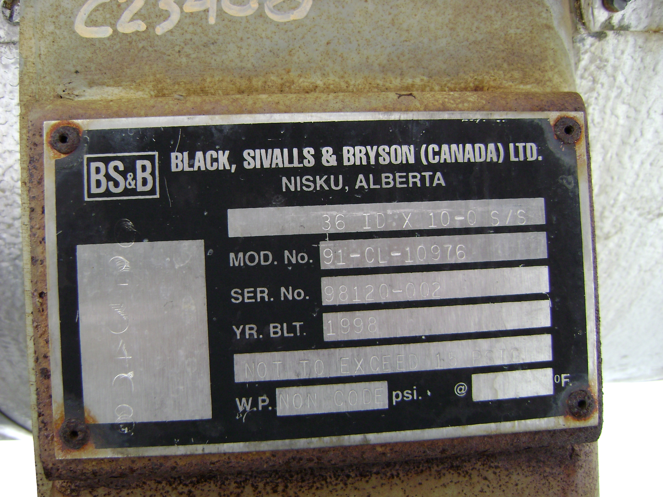 | 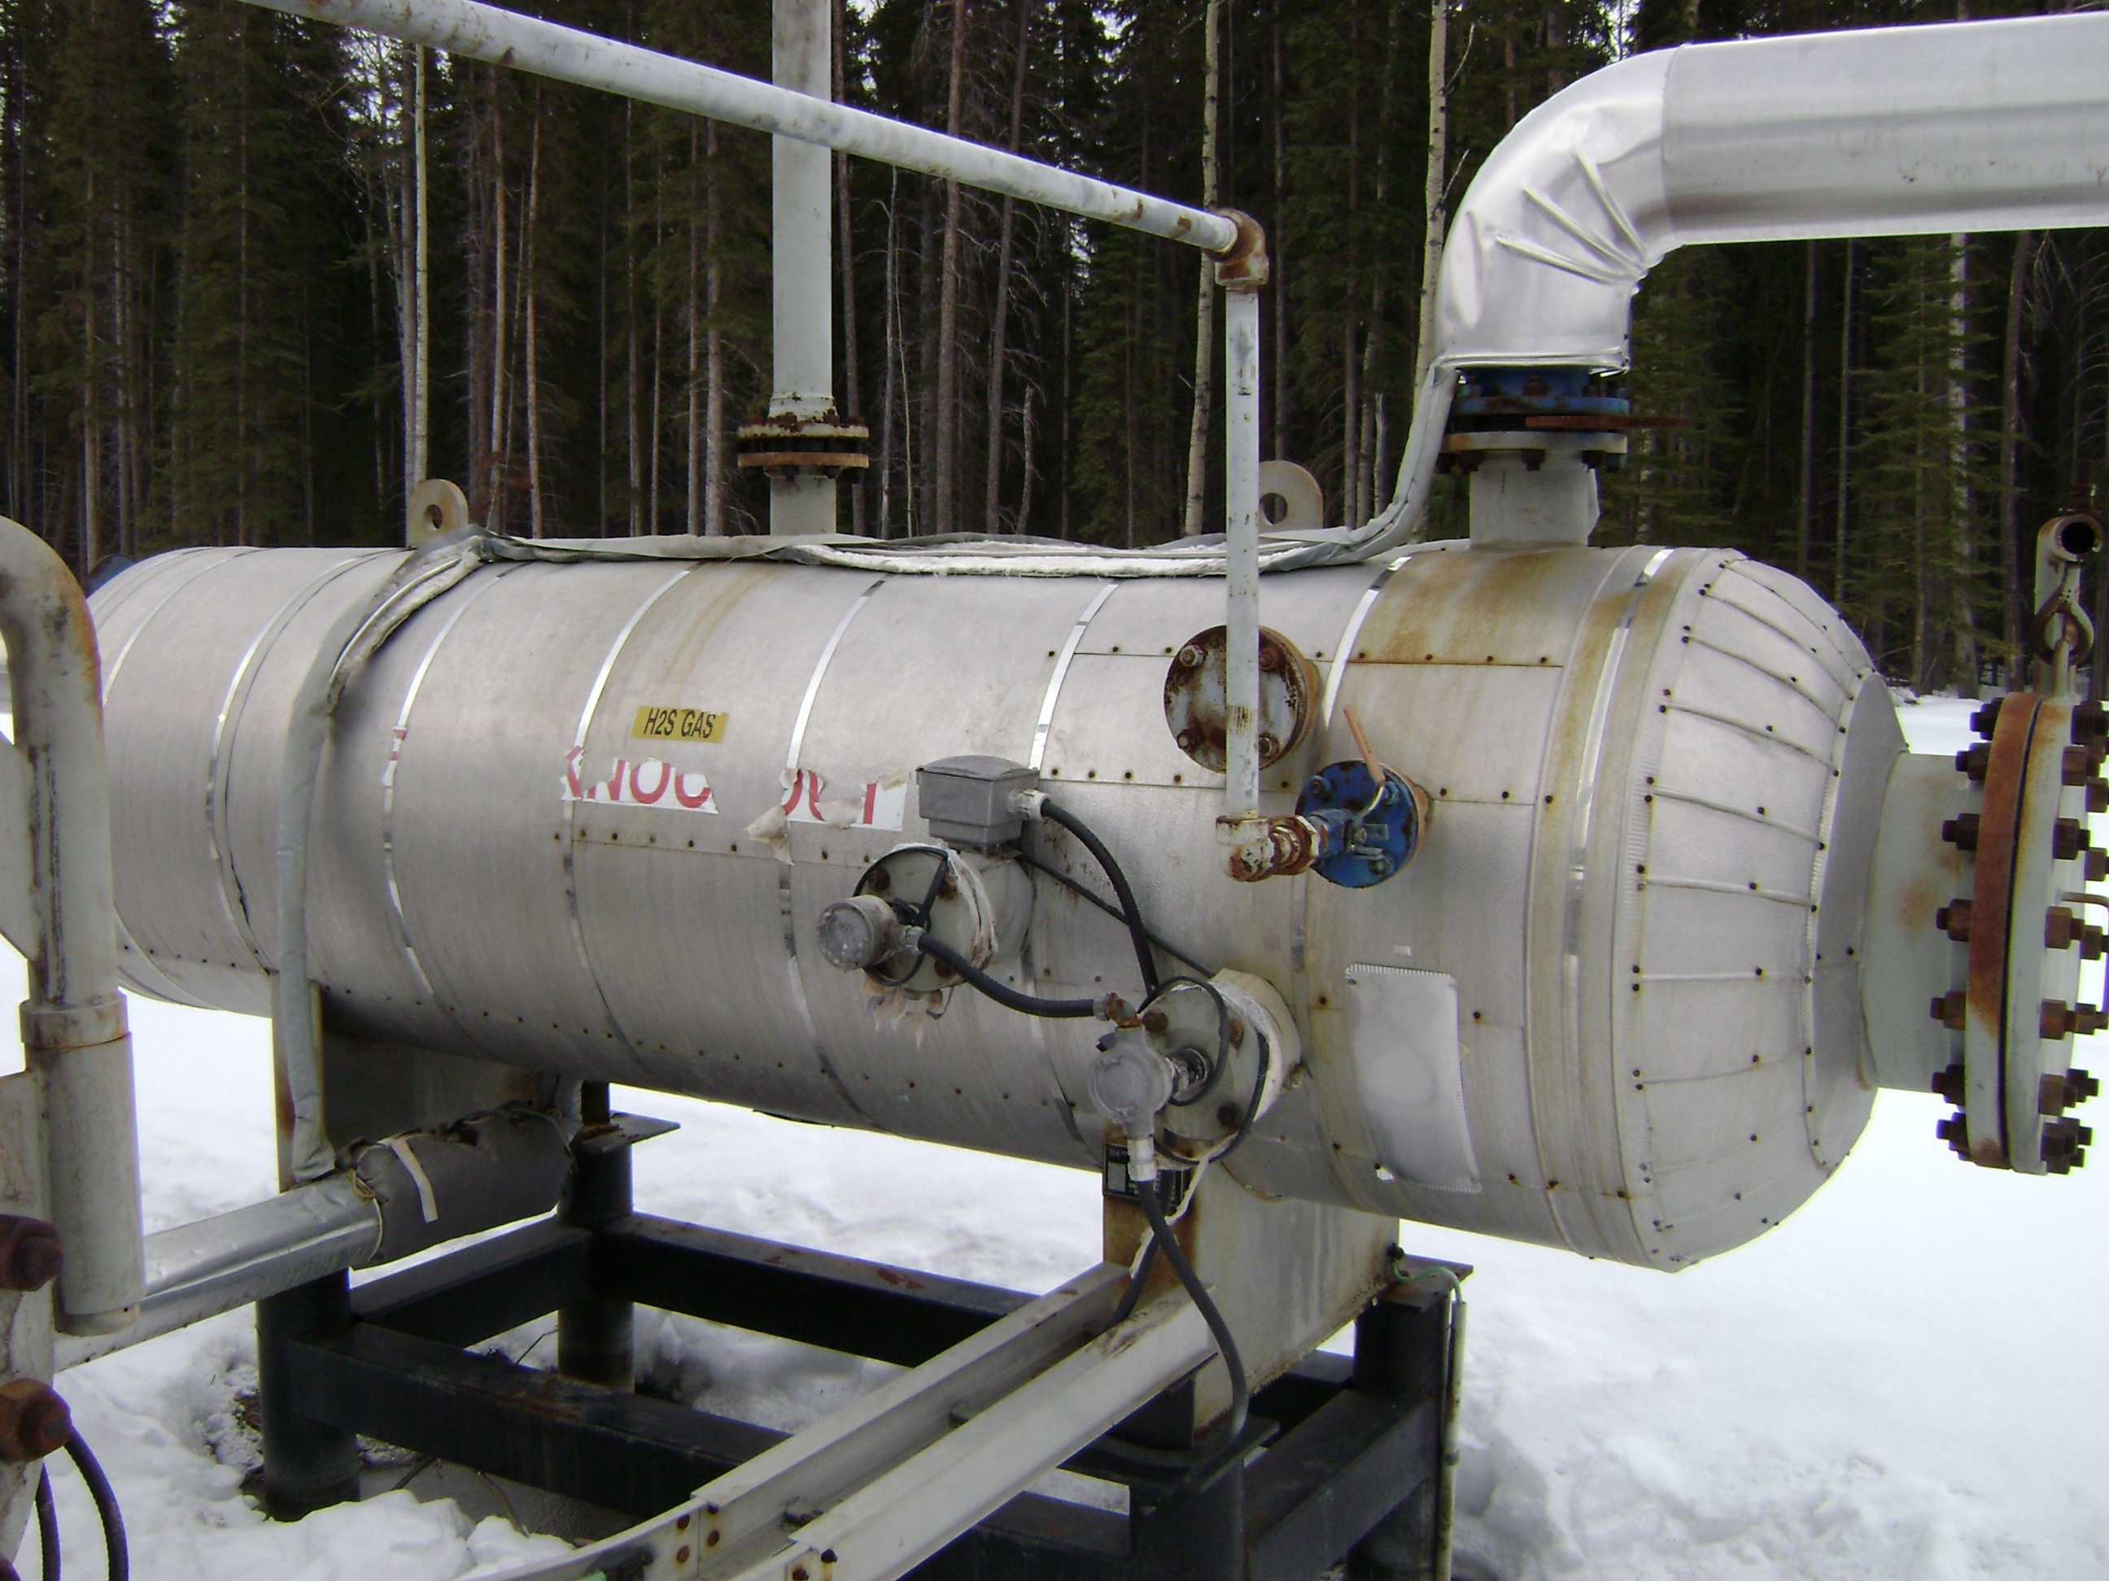
vessel data plate | vessel overview

