Canadian Natural Resources Limited

GENERAL PRESSURE VESSEL INFORMATION Job # 05.01510
District: Fort St John, B.C. |  |  |  |  |  | Skid No.
Facility: North Nig Compressor Station |  |  |  |  |  | Location (LSD): d-41-J/94-H-4
Vessel Name Equipment Number: Glycol Contactor

Orientation: Vertical
Status: In Service |  |  |  |  |  | Regulatory Inspection
PRESSURE VESSEL NAMEPLATE DATA
“A” or “G” or “S” (Sask.) or BC Registration Number.  A2666046 |  |  |  |  |  |  | CRN Number:  K-1778.2
Vessel serial number: 4829-20 |  |  |  |  |  |  | Size: 2.5 ft x 20 ft
Shell thickness: 31.8 mm |  |  |  |  |  |  | Shell material: SA 516-70N
Head thickness: 30.5 mm |  |  |  |  |  |  | Head material: SA 516-70N
Tube wall thickness: |  |  |  |  |  |  | Tube material:
Tube diameter: |  |  |  |  |  |  | Tube length:
Channel thickness: |  |  |  |  |  |  | Channel material:
Design pressure |  | Shell: 9067 kPa |  |  |  |  | Operating pressure |  | Shell:
 |  | Tubes: |  |  |  |  |  |  | Tubes:
Design Temp. |  | Shell: 93°C |  |  |  |  | Operating Temp. |  | Shell:
 |  | Tubes: |  |  |  |  |  |  | Tubes:
X-ray: RT-1 |  |  |  |  |  |  | Heat treatment: Nil
Code parameters: ASME VIII, Div 1 |  |  |  |  |  |  | Coated: No
Manufacturer: PRESSON Manufacturing LTD. |  |  |  |  |  |  | Year built: 1990
Corrosion allowance: 1.6 mm |  |  |  |  |  |  | Manway: No

PRESSURE SAFETY VALVE NAMEPLATE DATA
PSV Tag # | Manufacture |  | Model # |  | Serial # |  |  | Set Pressure  (PSI) |  | Capacity  (scfm) |  |  | Service  Date
No Access

SERVICE CONDITIONS-INDICATE ALL THAT APPLY
Sweet X |  | Sour |  |  | Oil |  |  |  | Gas X |  | Water X
Amine |  | LPG |  |  | Condensate |  |  |  | Air |  | Glycol X
Other (Describe):

Inspection Interval ________________________________________PSV Service Interval_________________________________

(Determined by MIC in conjunction with Chief Inspector following guidelines of CNRL’s Owner-User Inspection Program)
Reports reviewed and accepted by:

Mechanical Integrity Coordinator________________________________________________Date__________________________

Fill out all forms as completely as possible. All information is important! Use back of sheets to record additional information or sketch if required.

Copy of report to be filed by MIC at site, and copy sent to Chief Inspector

A2666046
External Inspection Items | G | F | P | N/A | Comments
Insulation Verify sealed around manways, nozzles, no damage present, and there is no egress of moisture. | X |  |  |  | Upper Shell is insulated, cladding is in good condition.  Roof seal intact.
External Condition Assess paint condition, areas peeling, record any corrosion, damage, etc (record location, size and depth of corrosion or damage) | X |  |  |  | Paint is in good overall condition – no exposed metal
Leakage Record any leakage at flanges, threaded joints, weep holes on repads, etc. | X |  |  |  | No leaking detected.
Saddle/skirt Assess condition of paint, fire protection, and concrete. Look for corrosion, buckling, dents, etc. Look at vessel surface area near supports. Verify no signs of leakage at attachment to vessel and attachment welds are acceptable. Ground wire attached? | X |  |  |  | Skirt is in good condition – no buckles or distortion.  Paint intact – with little to no corrosion.  Vessel grounded through the skid package.  No signs of leakage.
Anchor Bolts Hammer tap to ensure secure. Look for cracking in treads or signs of deformation. | X |  |  |  | Firmly secured.  No signs of deformation.
Concrete foundation Check for cracks, spalling, etc. |  |  |  | X | None.
Ladder / Platform Describe general condition, ensure support is secure to vessel, and describe any hazards. |  |  |  | X | None.
Nozzle Assess paint, look for leakage, and ensure stud threads are fully engaged. Record any damage, deflection, etc. Are nozzles gusseted? | X |  |  |  | All threads engaged.  No deflection – no leaks.  No stud threads, no gussets.  Paint is in good overall condition.
Gauges Ensure gauges are visible, working, no leakage, and suitable for range of MAWP/ Temp. | X |  |  |  | Temperature Gauge -100-160°F Not Suitable for overall range.  Pressure Gauge 0-2000 PSI Suitable for MAWP
External Piping Ensure pipe is well supported. All clamps, supports, shoes, etc. in place. Look for evidence of structural overload, deflection, etc. Paint condition, external corrosion? |  | X |  |  | Well supported – no deflection – all clamps and shoes in place.  Piping is painted and is in good overall condition.
Valving Ensure no leaks are visible. Valves are properly supported and chained if necessary. | X |  |  |  | Well supported – no leaks.
PSV Ensure PSV is set at pressure at or below that of vessel. Discharge piping is same size as inlet to valve and is properly supported and routed. Ensure no block valves between PSV and vessel or if there are they are locked open. |  |  |  | X | No Access
NDE methods Was UT/ MPI done on vessel  (MI coordinator to review results) | X |  |  |  | Ultrasonic corrosion survey carried out, no metal thickness detected below nominal minus corrosion allowance.
Recommendations or corrective actions : Vessel is Fit for Service or describe corrective actions required)
(MIC to review corrective actions with Operations, discuss with Chief Inspector where necessary, and get remedial action implemented)
Recommendations: 1) No recommendations
Summary: This vessel is in good condition, visual external and ultrasonic thickness inspection carried out – no metal thickness detected below nominal minus corrosion allowance.
Short term corrosion rate based on greatest thickness loss (head) 0.283mm per year. Retirement Date to “T”min is year 2028.
Vessel is fit for service.
Inspected By: Dellas Weidman Date: Feb 03, 2011

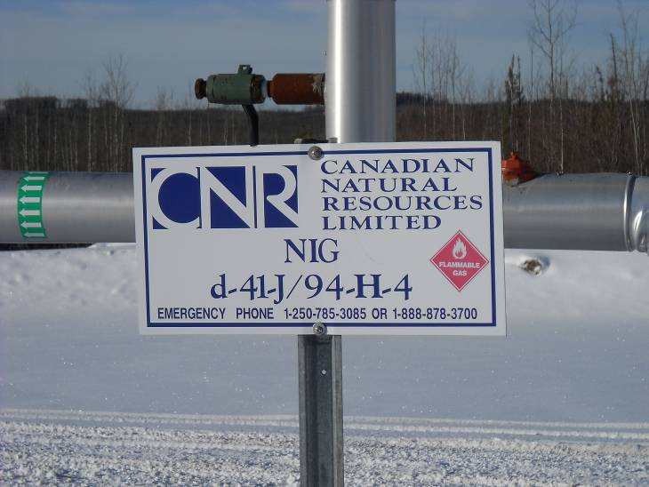 | 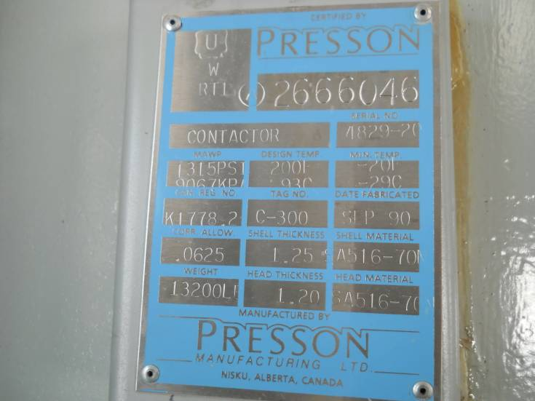
 | Data Plate Overview
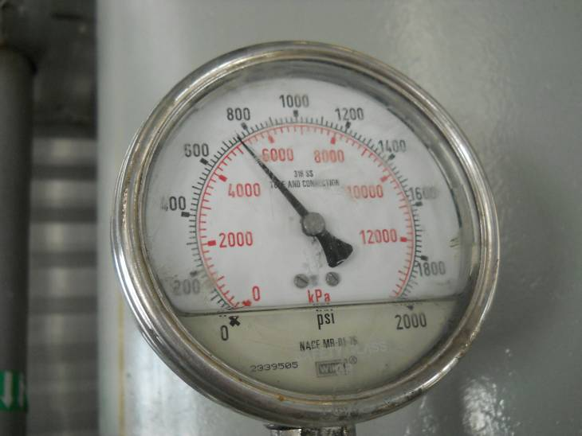 | 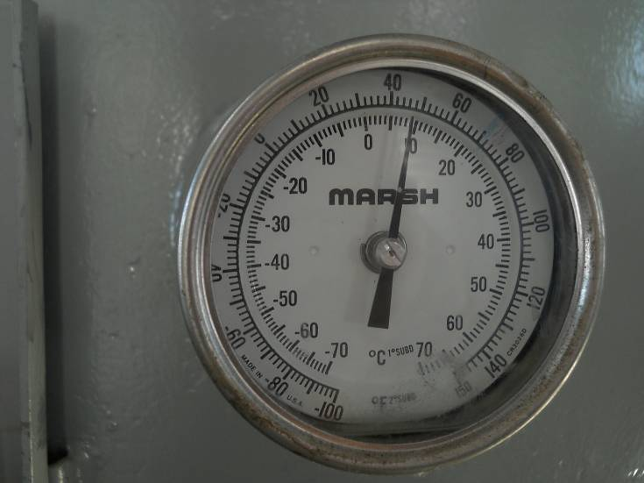
Pressure gauge | Temperature gauge
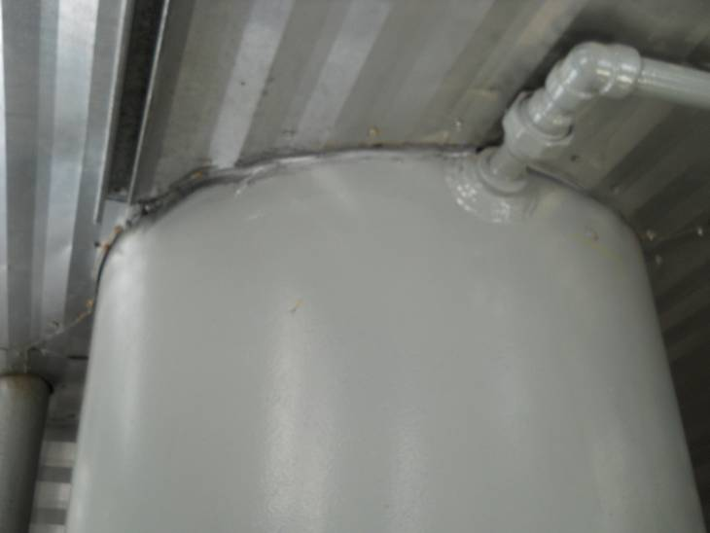 | 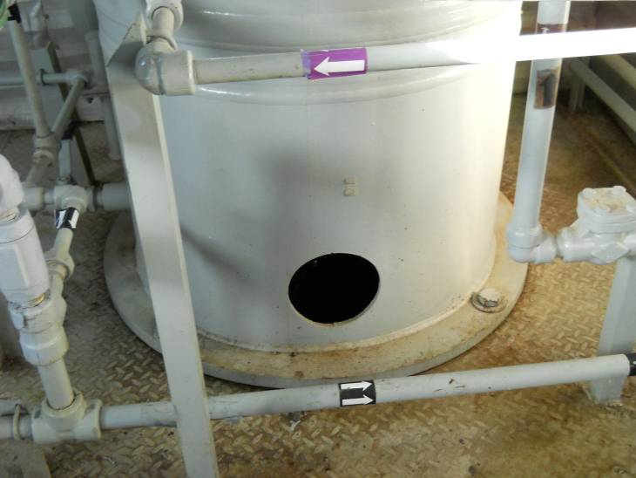
Roof seal | Skirt
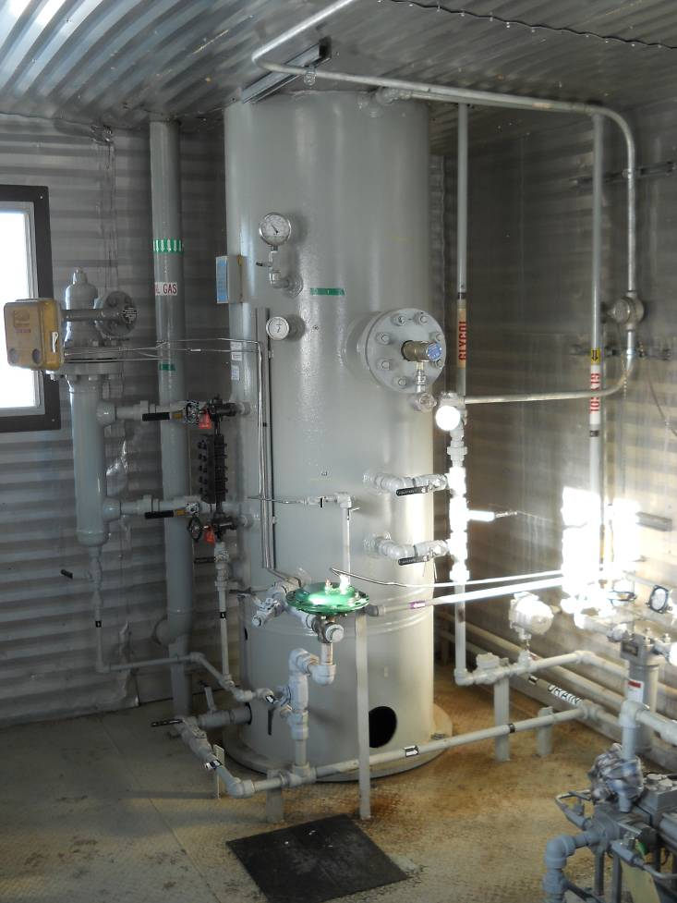 | 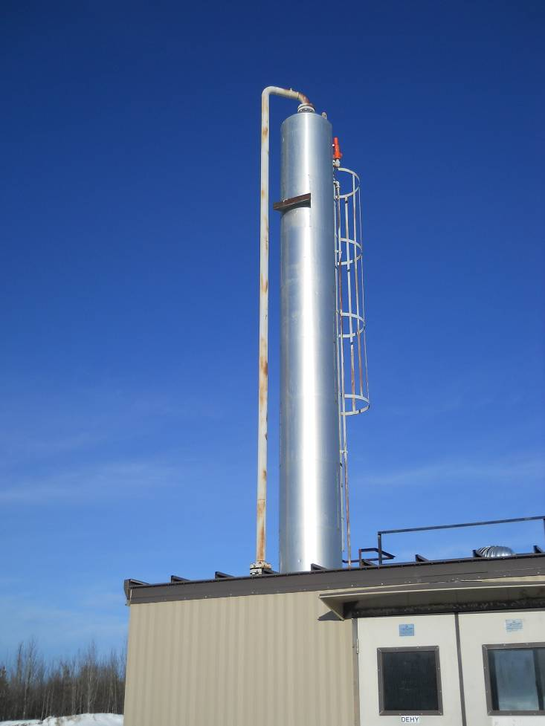
Overview | Overview

