 

**CNRL – Performance Valve Exchange (VEx)**

**CNRL**

Name

Title

Fort St John, Canada

HOERBIGER contact:

Toni Moretto

**HOERBIGER (Canada) Ltd**

November 17, 2017

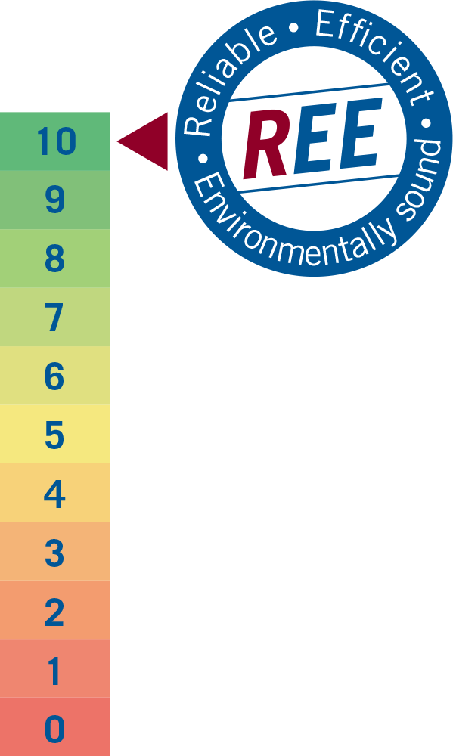

**Proposal**

**Valve Exchange (VEx)**



1. Introduction Error! Bookmark not defined.

2. REE Index Error! Bookmark not defined.

3. REE Improvement Process Error! Bookmark not defined.

4. REE Audit Error! Bookmark not defined.

5. Executive Summary Error! Bookmark not defined.

6. Next Steps Error! Bookmark not defined.

Content

1. **INTRODUCTION………………………………………………………………………… 3**
2. **PERFORMANCE VALVE EXCHANGE (VEx).………………………………………. 3**
3. **INITIAL VALVE PURCHASE..……………………………………………………….... 4**
4. **CUSTOMER OBLIGATIONS...………………………………………………………… 4**
5. **HOERBIGER OBLIGATIONS..………………………………………………………… 4**
6. **VEx PAYMENT PROPOSAL..……..…………………………….……..…………..…. 5**
7. **HOERBIGER GUARANTEE…………………………………………………………... 5**
8. **90 DAY DEMONSTRATION PERIOD..…………….………………………………… 5**
9. **END OF CONTRACT – VALVE and KIT BUYBACK.…………….……………….. 5**
10. **TERMS AND CONDITIONS..…………………………………………………………… 6**
11. **PAYMENT AND INVOICING TERMS……………..…………………………………... 6**
12. **SUMMARY…………………...…………………………………………………………… 6**

# Introduction

The following proposal outlines HOERBIGER’s **“Performance Valve Exchange” (VEx)** offering to CNRL. Key features of the VEx offering include:

* Predictive maintenance model
* Technology upgrade
* Equipment lease
* Vendor Managed Inventory
* High quality valve repair
* Committed partner

VEx will deliver significant value to CNRL. The scope of the value delivered includes:

* Improved Safety for personnel and reduced risk to equipment
* Increased unit production and availability
* Increased employee productivity and lower operating cost
* Reduced working capital
* Reduced emissions

# Performance Valve Exchange

The primary deliverables of HOERBIGER’s “VEx” offering are increased unit production due to reduced unit downtime, increase valve service life measured by mean time between failures (MTBF), reduced operating cost through increased employee productivity and reduced working capital. This is achieved through:

Predictive maintenance model:

* Based on calculated maintenance intervals, all valves in a cylinder are changed at one time versus experiencing many frequent unplanned failures, downtime and callouts associated with the current reactive maintenance model

Technology upgrade:

* HOERBIGER Engineering tailors the valves to each unit’s operating conditions
* Valves are upgraded to the new long life CP valve technology at no additional cost
* VENTIL app is used to track valve location through the complete process and records when valves are installed and removed from compressor

Equipment lease:

* Valves in the unit and spare valves are owned by HOEBIGER and leased to customer
* HOERBIGER purchases existing valves, spares and kits based on defined criteria

Vendor managed inventory:

* Valve inventory levels and logistics fully managed by HOERBIGER
* Spare valve inventory is provided for units and valve availability is guaranteed
* Valves are replaced immediately when used, no waiting on the return of worn valve from repair

High quality valve repair:

* Valves are inspected, repaired and tested to OEM specifications using 100% OEM parts
* Valves are repaired at OPM facility where valves were initially manufactured and assembled
* Valve failure modes are recorded at time of repair for continuous valve life improvement

Committed partner:

* Lease model drives alignment between CNRL and HOERBIGER to continuously work together to increase valve MTBF unlike the current supplier relationship

# Initial Valve Purchase

A key benefit of the VEx offering is HOERBIGER owns the inventory. At the end of the demonstration period, HOERBIGER will purchase the existing valves in the VEx units, spare valves and kits required to support the VEx fleet. The purchase price for the VEx fleet, assuming a 50% remaining service life and 30% spares ratio, is estimated to be **$330,000 (CAN)** as defined below:

* Purchase existing kit inventory as required to support the VEx fleet: (OEM List Price x HOERBIGER Discount) x 90%
* Purchase valves in the units and spares as required to support the VEx fleet: The first time a valve arrives at HOERBIGER for repair, HOERBIGER will measure the seat thickness and determine and record the remaining service life of the valve. On a monthly basis, these valves will be purchase at the following pricing (OEM list price x HOERBIGER discount x remaining service life) x 90% until all initial valves in the VEx fleet have been evaluated.
* HOERBIGER will supply spare valve inventory to the CNRL, Fort St John, Canada facility
* HOERBIGER guarantees to maintain inventory levels in alignment with the service / field needs

# Customer Obligations

* Provide compression fleet information required for the valve exchange program
* Insure accurate and timely scans of all valve movements
* Provide a list of associated employees involved within the program
* Make employees available for system / program training ~ 1hr
* Allow HOERBIGER access to all units to record operating conditions
* Provide current valve and kit inventory information
* Provide data and work with HOERBIGER to define a Mean Time Between Failure (MTBF) for the VEx fleet
* Attend a quarterly management meeting to review all KPI’s
* Commit to a 5 year contract term

# HOERBIGER Obligations

* Provide the Valve Management Program (VxMP) system with customer dashboard and VENTIL app, a cloud based system for tracking the valves and automating inventory management
* Train CNRL personnel to effectively to use the VxMP and the VENTIL app
* Gather current operating data for each unit in the identified fleet
* HOERBIGER Engineering will tailor valves for each unit based on operating conditions
* Provide a serialized code on all valves and units to insure accurate valve tracking
* Implement a predictive maintenance model for all units reducing unplanned downtime
* Effectively manage local inventory at the Fort St John, Canada facility and all valve logistics from HOERBIGER to CNRL, in and out of compressor and back to HOERBIGER.
* Upgrade valves to the new high performance CP valve technology
* Repair valves to OEM specifications using 100% OEM parts
* Monitor, evaluate and recorded valve life and valve failure mode by unit to enable HOERBIGER and CNRL to identify and resolve bad actors improving operational performance
* Maintain data to enable the CNRL and HOERBIGER partnership to evaluate data trends around process, operational performance and progress to business KPI’s.
* Attend a quarterly management meeting to review all KPI’s of the valve exchange program

# VEx Payment Proposal

Monthly Payment –

* Determined using weighted average valve life at the beginning of the contract. Based on available data, initial average valve life for the fleet is estimated at 10 months.
* Valve failures tracked, actual valve life calculated and monthly fee trued up (+/-) quarterly
* After 24 months, weighted average valve life and monthly fee established for term of contract



# HOERBIGER Guarantee

In the event that CNRL experiences a “stock out” event during normal operation where HOERBIGER has not delivered against the contracted obligations, HOERBIGER will reduce the contracted monthly fee by 5% for the month in which the event occurred. Should there be multiple events within the same calendar month, HOERBIGER will reduce the contracted monthly fee by a further 2% per event up to a maximum reduction of 20% in one calendar month period.

# 90 Day Demonstration Period

For the first 90 days of the agreement, CNRL will have the option to return all VEx valves in the unit and spares. It will be CNRL option to either have the valves return in the condition that they were initially received at the start of the contract or fully evaluated and repaired to OEM specifications.

# End of Contract – Valve and Kit Buy Back

Should CNRL choose not to extend the Valve Exchange contract at the end of the 5 year contract term, CNRL will have the option to return all valves to HOERBIGER or buy back all valves in the VEx fleet and a comparable amount of spare valves and service kits to ensure seamless operation of CNRL units as stated below:

* CNRL will purchase an equal number of valves and kits on the exit of the contract as were purchased by HOERBIGER at the beginning of the contract.
* The valve and kit buy back price will be set using the same methodology as the initial valve purchase

# Terms and Conditions

As stated in the Valve Exchange and Equipment Lease Agreement.

# Payment and Invoicing Terms

HOERBIGER will invoice monthly at the agreed upon fee. All HOERBIGER invoices will be for the full amount due. All invoices are to be paid within 30 days from date of invoice.

# Summary

HOERBIGER is pleased to provide this Performance Valve Exchange proposal to CNRL.

HOERBIGER reserves the right to correct any clerical errors in this proposal. Proposal is valid for 30 days from the date of proposal. The Quotation price excludes applicable taxes. Any applicable taxes will be added as appropriate at time of invoicing.

Please do not hesitate to call me at 780-983-2313 if you have any questions regarding this proposal.

Sincerely,

HOERBIGER Service Incorporated

Toni Moretto

Head of Service

**HOERBIGER (Canada) Ltd**