 |  |  |  |  |  |  | Applus-RTD  5504-36 Street,  Edmonton, Ab., Canada  T6B 3P3  Tel: (780) 440-6600 Fax: (780) 440-2538 |  |  |  |  |  |  |  |  |  |  |  |  |  |  |  |  |  |  |  | General NDE Report |  |  |  |  |  |  |  |  |  |  |  | KMK06-02-2009a
 |  |  |  |  |  |  |  |  |  |  |  |  |  |  |  |  |  |  |  |  |  |  |  |  |  |  | Date |  |  | 2 June 2009 |  |  |  |  |  |  | Page |  |  |  |  | 1 |  |  | of |  |  | 1
 |  |  |  |  |  |  |  |  |  |  |  |  |  |  |  |  |  |  |  |  |  |  |  |  |  |  | RTD Job #: |  |  |  |  | 05.003218
 |  |  |  |  |  |  |  |  |  |  |  |  |  |  |  |  |  |  |  |  |  |  |  |  |  |  | RTD Dep. #: |  |  |  |  | Grande Prairie
Client: |  |  |  | Canadian Natural Resources Ltd. |  |  |  |  |  |  |  |  |  |  |  |  |  |  |  |  |  |  |  |  |  |  | LSD: |  |  |  |  | d-44-A/94-G-10
Address: |  |  |  | Bucking Horse Gas Plant |  |  |  |  |  |  |  |  |  |  |  |  |  |  |  |  |  |  |  |  |  |  | Location: |  |  |  |  | Bucking Horse Gas Plant
P.O.#: |  |  |  |  |  |  |  |  |  |  |  |  |  |  |  |  |  |  |  |  |  |  |  |  |  |  | Procedure: |  |  |  |  | RTD NDE: MT 001
Client Rep.: |  |  |  | Matt Lorenze |  |  |  |  |  |  |  |  |  |  |  |  |  |  |  |  |  |  |  |  |  |  | Code: |  |  |  |  | ASME VIII, Div 1
Description: |  |  |  | Magnetic Particle Inspection on Amine Re-boiler Fire Tube
Surface Condition: |  |  |  |  |  |  |  | Weldment Ground |  |  |  |  | Machined  Sandblasted |  |  |  |  |  |  |  | Painted  Other |  |  |  |  |  |  | Surface Temp (C°): |  |  |  |  |  |  | < 5 > 5 • < 60 > 60
MAGNETIC PARTICLE INSPECTION
Equipment Type: |  |  |  |  |  |  |  | Yoke |  |  |  | Bench |  |  |  |  |  |  |  |  |  | Asset No.: |  |  |  |  |  |  |  |  | 10766 |  |  |  | Calibration Due Date: |  |  |  |  |  |  |  |  |  |  |  | Sep 2009
Blacklight: |  |  | Intensity Check: |  |  |  |  |  |  |  |  |  |  |  |  |  | μW/cm² |  |  |  |  | Asset No.: |  |  |  |  |  |  |  |  |  |  |  |  | Calibration Due Date:
Method: | A/C D/C |  |  |  |  |  |  |  |  | Type: |  |  |  |  | Continuous Residual |  |  |  |  |  |  |  |  |  |  |  |  |  | Power Supply: |  |  |  |  |  | 120 V |  |  | Battery |  |  |  |  |  |  |  | Natural
Type: | Dry Powder: |  |  |  |  |  |  |  |  |  | Colour; |  |  |  |  |  |  |  |  | Wet: |  |  |  | Black and White |  |  |  |  |  |  |  |  | Fluorescent
Product Manufacturer: |  |  |  |  |  |  |  |  | Magnaflux |  |  |  |  |  |  |  |  |  |  | Product Identification Code: |  |  |  |  |  |  |  |  |  |  |  |  |  | 7HF

inspection Details
Scope: |  |  |  |  | MT Inspection all welds on the Amine Re-boiler fire tube.
Results: |  |  |  |  | No Cracking detected.  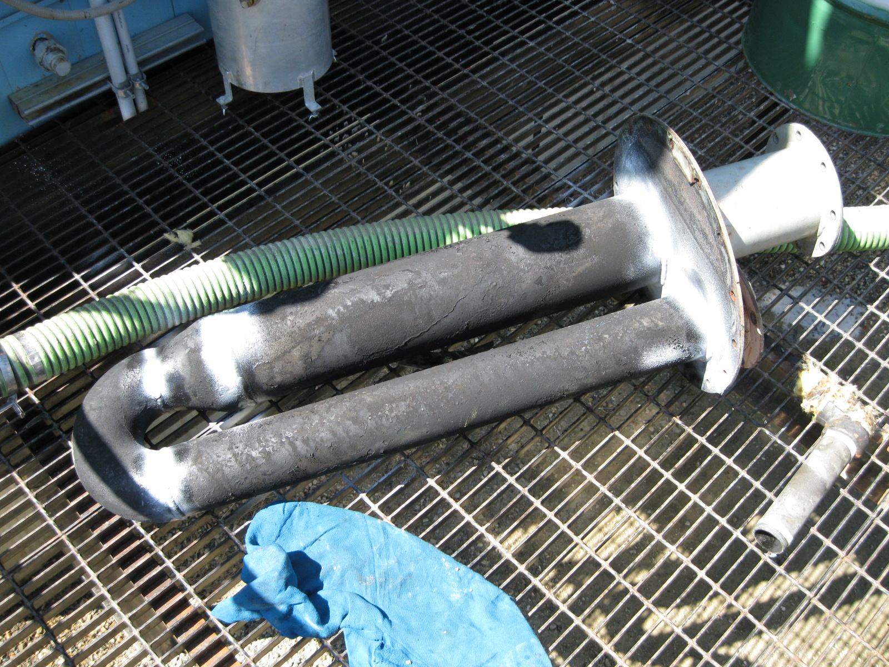
Technician: |  | Keith Kowal |  |  |  |  |  |  |  |  |  |  |  | CGSB /ASNT/SNT Level: |  |  |  |  |  |  |  |  | 2 |  |  | Start Time: |  |  |  |  |  |  | Stop Time: |  |  |  |  |  |  |  |  |  | ST |  |  |  | OT
Signature: |  |  |  |  |  |  |  |  |  |  |  |  |  | Method:: |  |  |  | MT |  |  |  |  |  |  |  | Unit: |  |  |  |  |  |  | Km: |  |  |  |  |  |  | Travel Time:
Assistant: |  |  |  |  |  |  |  |  |  |  |  |  |  | CGSB /ASNT/SNT Level: |  |  |  |  |  |  |  |  |  |  |  | Subsistence required OT Meal
Client Signature: |  |  |  |  |  |  |  |  |  |  |  |  |  |  |  |  |  |  |  |  |  |  |  |  |  | Consumables:
*Results are an interpretation of the inspection method, not a guarantee. Client signature indicates acceptance of report, results and applicable charges.

