GENERAL INSPECTION FORM
District: Ft St John, B.C. |  |  |  | Skid No.
Facility: South Buick Compressor Station |  |  |  | Location (LSD): D-78-I-94-A-11-W6M
Vessel Name & Equipment Number: Treater
Orientation: Horizontal
Status: In Service |  |  |  | Regulatory Inspection
PRESSURE VESSEL NAMEPLATE DATA
“A" or “G” or “S” (Sask.) or BC Registration Number.  A# 228342 |  |  |  |  | CRN Number  F-640.23
Vessel serial number: L-6-336 |  |  |  |  | Size: 72in. X 17ft
Shell thickness: 7.9 mm |  |  |  |  | Shell material: SA-516-70
Head thickness: 9.5 mm |  |  |  |  | Head material: SA-516-70
Tube wall thickness: N/A |  |  |  |  | Tube material: N/A
Tube diameter: N/A |  |  |  |  | Tube length: N/A
Channel thickness: N/A |  |  |  |  | Channel material: N/A
MAWP | Shell: 50PSI |  |  |  | Operating pressure | Shell: 0-60 PSI Not in operation
 | Tubes: |  |  |  |  | Tubes: During Inspection
Design Temp. | Shell: 200 Deg. F |  |  |  | Operating temperature | Shell: 0-120 Deg. C Not in operation during Inspection
 | Tubes: |  |  |  |  | Tubes:
X-ray: RT-4 |  |  |  |  | Heat treatment: No
Code parameters: ASME VIII Div.1 |  |  |  |  | Joint efficiency (if on nameplate): N/S
Manufacturer: Natco Ltd. |  |  |  |  | Year built: 1986
Corrosion allowance: 1.6 mm |  |  |  |  | Manway: Yes

PRESSURE SAFETY VALVE NAMEPLATE DATA
Tag Number(s) | Set Pressure PSI | CRN # | Manufacturer /Model / Serial# and Code Stamp |  |  | Capacity (Scfm) | Size | Set Date
Shell Side  2977G | 50 PSI | N/S | Farris/ 26JA10-120. Ser# CE-41705-A10. UV/NB |  |  | 1567 | 2”x 3” | April-2007

SERVICE CONDTIONS-INDICATE ALL THAT APPLY
Sweet | Sour X |  | Oil X |  |  | Gas X |  | Water X
Amine | LPG |  | Condensate X |  |  | Air |  | Glycol
Other (Describe):

Inspection Interval ________________________________________PSV Service Interval_________________________________

(Determined by MIC in conjunction with Chief Inspector following guidelines of CNRLs Canada Owner-User Inspection Program)
Reports reviewed and accepted by:

Mechanical Integrity Coordinator________________________________________________Date__________________________

Fill out all forms as completely as possible. All information is important! Use back of sheets to record additional information or sketch if required.

External Inspection Items | G | F | P | N/A | Comments
Insulation Verify sealed around manways, nozzles, no damage present, and there is no egress of moisture. Are straps secured? | X |  |  |  | No damage to Insulation, seal at both the fire tube and building end is broken needs to be resealing. No sign of moisture egress noted. No straps to support cladding. Secured with screws.
External Condition Assess paint condition, areas peeling, record any corrosion, damage, distortion etc (record location, size and depth of corrosion or damage) | X |  |  |  | Paint in good condition, West head  No external corrosion observed.
Leakage Record any leakage at flanges, threaded joints, weep holes on repads, etc. | X |  |  |  | No leaks observed.
Skirt: Assess condition of paint, fire protection, and concrete. Look for corrosion, buckling, dents, etc. Look at vessel surface area near supports. Verify no signs of leakage at attachment to vessel and attachment welds are acceptable. Is ground wire attached? | X |  |  |  | Saddle:  This vessel saddle is covered by Insulation, no signs of damaged or Insulation. No signs of leaks. Paint peeling to 20% of surface. Minor surface corrosion at base of supports.  Ground wire firmly attached to skid.
Anchor Bolts Hammer tap to ensure secure. Look for corrosion, cracking in threads or signs of deformation. | X |  |  |  | Anchor bolts are firmly secured No deformation noted.
Concrete foundation Check for cracks, spalling, etc. |  |  |  | X | None
Ladder / Platform Describe general condition, ensure support is secure to vessel, and describe any hazards. |  |  |  | X | None
Nozzle Assess paint, look for leakage, and ensure stud threads are fully engaged. Record any damage, deflection, etc. Are nozzles gusseted? Inspect gussets for cracking. | X |  |  |  | Stud threads are fully engaged to nuts.  No damage or deflections observed – no leaks.  Paint in good condition.  Nozzles are not gusseted.
Gauges Ensure gauges are visible, working, no leakage, and suitable for range of MAWP/ Temp. | X |  |  |  | Gauges are visible, working, no leaks and suitable for range of Temperature.  Temp gauge 0 – 120 Deg. C Press gauge 0-400Kpa.
External Piping Ensure pipe is well supported. All clamps, supports, shoes, etc. in place. Look for evidence of structural overload, deflection, etc. Paint condition, external corrosion? | X |  |  |  | Piping is well supported; all clamps, supports, and shoes are in place.  No structural overloads or deflections noted.  Paint in good condition – no corrosion.  Insulation on Gas off piping is damaged South side of vessel.
Valuing Ensure no leaks are visible. Valves are properly supported and chained if necessary. | X |  |  |  | No leaks are visible.  Valves are properly supported.
PSV Ensure PSV is set at pressure at or below that of vessel. Discharge piping is same size as valve outlet and is properly supported and routed. Are psv seals in place? Ensure no block valves between psv and vessel, or if there is that they are locked/sealed open. | X |  |  |  | PSV is set at MAWP of vessel.  Discharge piping is same size as outlet of valve.  PSV seal in place.  Block valve located on outlet of PSV.  Location: Top Shell.  PSV is properly supported.
NDE methods Was UT/ MPI done on vessel  (MI coordinator to review results) | X |  |  |  | MPI on fire tube flange weld – no indication found.  UT thickness reading performed on fire tube average readings 9.3mm to 9.4mm.

Other Observations:

Inspected By: Joe Holdstock Date: May 2, 2007

Internal Inspection Items | G | F | P | N/A | Comments
Coating Assess coating. Describe area coated, general condition of coating. | X |  |  |  | General condition of coating found to be in good – no exposed metal surface.  No holidays noted.
Anodes. How many, type, condition. % consumed. Are they being replaced? | X |  |  |  | 2 Anodes were found and consumed to less than – 5% max. Will not be replaced. Ground cable on  East anode was broken, needs to be repaired.
Internal Piping Is there any? If so, carbon or stainless steel. Describe condition, dents, corrosion, erosion, etc. Ensure supports are secure and any bolts are suitable for future use. |  |  |  | X | No internal piping.
Level indicator / Float:  Intact? Free Movement? | X |  |  |  | Good condition, no obstructions – free movement.
Thermal Well:  Intact, in place? | X |  |  |  | Intact and in place.
Trays How many? Type of material. Are valves in place. Check for erosion/ corrosion; wear on tray valve legs. Cleanliness? |  |  |  | X
Baffles, deflector plates, etc. If present, describe condition. Look closely at welds attached to vessel wall. | X |  |  |  | Weir in place – no failed coating.  Inlet diffusers (Horseshoes) in place no exposed metal or previous corrosion.
East Head Note all corrosion, erosion or mechanical damage. (If vessel is horizontal identify direction of this head) | X |  |  |  | Good condition, no exposed metal – no previous corrosion.
West Head Note all corrosion, erosion or mechanical damage. (If vessel is horizontal identify direction of this head) | X |  |  |  | Good condition, no exposed metal – no previous corrosion.
Shell Sections Record number of shell sections. Record location, size and depth of all erosion, corrosion or mechanical damage. Describe general condition. If any corrosion greater than corrosion allowance is observed in either shell or head, discuss with Chief Inspector before closing vessel. | X |  |  |  | Two shell sections were found to form this vessel. The shell was coated and in good condition – no failed areas.
Demister pad Is it in place? Is it clean? If any corrosion is apparent in vessel, lift pad and check top head for corrosion. |  |  |  | X | No demister pad.
Nozzles: Unobstructed? Identify and corrosion, pitting – quantitify. | X |  |  |  | Coated – no failed areas.
Welds Inspect all welds, including attachment welds. Record all service-related damages and if there is any discuss with Chief Inspector before closing. | X |  |  |  | Good condition, no exposed metal – no previous corrosion.
Repairs Required. If yes, ensure procedure and copy of AB 40 is on file, and one sent to local ABSA, and Chief Inspector |  |  |  | X | No repairs required.
NDE Was any NDE done. ( MI coordinator to review results) |  |  |  |  | No internal NDE performed at this time.
Recommendations or corrective actions : Vessel is Fit for Service or describe corrective actions required)
(MIC to review corrective actions with Operations, discuss with Chief Inspector where necessary, and get remedial action implemented)
Recommendation: 1. West end anode ground broken needs to be repaired.
Summary: This vessel is in good overall condition, visual internal, external carried out – no failed coating – no previous corrosion. Magnetic Particle inspection carried out on fire tube – no cracking detected.
Vessel fit for service.

Inspected By: Joe Holdstock Date: May 2, 2007
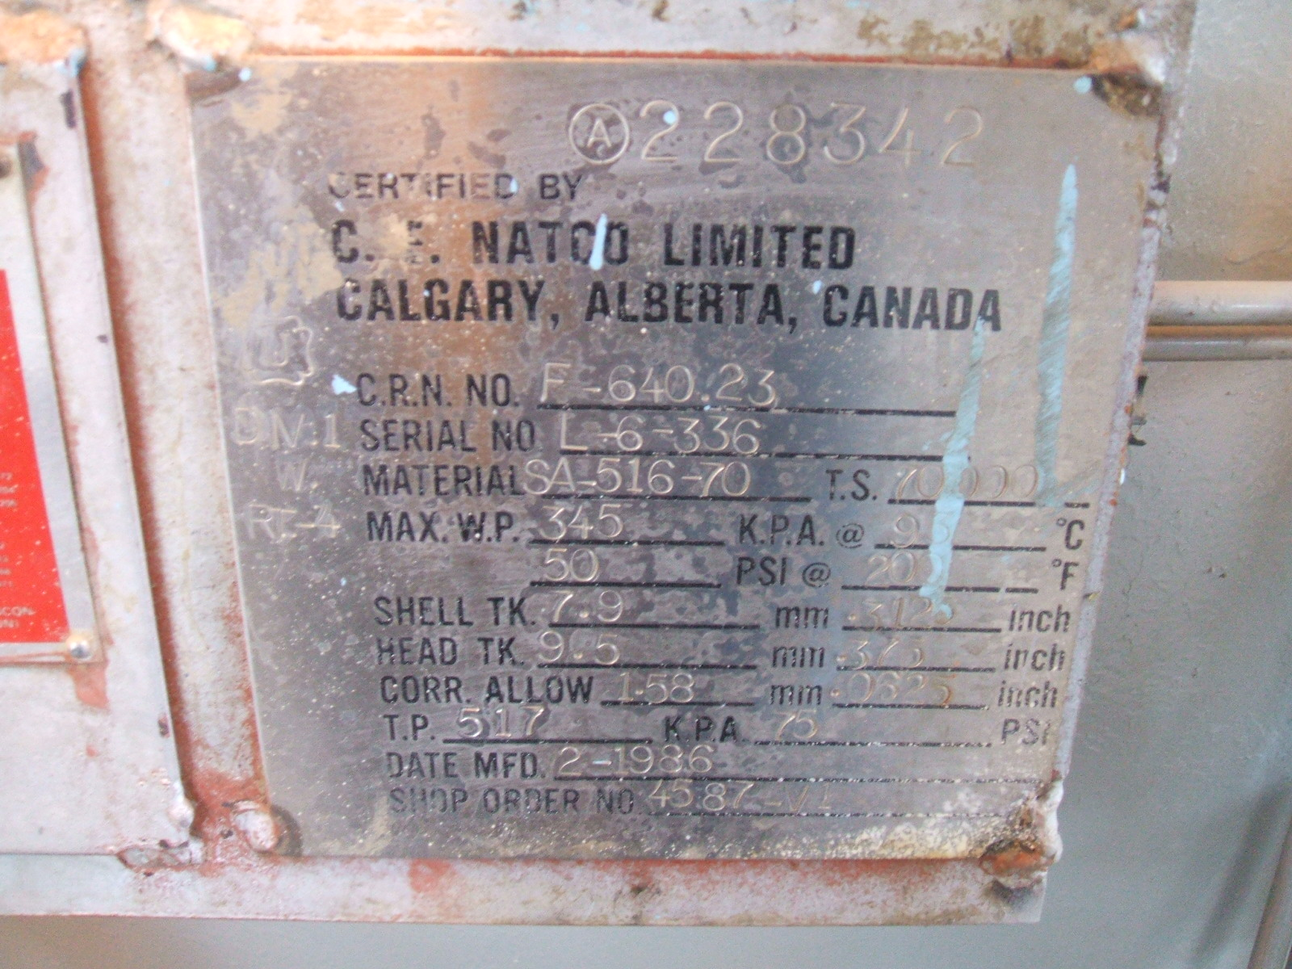 | 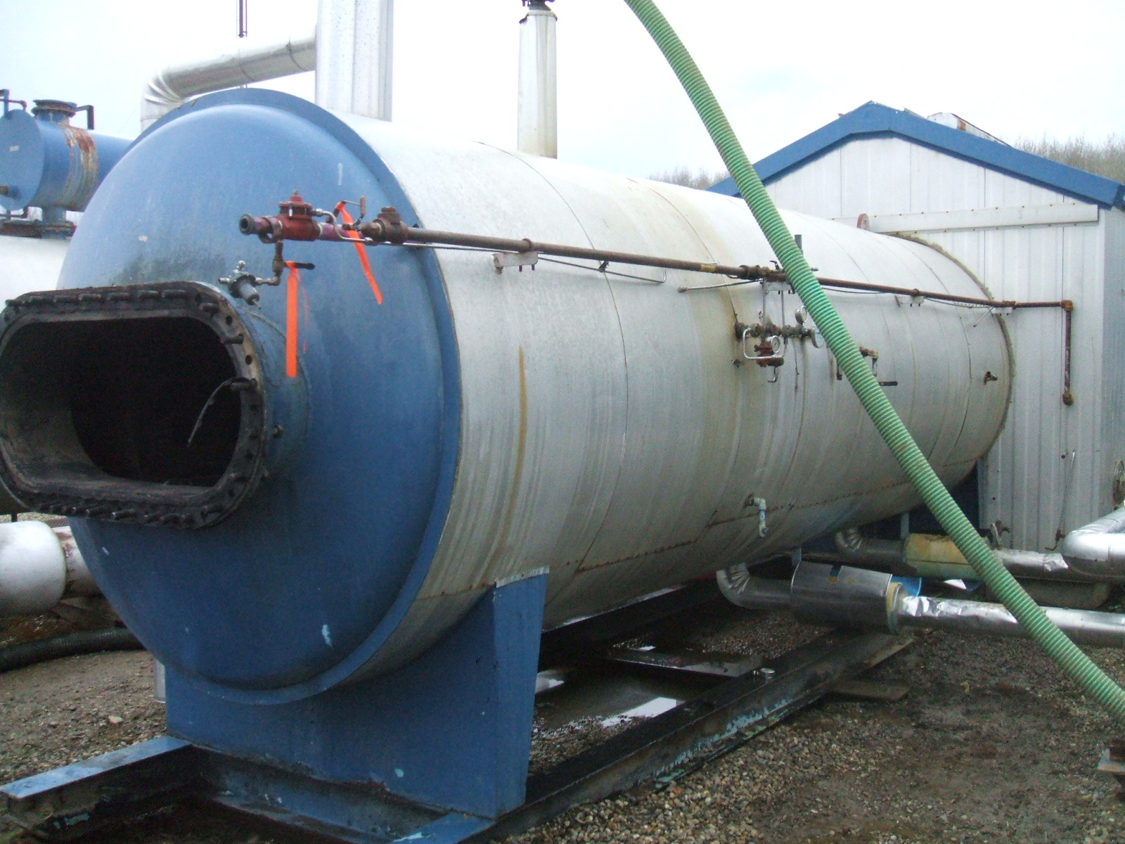
Name Plate | Vessel Overview
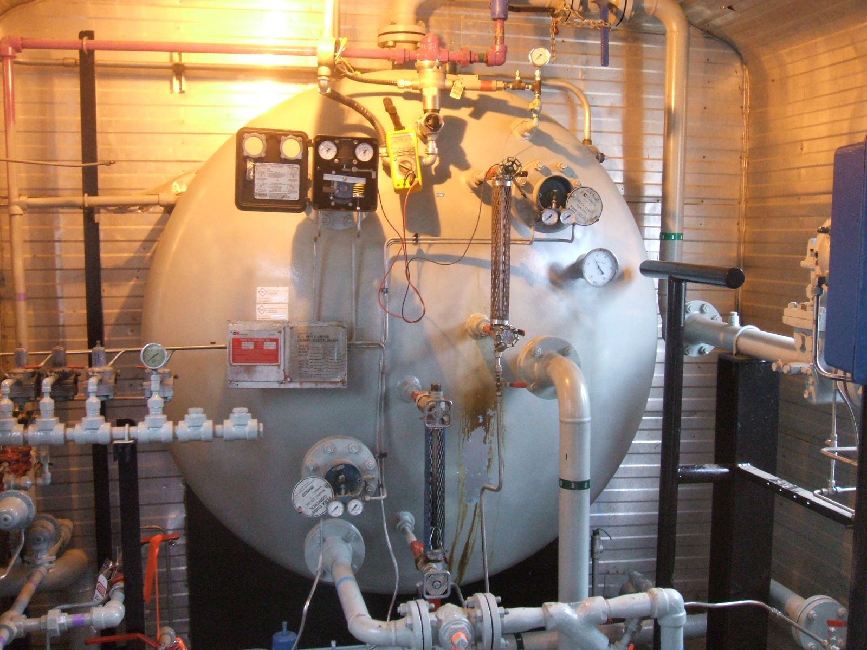 | 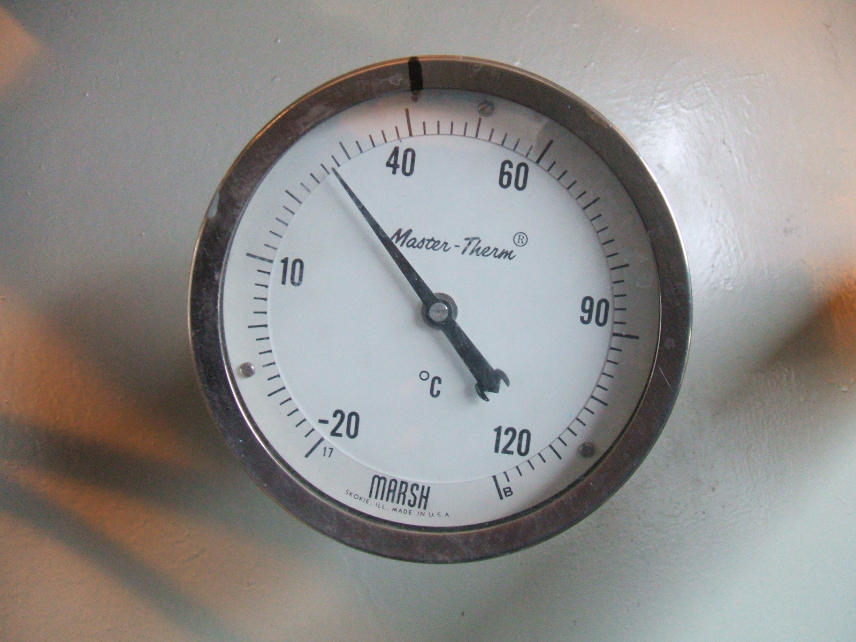
Vessel Overview West end | Temperature Gauge
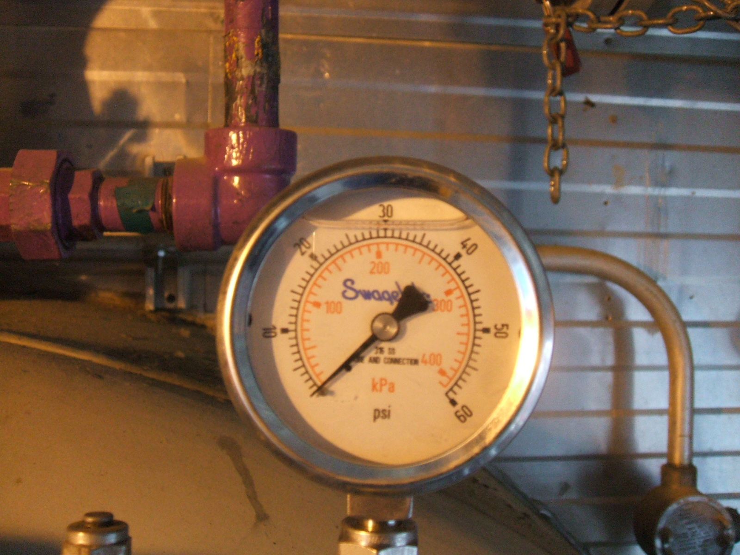 | 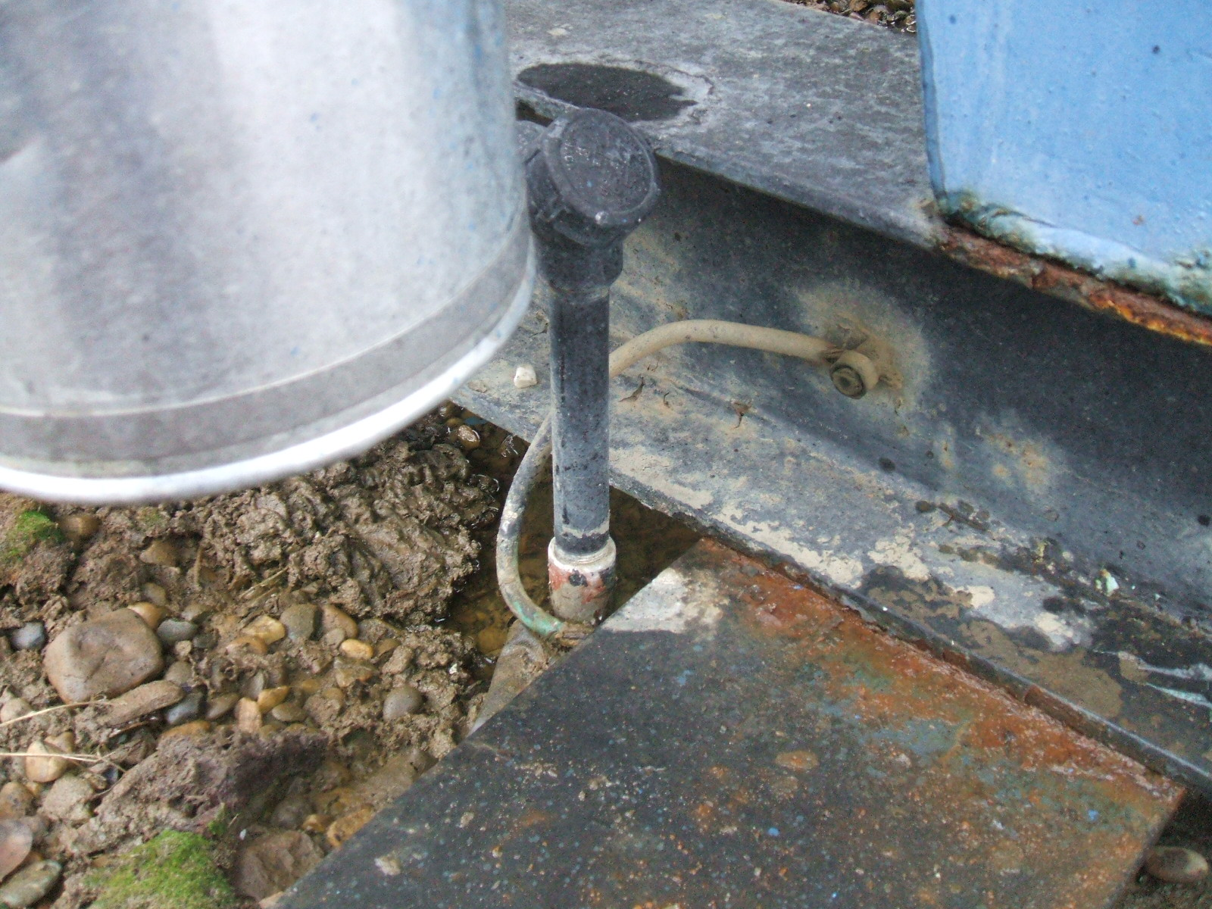
Pressure Gauge | Ground firmly attached
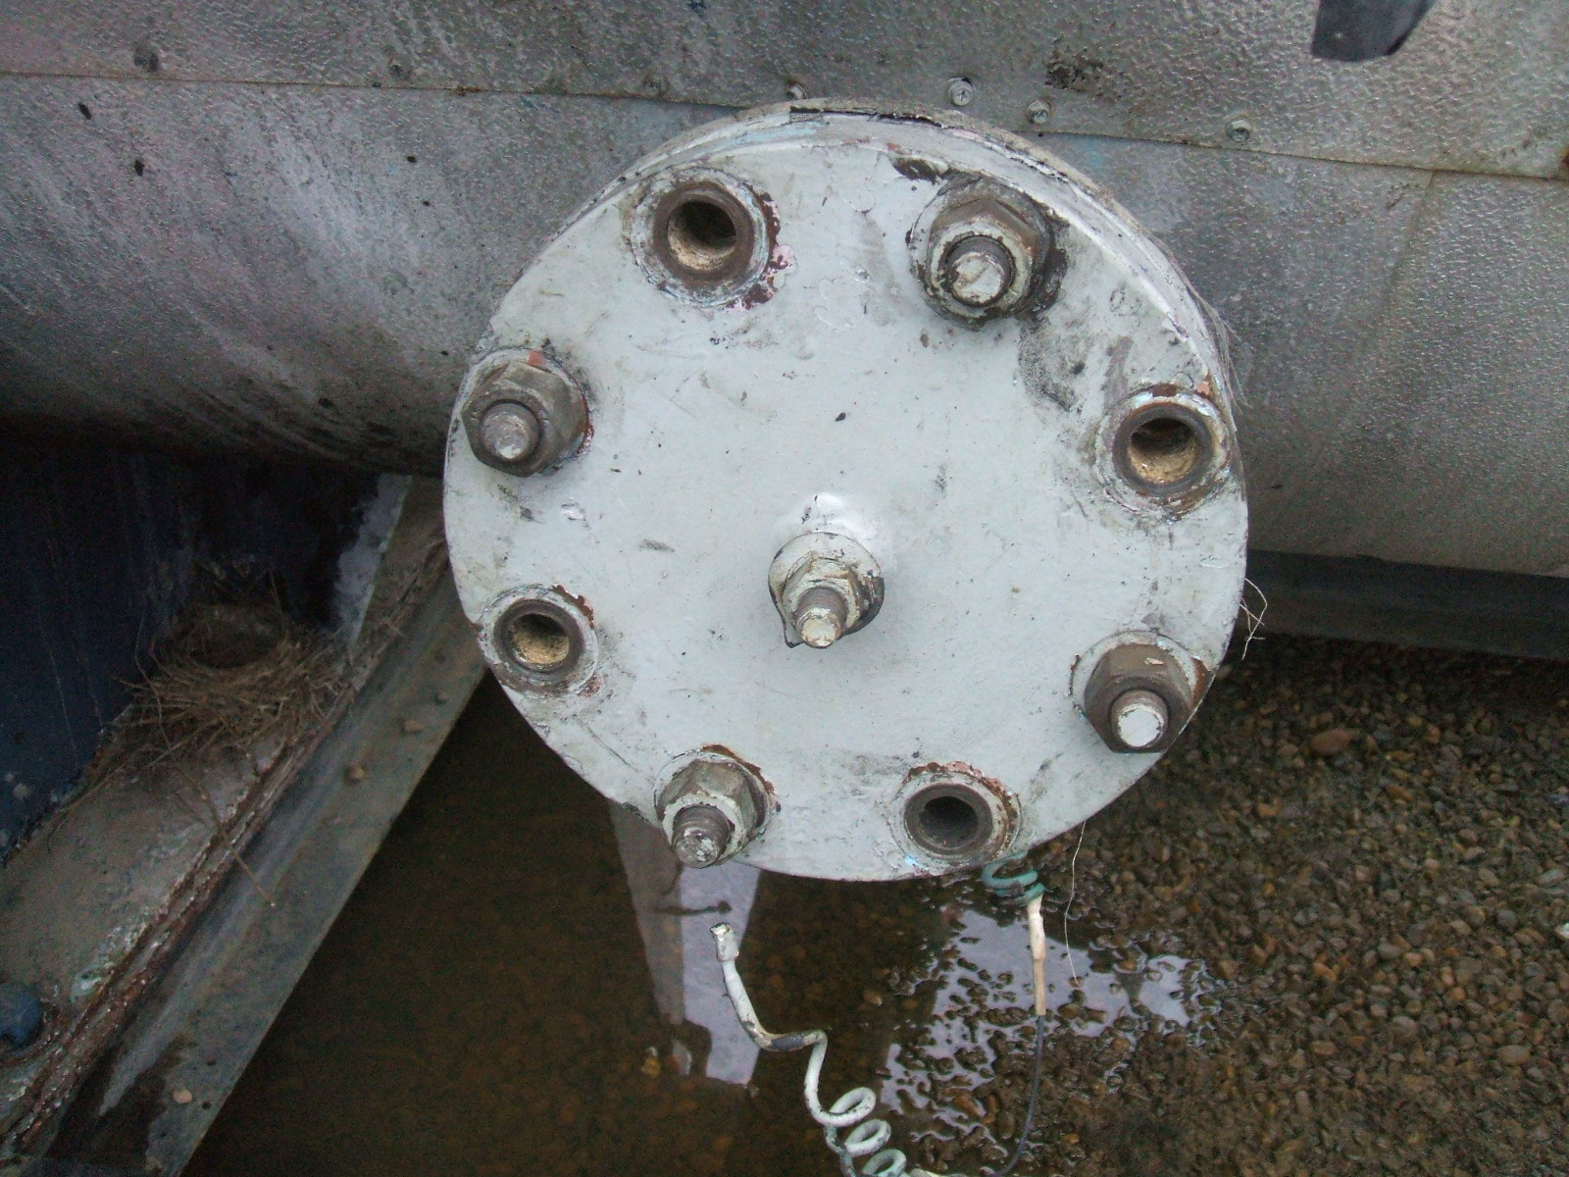 | 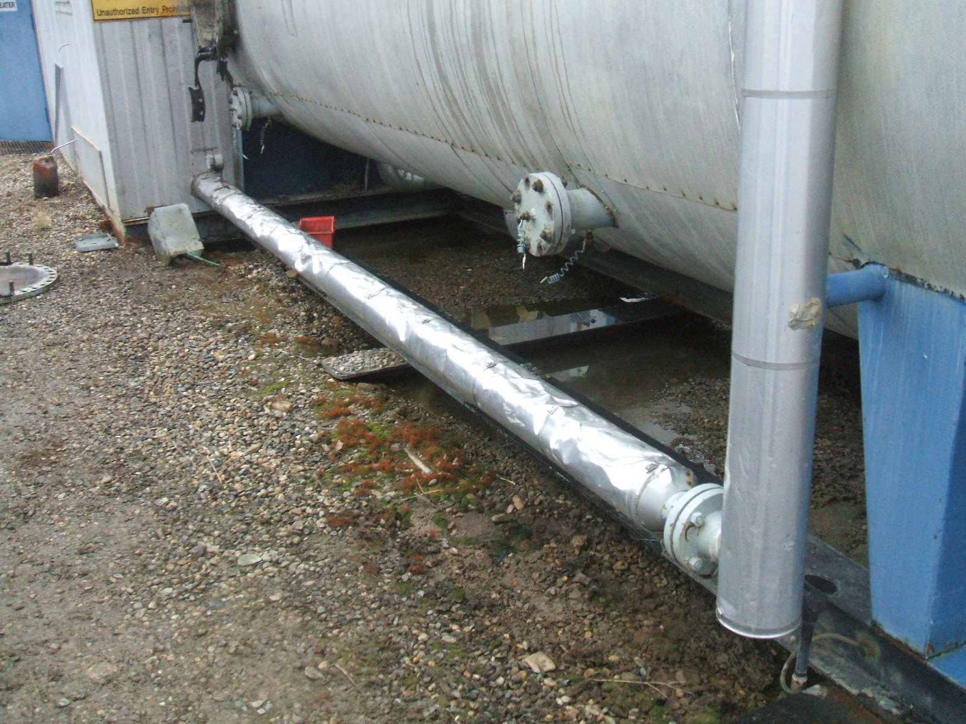
Broken Ground cable on Anode | Insulation damage
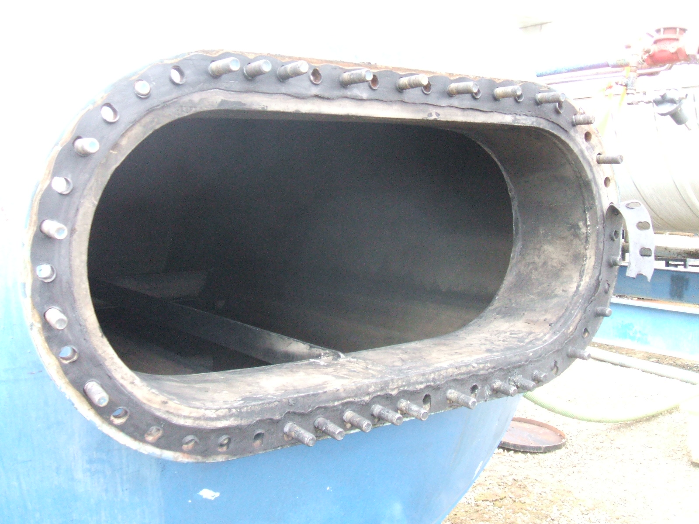 | 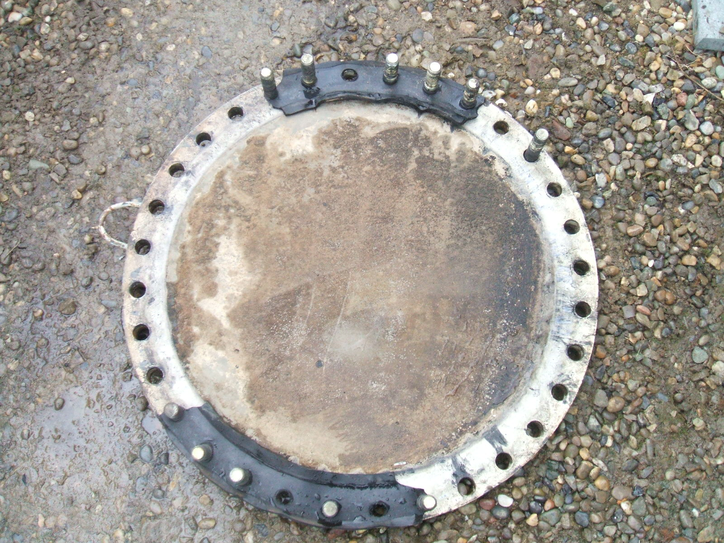
Fire tube manway | West end manway
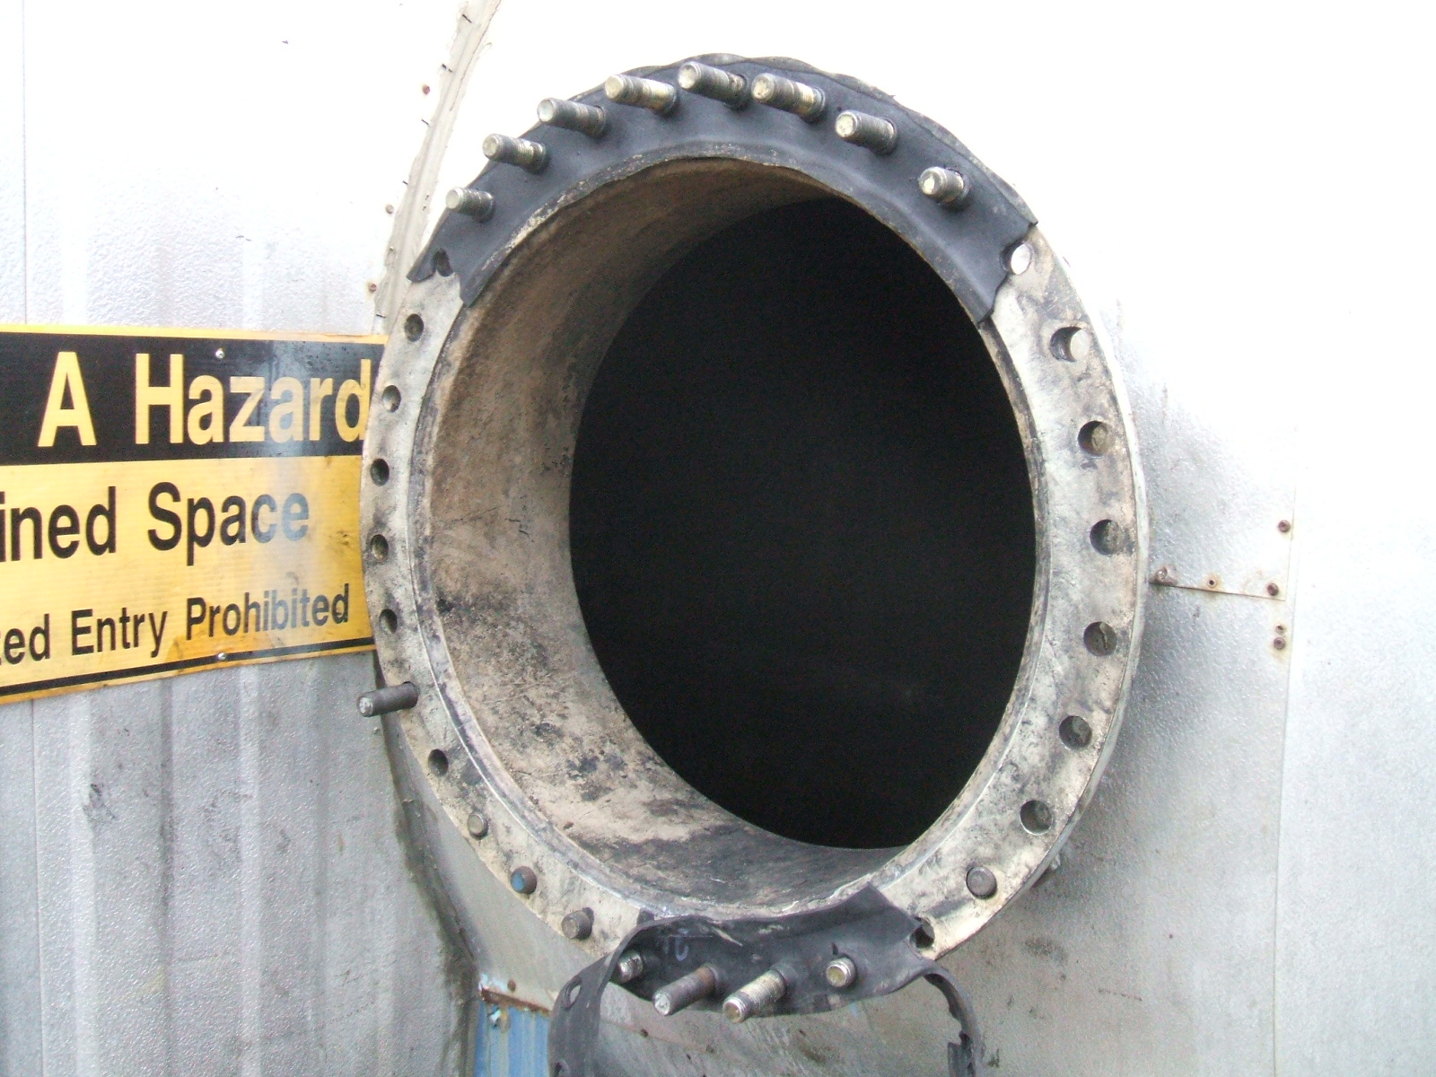 | 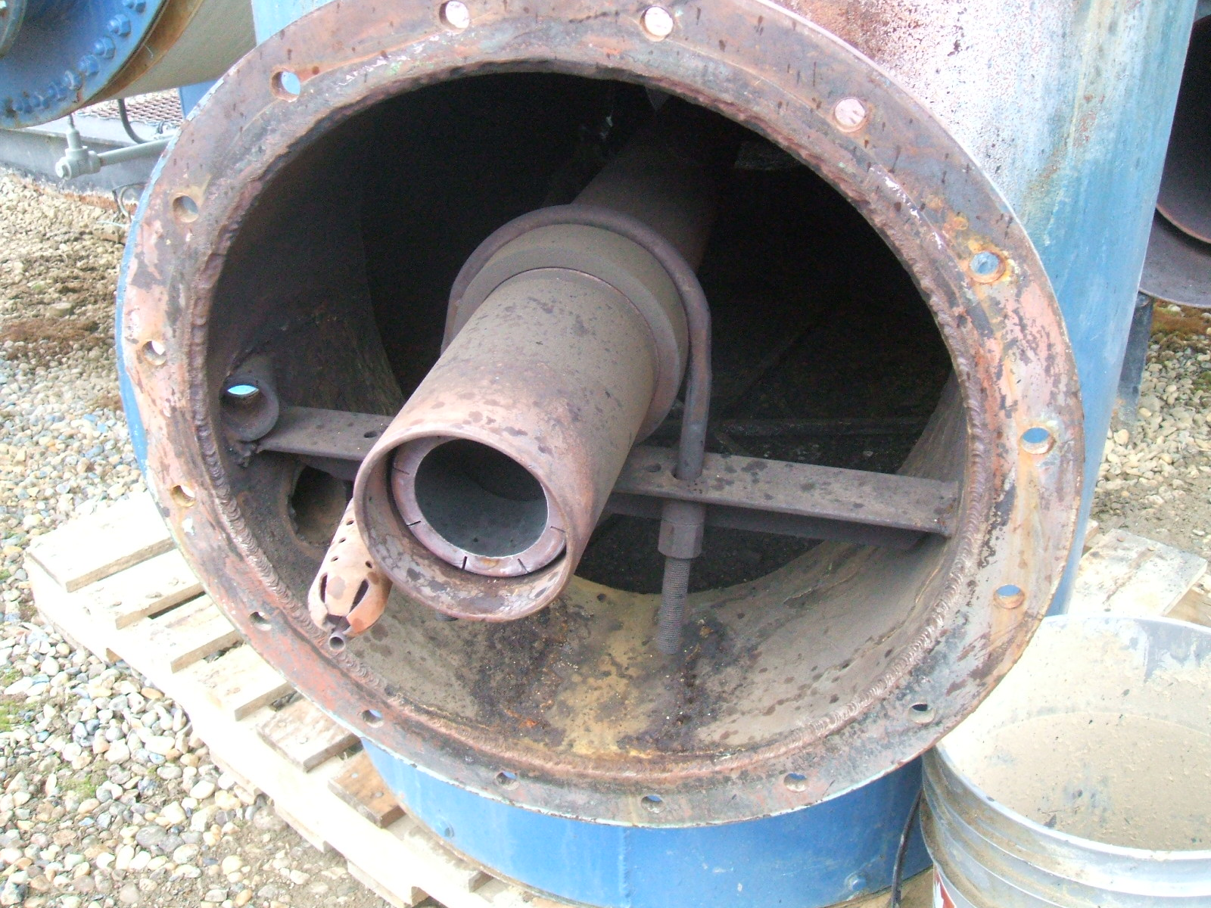
West end manway | Burner
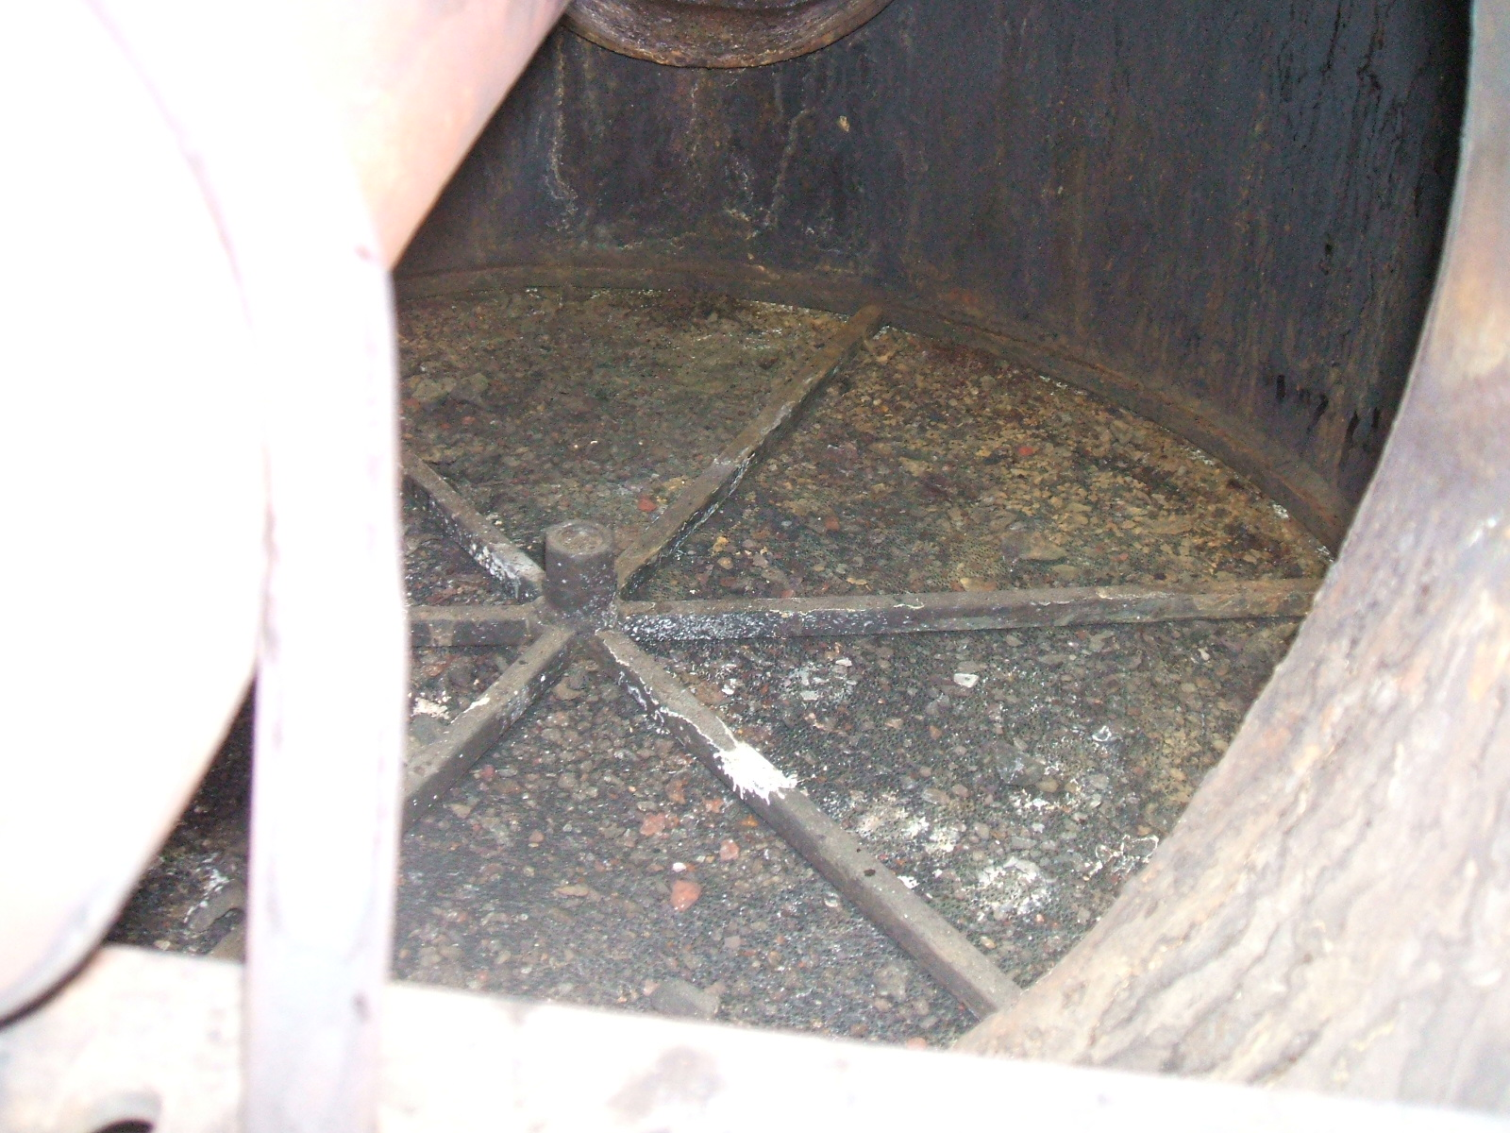 | 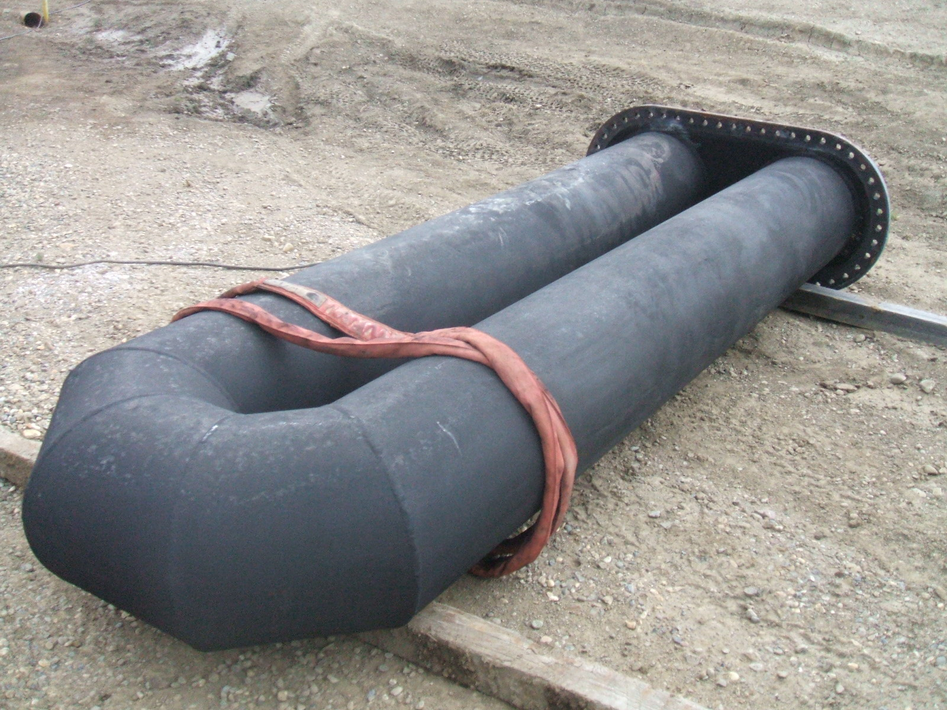
Flame arrestors | Fire tube overview
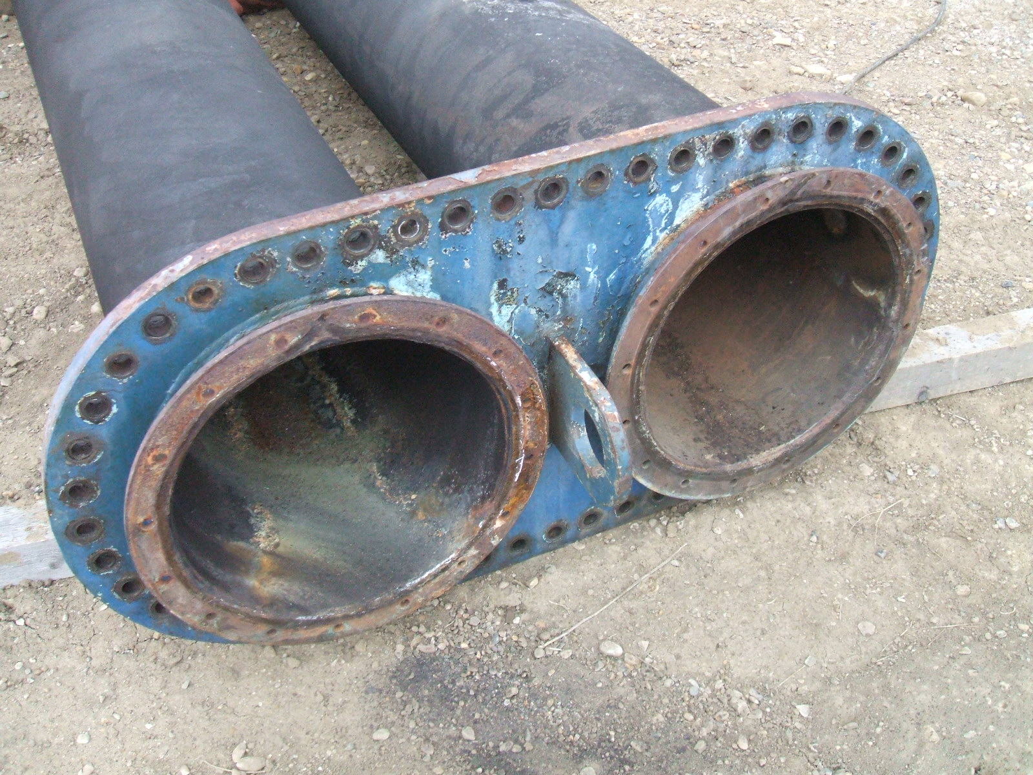 | 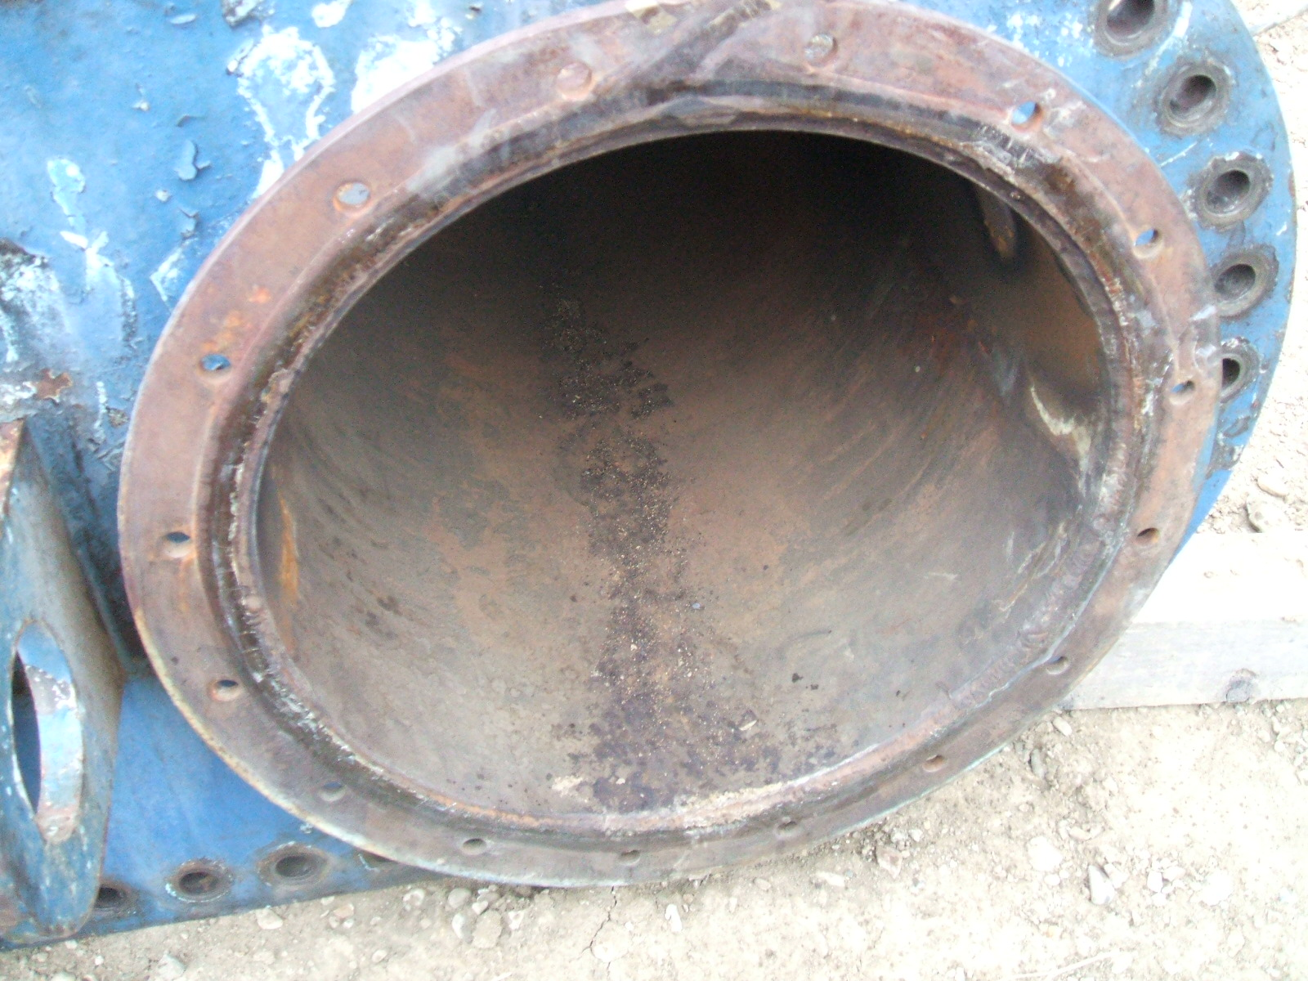
Fire tube overview | Fire tube inlet
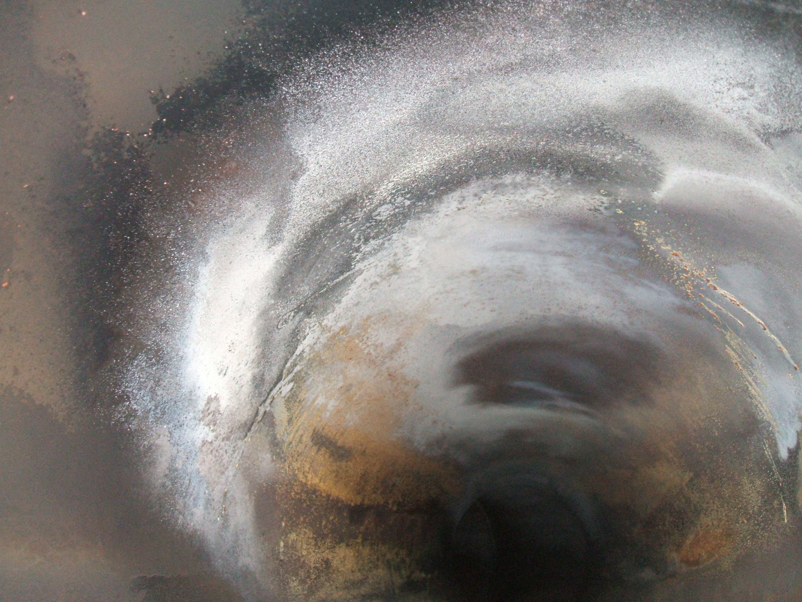 | 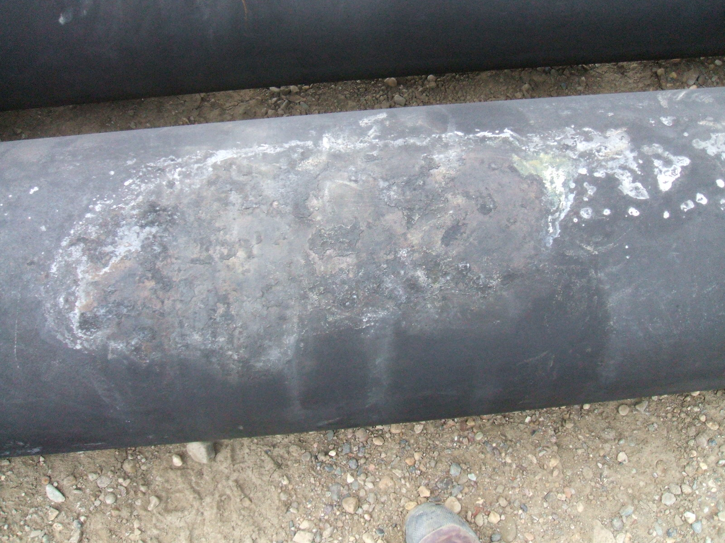
Fire tube Hot spot internal | Fire tube Hot spot external
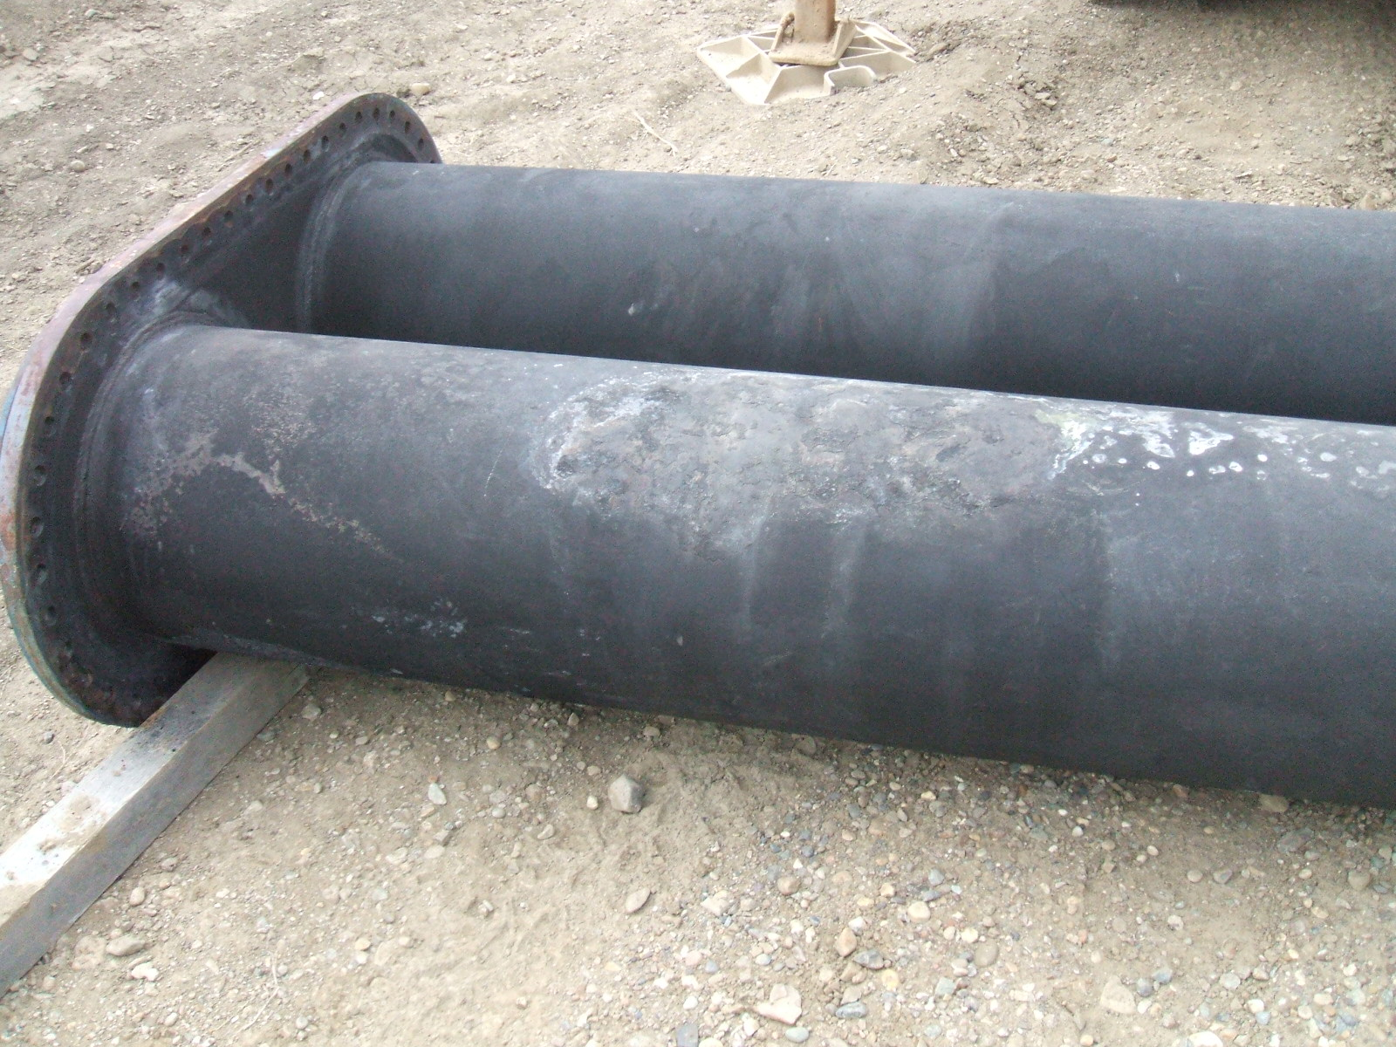 | 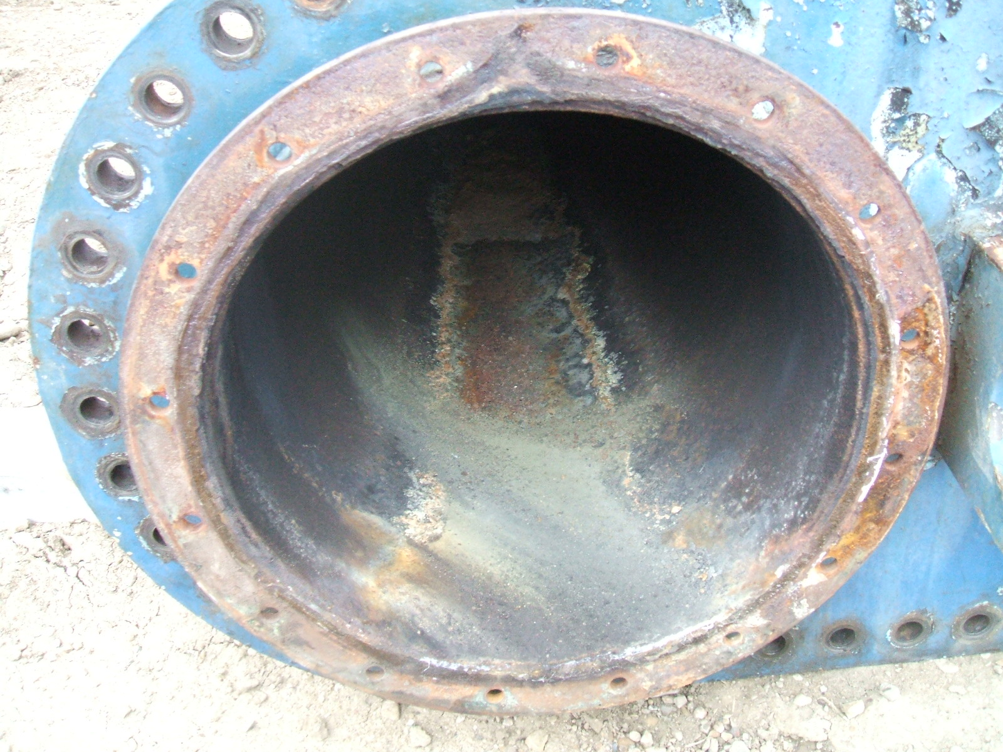
Fire tube Hot spot external overview | Fire tube Outlet
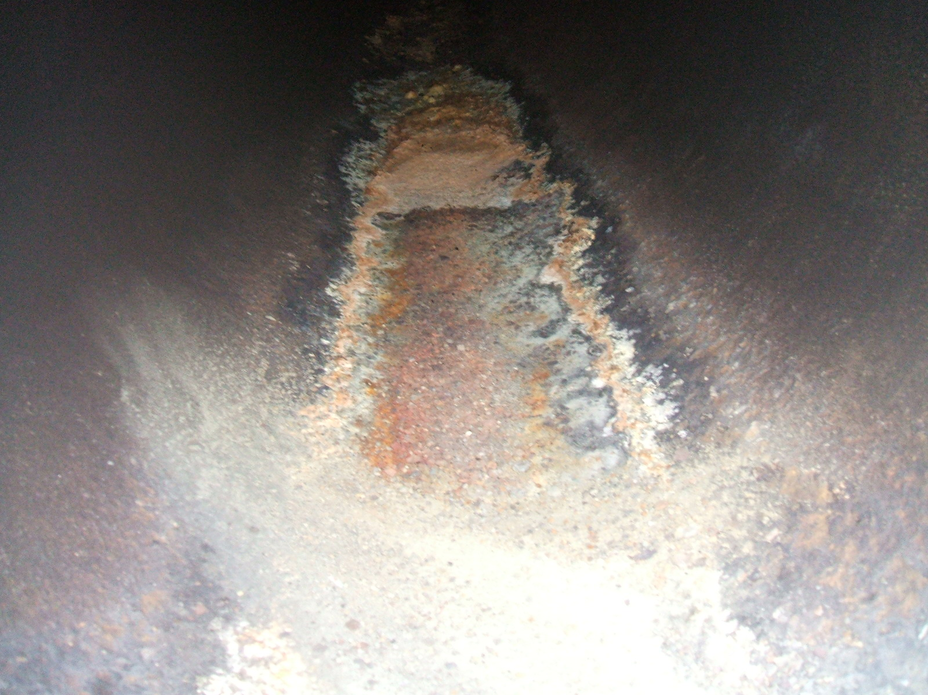 | 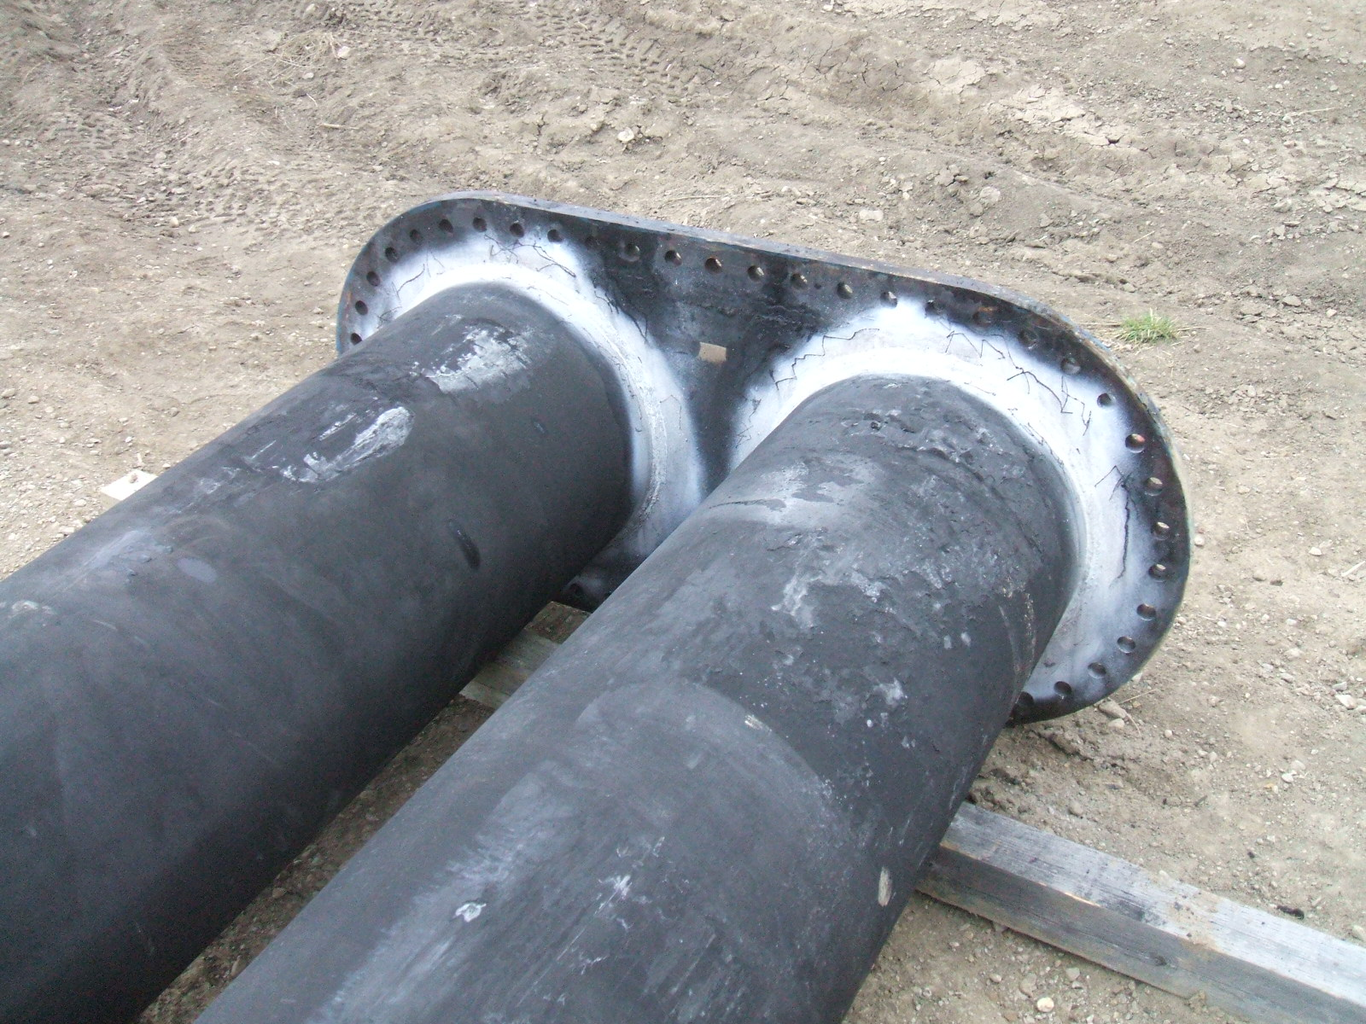
Fire tube internal Outlet iron sulfides. | Fire tube Flange welds overview
Internal Inspection Pictures
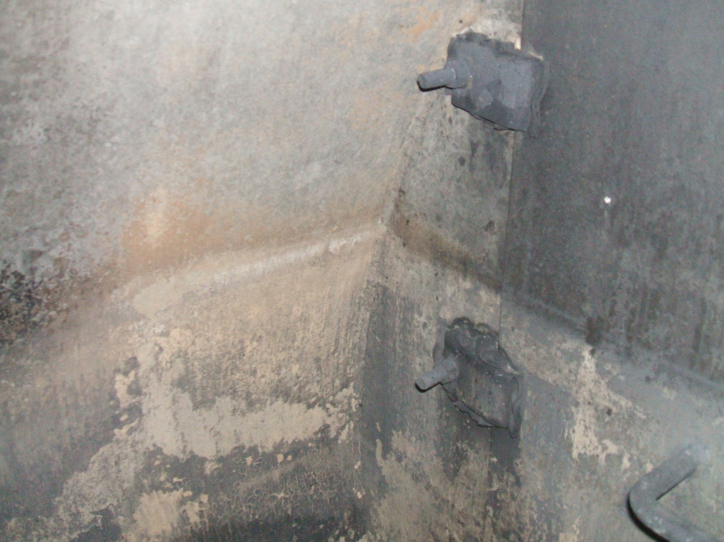 | 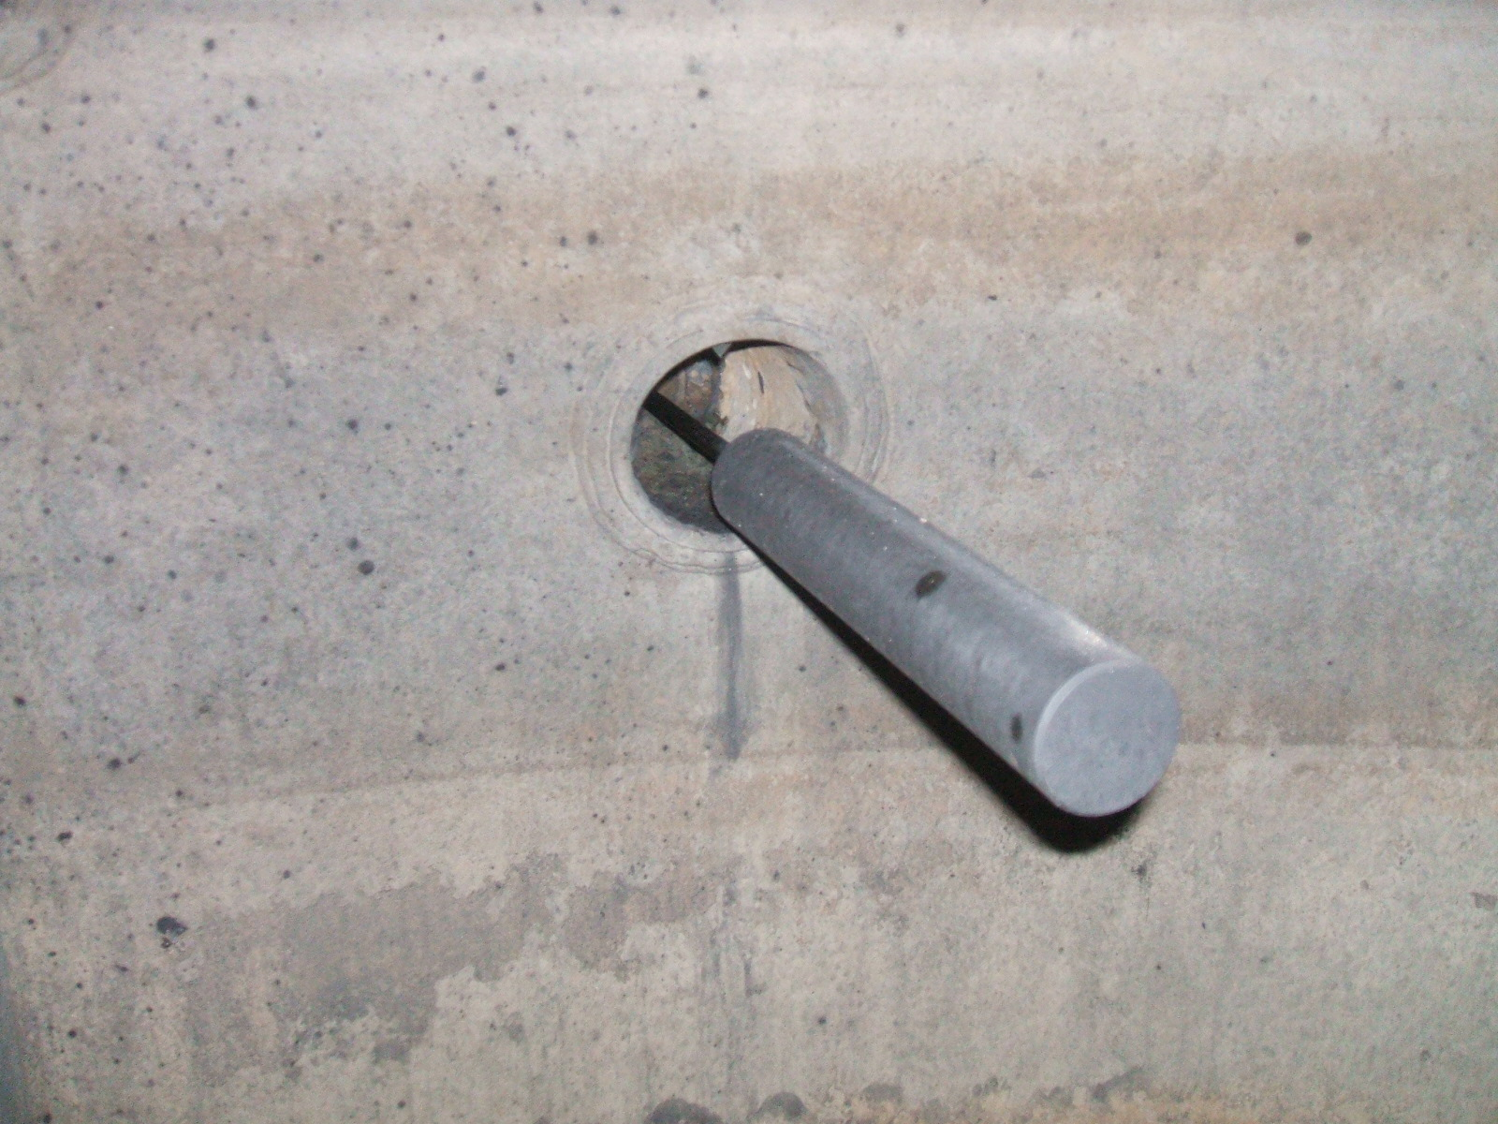
West end Shell surface | West end float
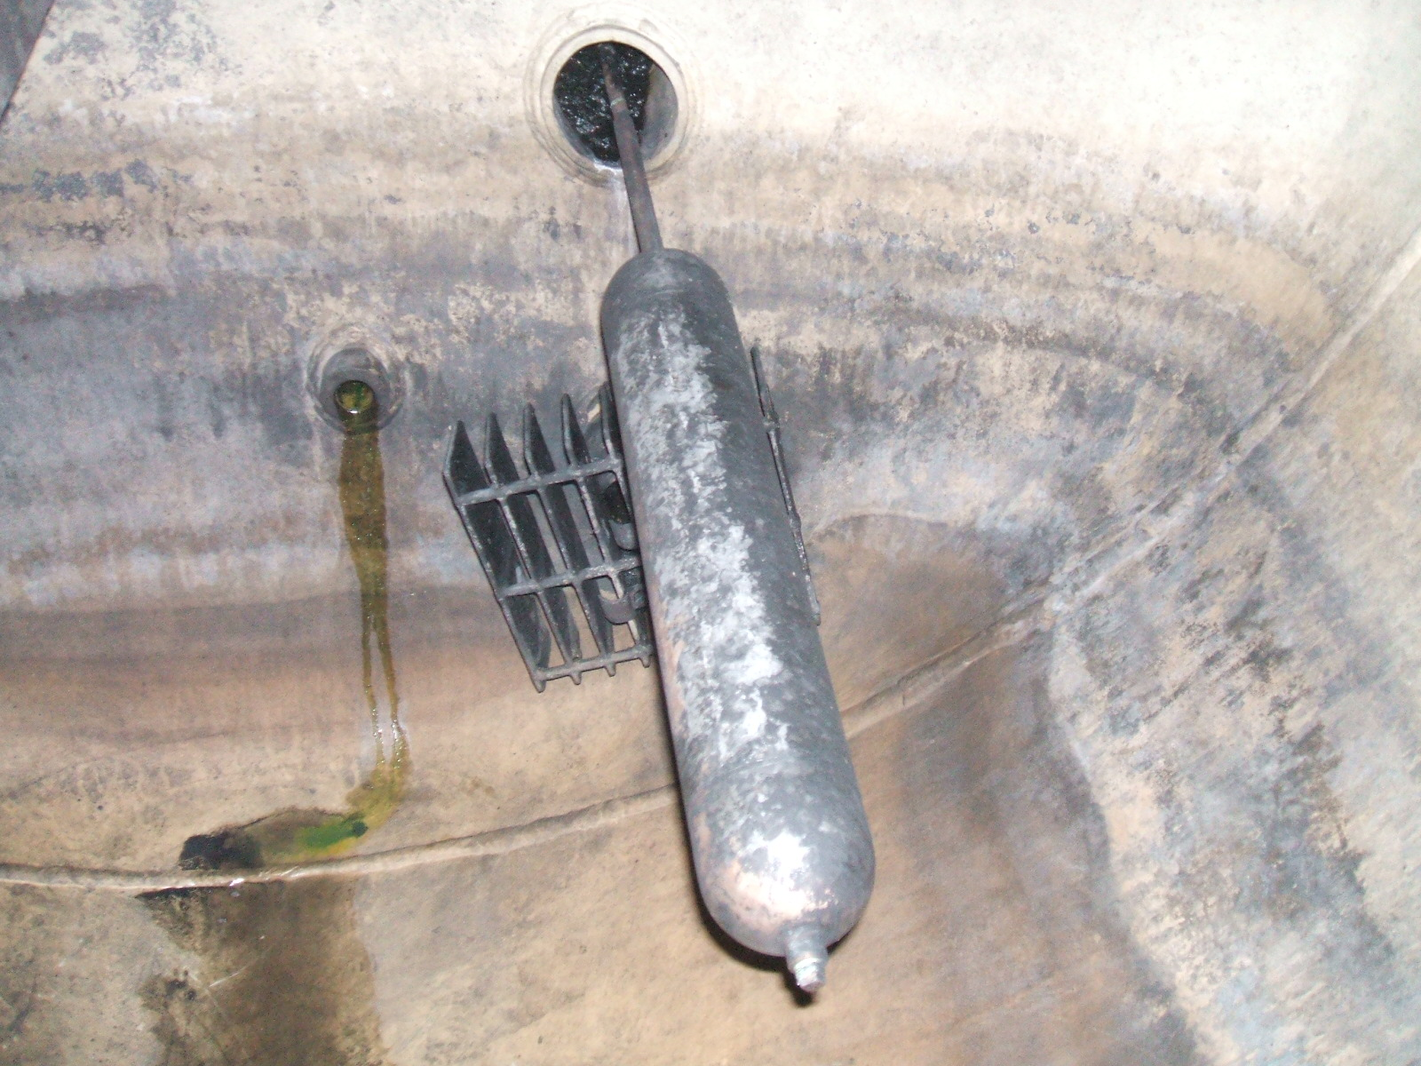 | 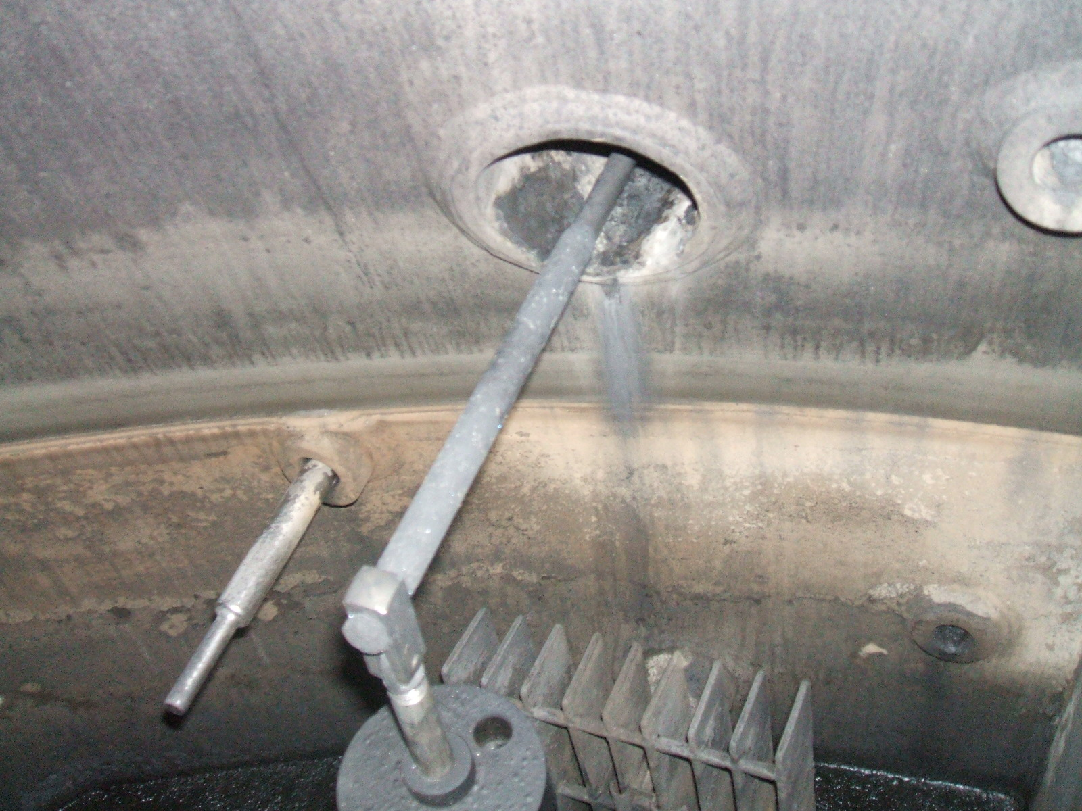
West end float | West end float Inside Weir
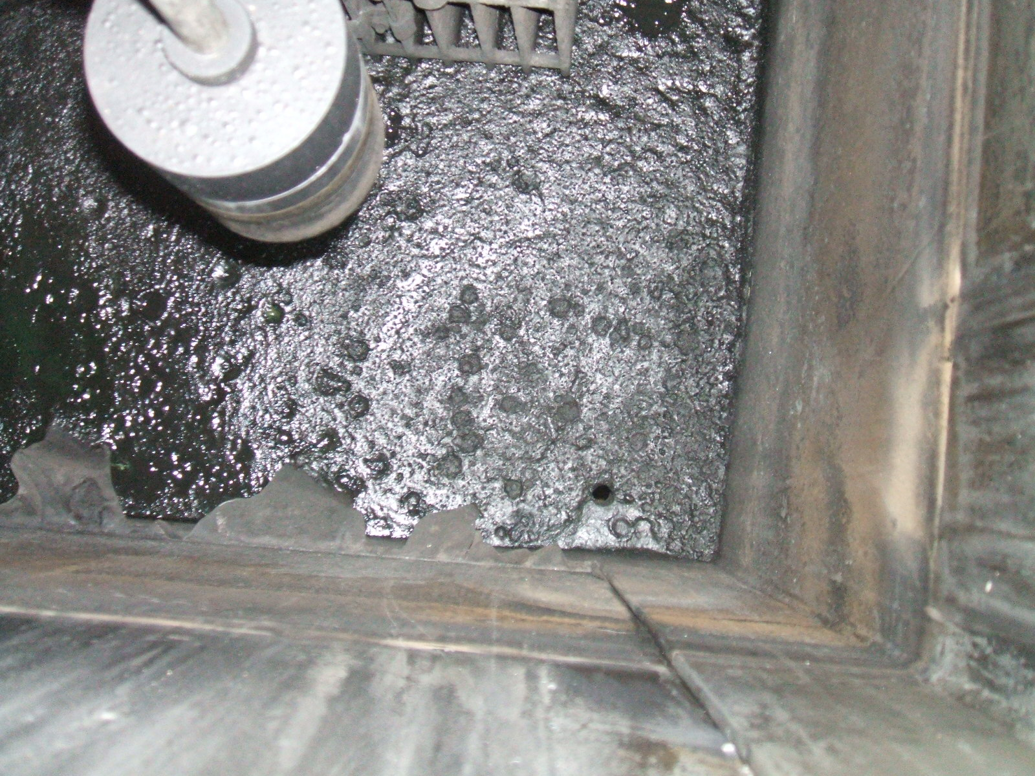 | 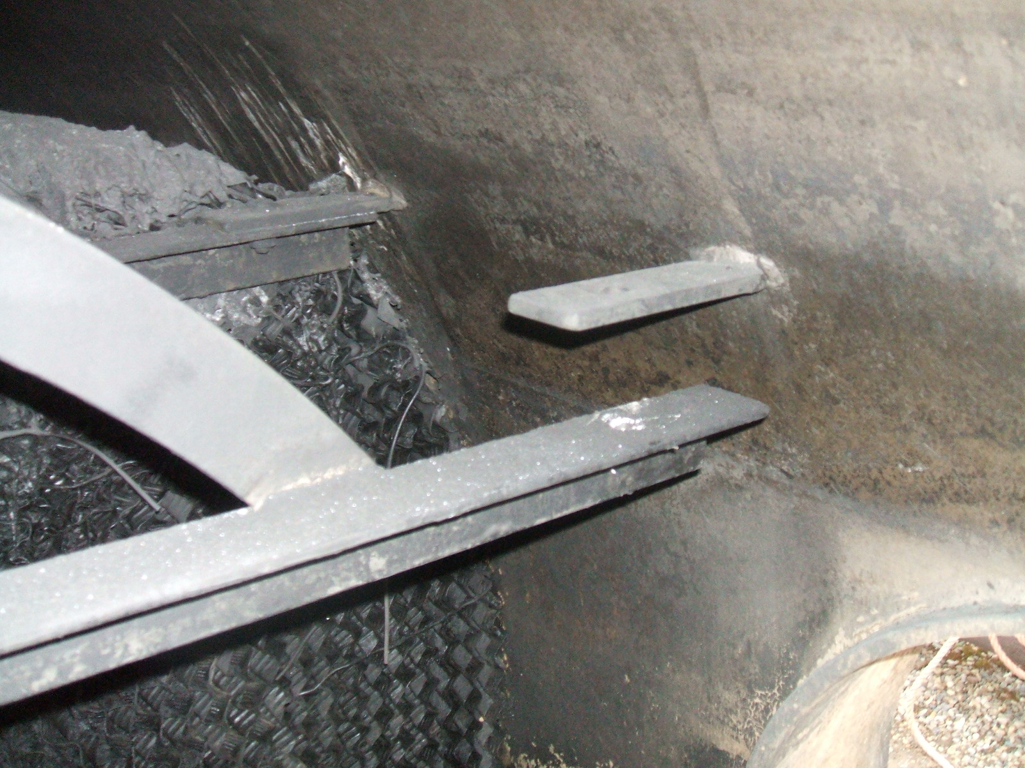
West end float Inside Weir | West end Missing bolt / Bolt was replaced
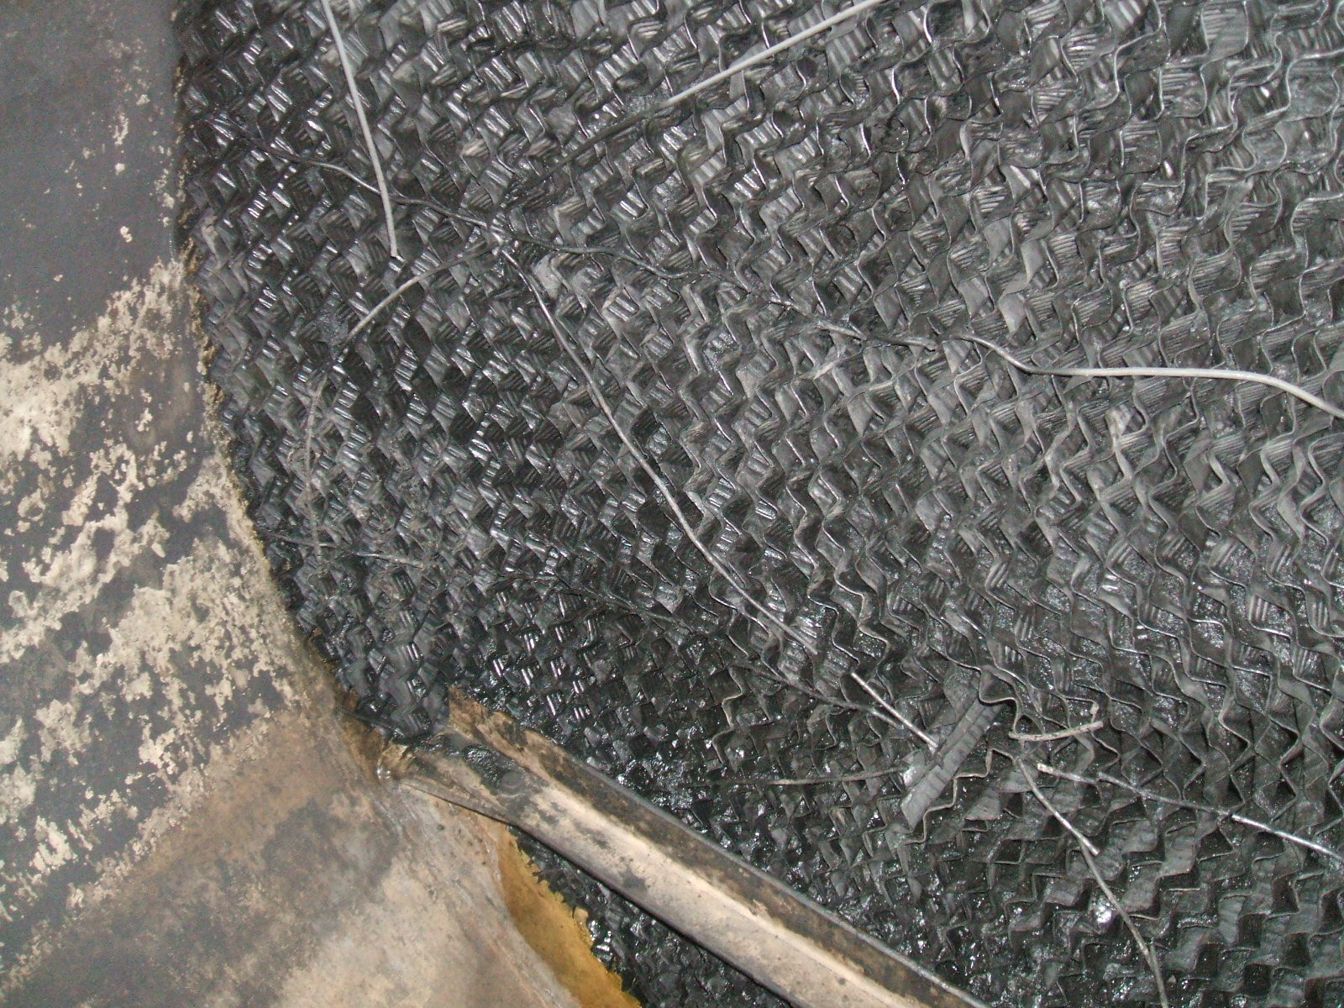 | 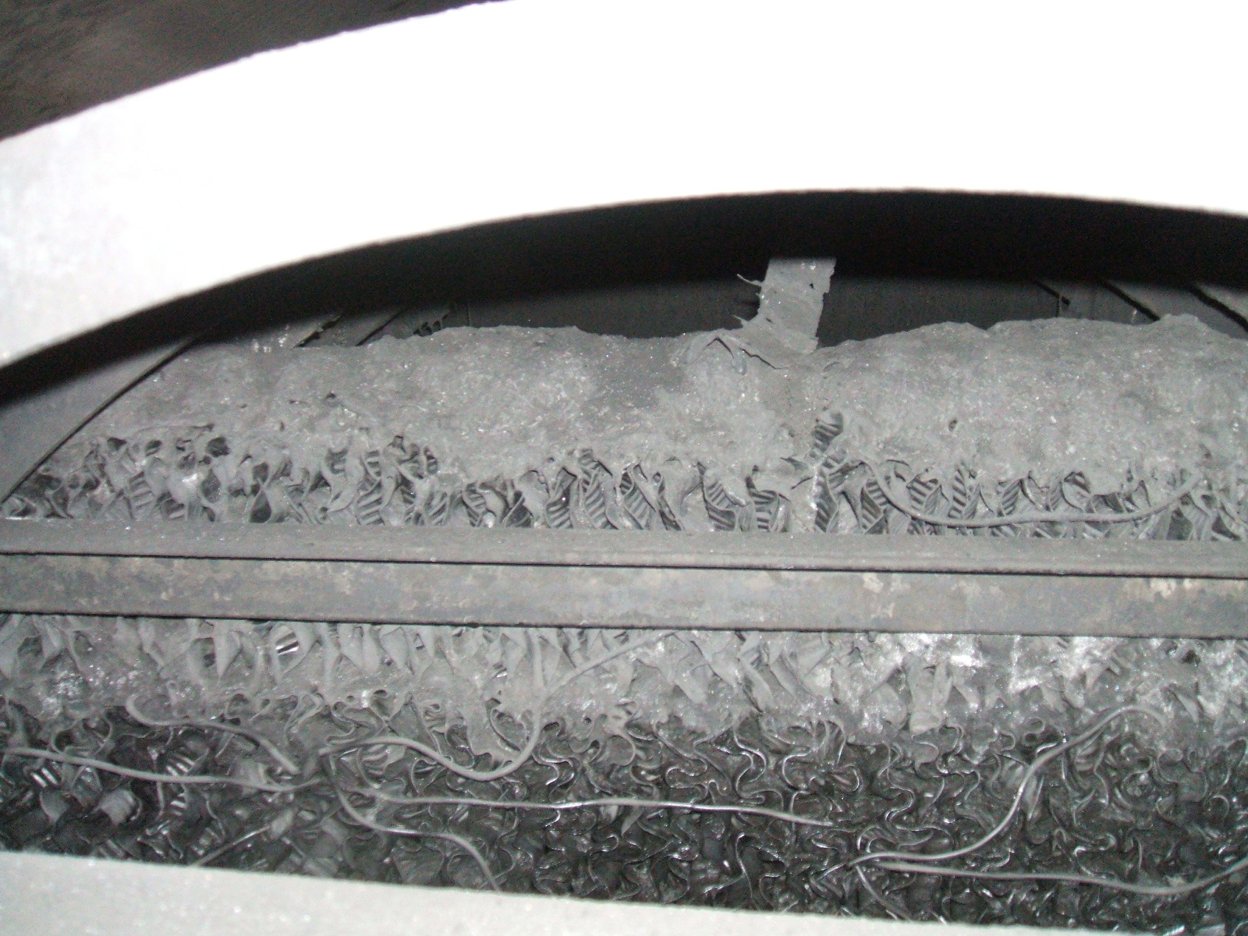
Internal pads | Internal pads debris on top of pads
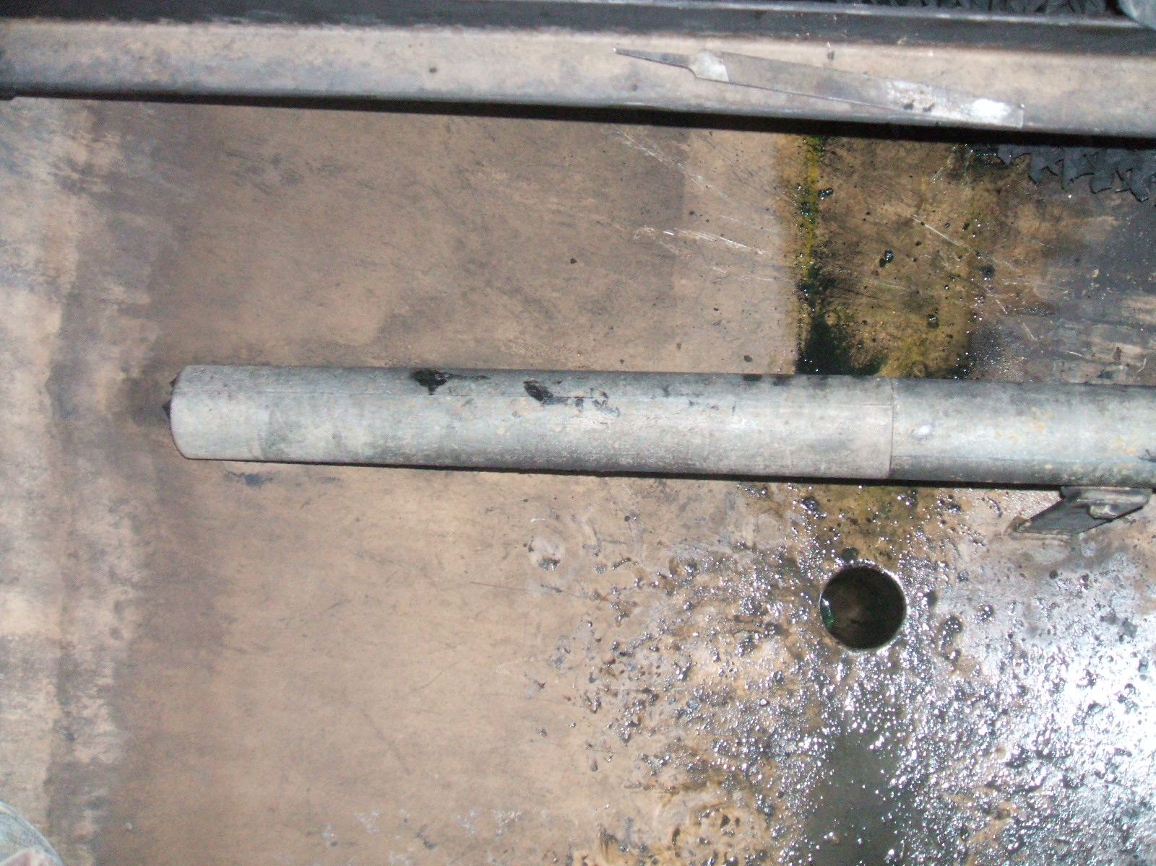 | 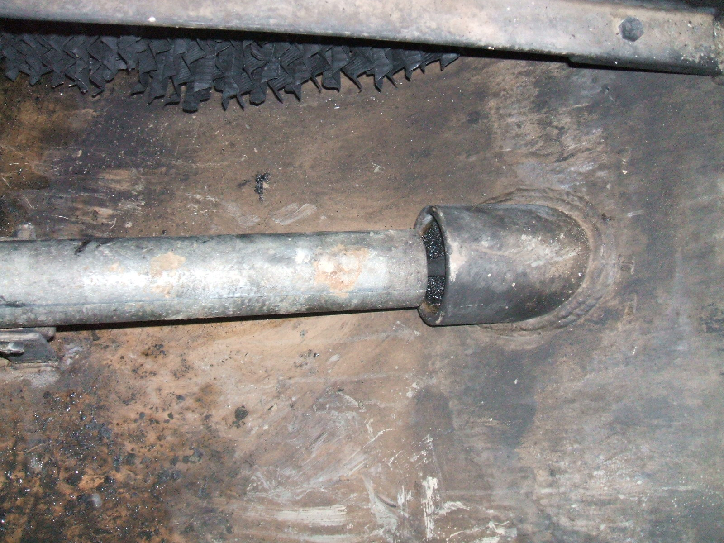
West end Anode | West end Anode nozzle
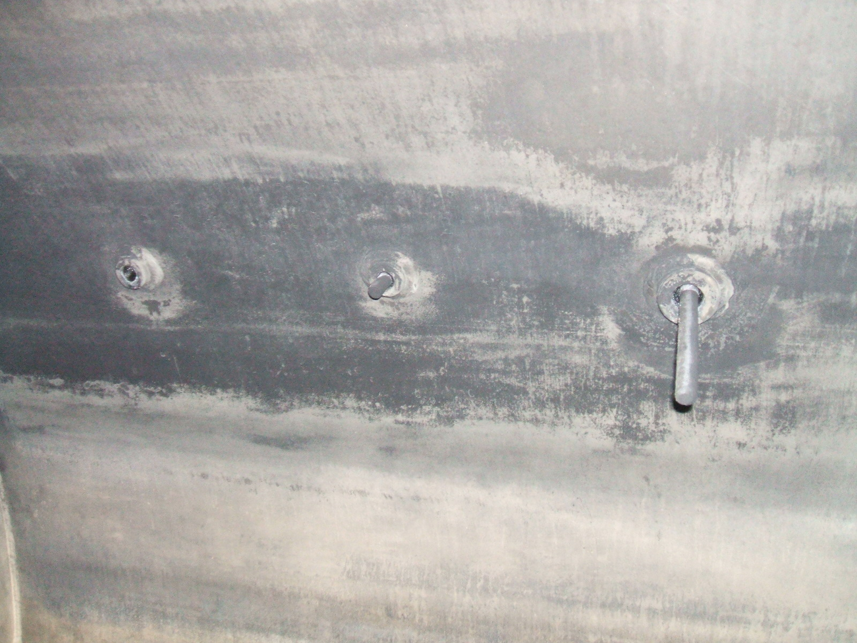 | 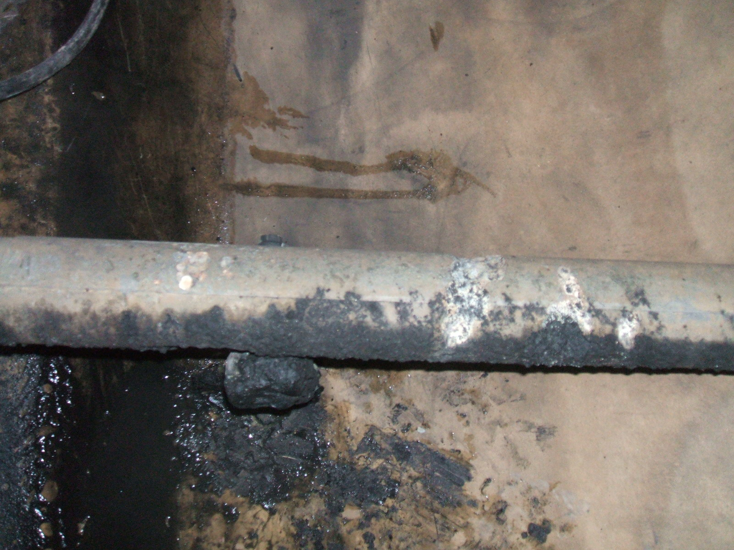
Thermal probe and nozzles | East end Anode
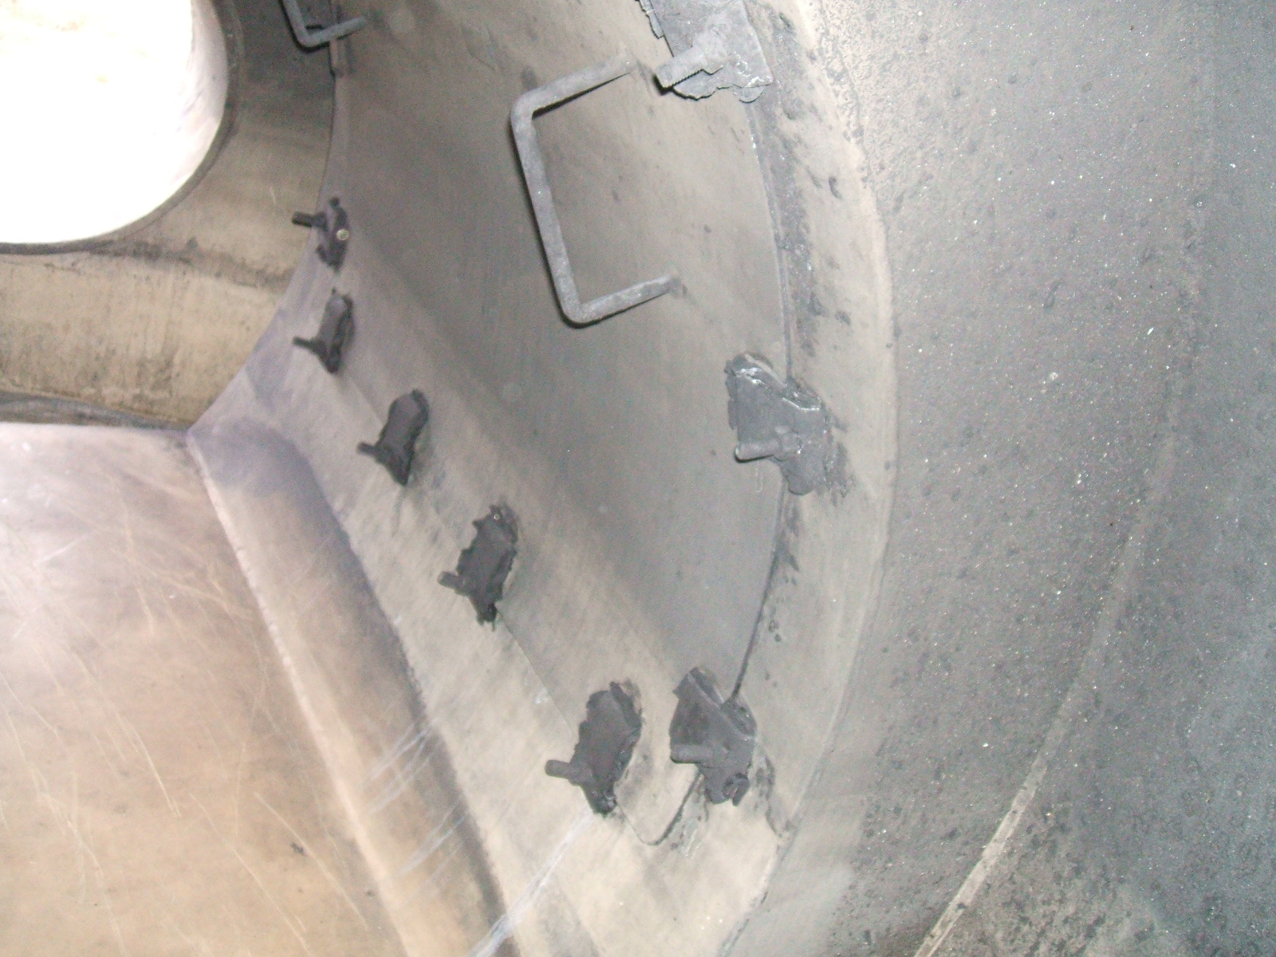 | 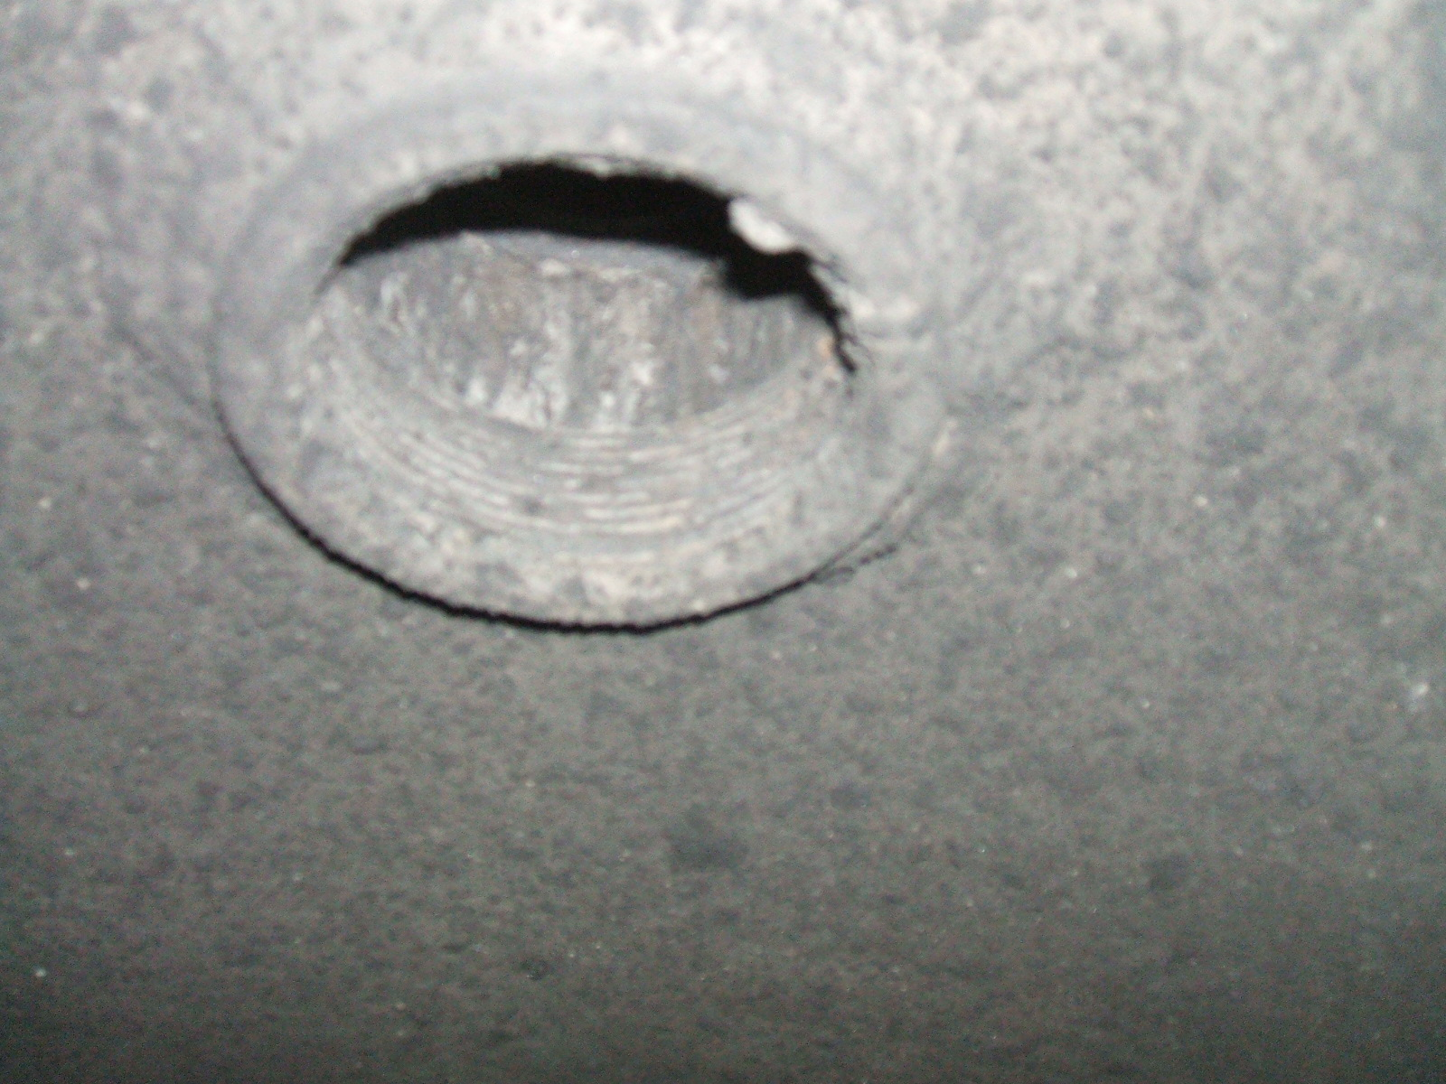
Deflector plate East end | Top nozzle East end
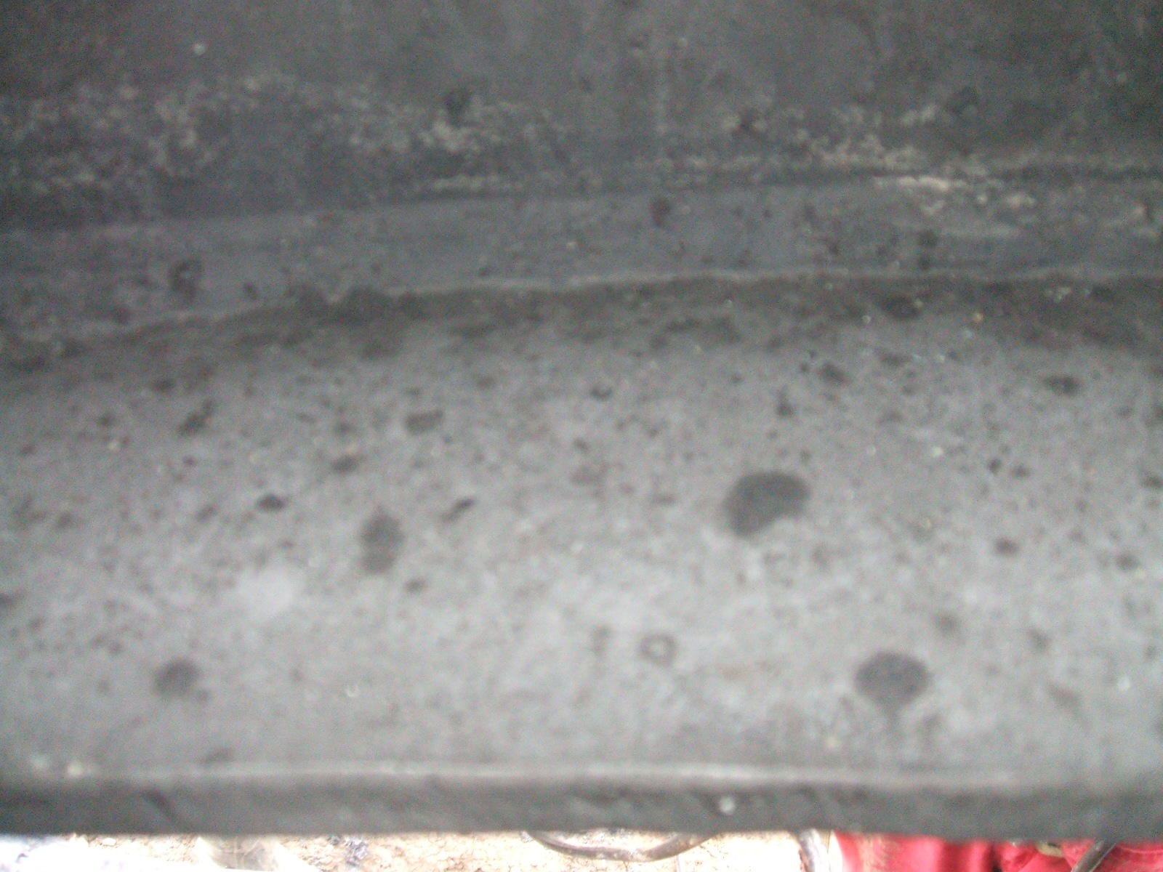 | 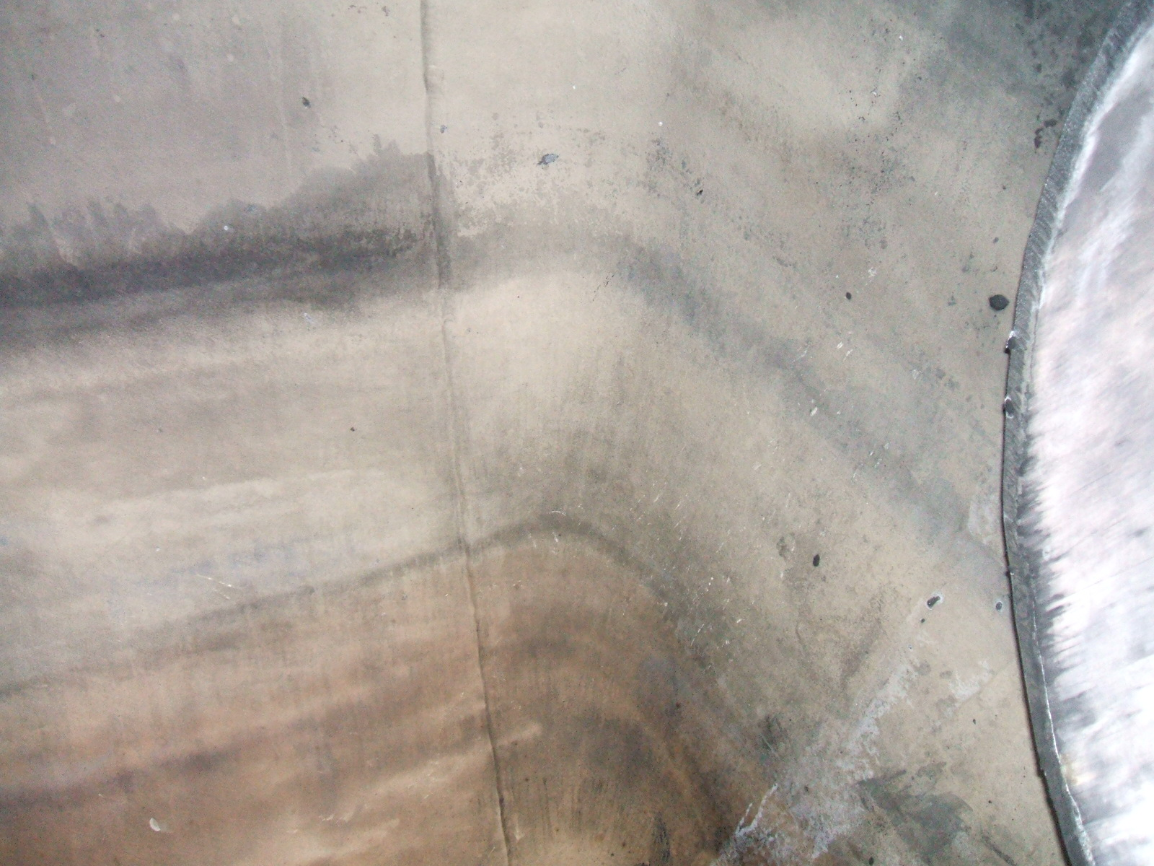
Fire Tube manway top Shell weld | East end head to shell circ weld
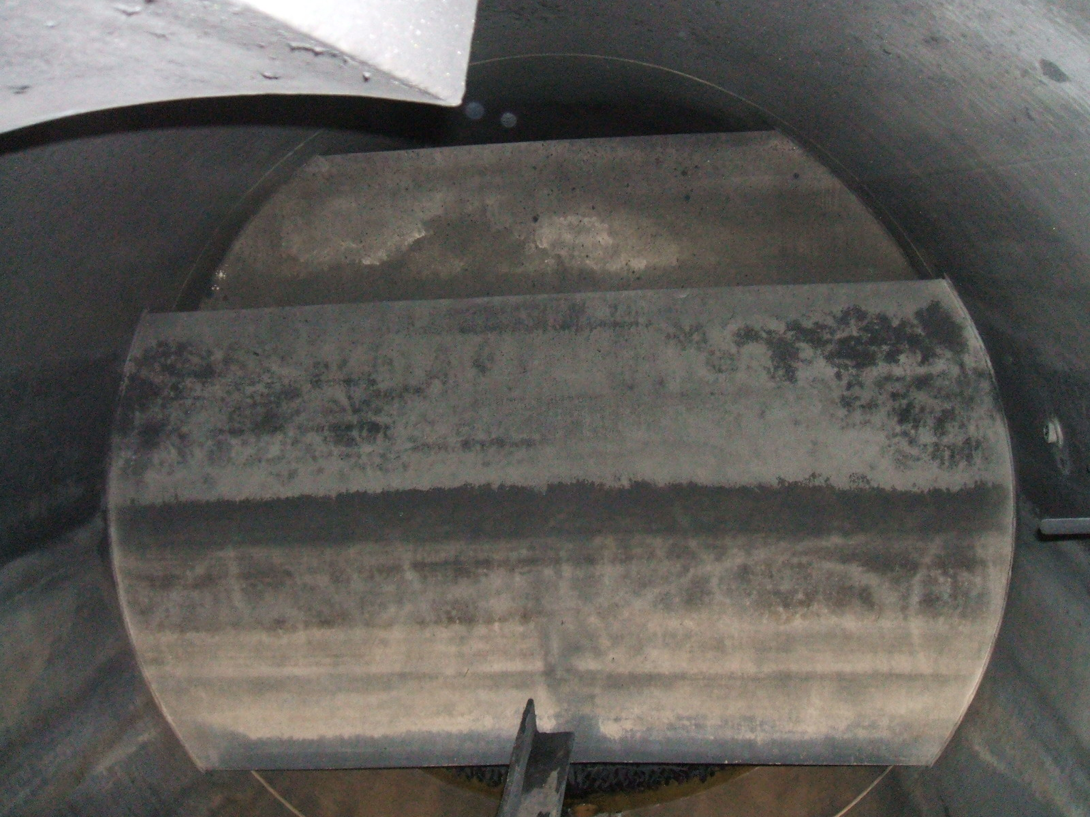 | 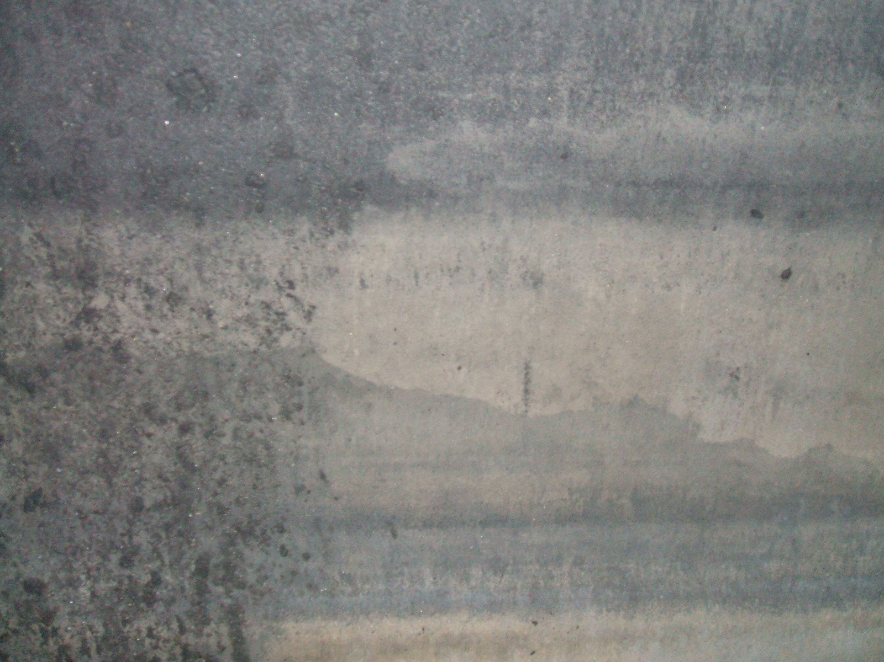
Double Weir plates view is West | Shell surface East end
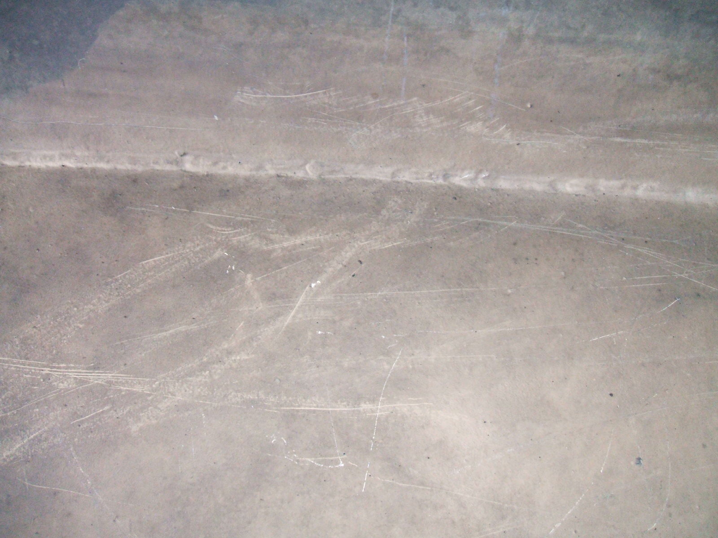
Deflector plate surface coating East end

