Canadian Natural Resources Limited

GENERAL PRESSURE VESSEL INFORMATION
District: Ft St John, BC |  |  |  |  | Skid No.
Facility: South Buick Compressor Station |  |  |  |  | Location (LSD): d-78-I/94-A-11
Vessel Name Equipment Number: Sour Emulsion Separator

Orientation: Horizontal
Status: In Service |  |  |  |  | Regulatory Inspection
PRESSURE VESSEL NAMEPLATE DATA
“A” or “G” or “S” (Sask.) or BC Registration Number.  CN 96122 |  |  |  |  |  | CRN Number:  M 9977.231
Vessel serial number: 95-8021-0 |  |  |  |  |  | Size: 96in x 20ft
Shell thickness: 22.2mm |  |  |  |  |  | Shell material: SA 516 70N
Head thickness: 21.5mm |  |  |  |  |  | Head material:
Tube wall thickness: |  |  |  |  |  | Tube material:
Tube diameter: |  |  |  |  |  | Tube length:
Channel thickness: |  |  |  |  |  | Channel material:
Design pressure | Shell: 1724 kPa |  |  |  |  | Operating pressure |  | Shell:
 | Tubes: |  |  |  |  |  |  | Tubes:
Design Temp. | Shell: 66°C |  |  |  |  | Operating temperature |  | Shell:
 | Tubes: |  |  |  |  |  |  | Tubes:
X-ray: RT-1 |  |  |  |  |  | Heat treatment: HT
Code parameters: ASME VIII, Div 1 |  |  |  |  |  | Coated: Yes
Manufacturer: Wells Hall Fab. |  |  |  |  |  | Year built: 1996
Corrosion allowance: Not Stated |  |  |  |  |  | Manway: No

PRESSURE SAFETY VALVE NAMEPLATE DATA
PSV Tag # | Manufacture | Model # |  | Serial # |  |  | Set Pressure  (kPa) |  | Capacity  (scfm) |  | Service  Date
2981G | FARRIS | 26LA10-120 | CE-42987-1-A10 |  |  |  | 690 |  | 6207 | 04/2004
CRN # | Service By | Block Valve | Location |  |  |  | Size |  | Code Stamp
OG2369.5C | UNIFIED | NO | TOP SHELL ON BOOT |  |  |  | 3”x4” |  | UV/NB

SERVICE CONDITIONS-INDICATE ALL THAT APPLY
Sweet | Sour X |  |  | Oil X |  |  |  | Gas X |  |  | Water X
Amine | LPG |  |  | Condensate X |  |  |  | Air |  |  | Glycol
Other (Describe):

Inspection Interval ________________________________________PSV Service Interval_________________________________

(Determined by MIC in conjunction with Chief Inspector following guidelines of CNRL’s Owner-User Inspection Program)

Reports reviewed and accepted by:

Mechanical Integrity Coordinator________________________________________________Date__________________________

Fill out all forms as completely as possible. All information is important! Use back of sheets to record additional information or sketch if required.

Copy of report to be filed by MIC at site, and copy sent to Chief Inspector

External Inspection Items | G | F | P | N/A | Comments
Insulation Verify sealed around manways, nozzles, no damage present, and there is no egress of moisture. | X |  |  |  | 1/3rd insulated – no open or torn sections.
External Condition Assess paint condition, areas peeling, record any corrosion, damage, etc (record location, size and depth of corrosion or damage) | X |  |  |  | Good condition – no exposed metal.
Leakage Record any leakage at flanges, threaded joints, weep holes on repads, etc. | X |  |  |  | Man way access gasket seal leaking.
Saddle Assess condition of paint, fire protection, and concrete. Look for corrosion, buckling, dents, etc. Look at vessel surface area near supports. Verify no signs of leakage at attachment to vessel and attachment welds are acceptable. Ground wire attached? | X |  |  |  | No distortion – no leaks at saddle to shell attachment welds.  No corrosion or missing paint.  Skid package is grounded.
Anchor Bolts Hammer tap to ensure secure. Look for cracking in treads or signs of deformation. | X |  |  |  | Saddle firmly bolted to skid deck.
Concrete foundation Check for cracks, spalling, etc. |  |  |  | X
Ladder / Platform Describe general condition, ensure support is secure to vessel, and describe any hazards. |  |  |  | X
Nozzle Assess paint, look for leakage, and ensure stud threads are fully engaged. Record any damage, deflection, etc. Are nozzles gusseted? | X |  |  |  | All studs fully engaged to nuts – no short bolts.  No deflection – no missing paint – no leaks.  No gussets.
Gauges Ensure gauges are visible, working, no leakage, and suitable for range of MAWP/ Temp. | X |  |  |  | Pressure gauge: 0 to 2000 kpa.  Temp gauge: minus 20 to 120 deg C
External Piping Ensure pipe is well supported. All clamps, supports, shoes, etc. in place. Look for evidence of structural overload, deflection, etc. Paint condition, external corrosion? | X |  |  |  | Well supported, no deflection, all clamps in place.  Painted piping in good condition – no exposed metal – no corrosion.  Insulated piping – cladding intact – no exposed metal – no wet insulation.
Valving Ensure no leaks are visible. Valves are properly supported and chained if necessary. | X |  |  |  | Well supported – no leaks.
PSV Ensure PSV is set at pressure at or below that of vessel. | X |  |  |  | Located on gas outlet piping – set below MAWP of vessel.  Seal intact – no block valve.
NDE methods Was UT/ MPI done on vessel  (MI coordinator to review results) | X |  |  |  | Ultrasonic thickness survey carried out-no metal thickness detected below nominal.

Other

Recommendations or corrective actions : Vessel is Fit for Service or describe corrective actions required)
(MIC to review corrective actions with Operations, discuss with Chief Inspector where necessary, and get remedial action implemented)
Recommendations: No recommendations at this time.
Summary: This vessel is in good over all condition, visual external and ultrasonic thickness survey carried out-no metal thickness detected below nominal.
Vessel is fit for service

Inspected By: Dellas Wiedman Date: March 23 – 2007
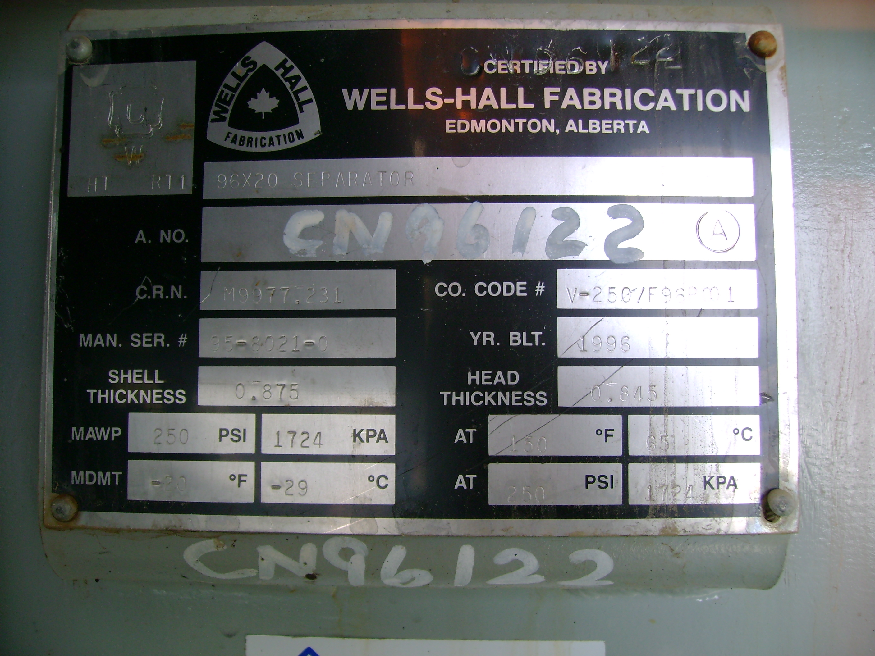 | 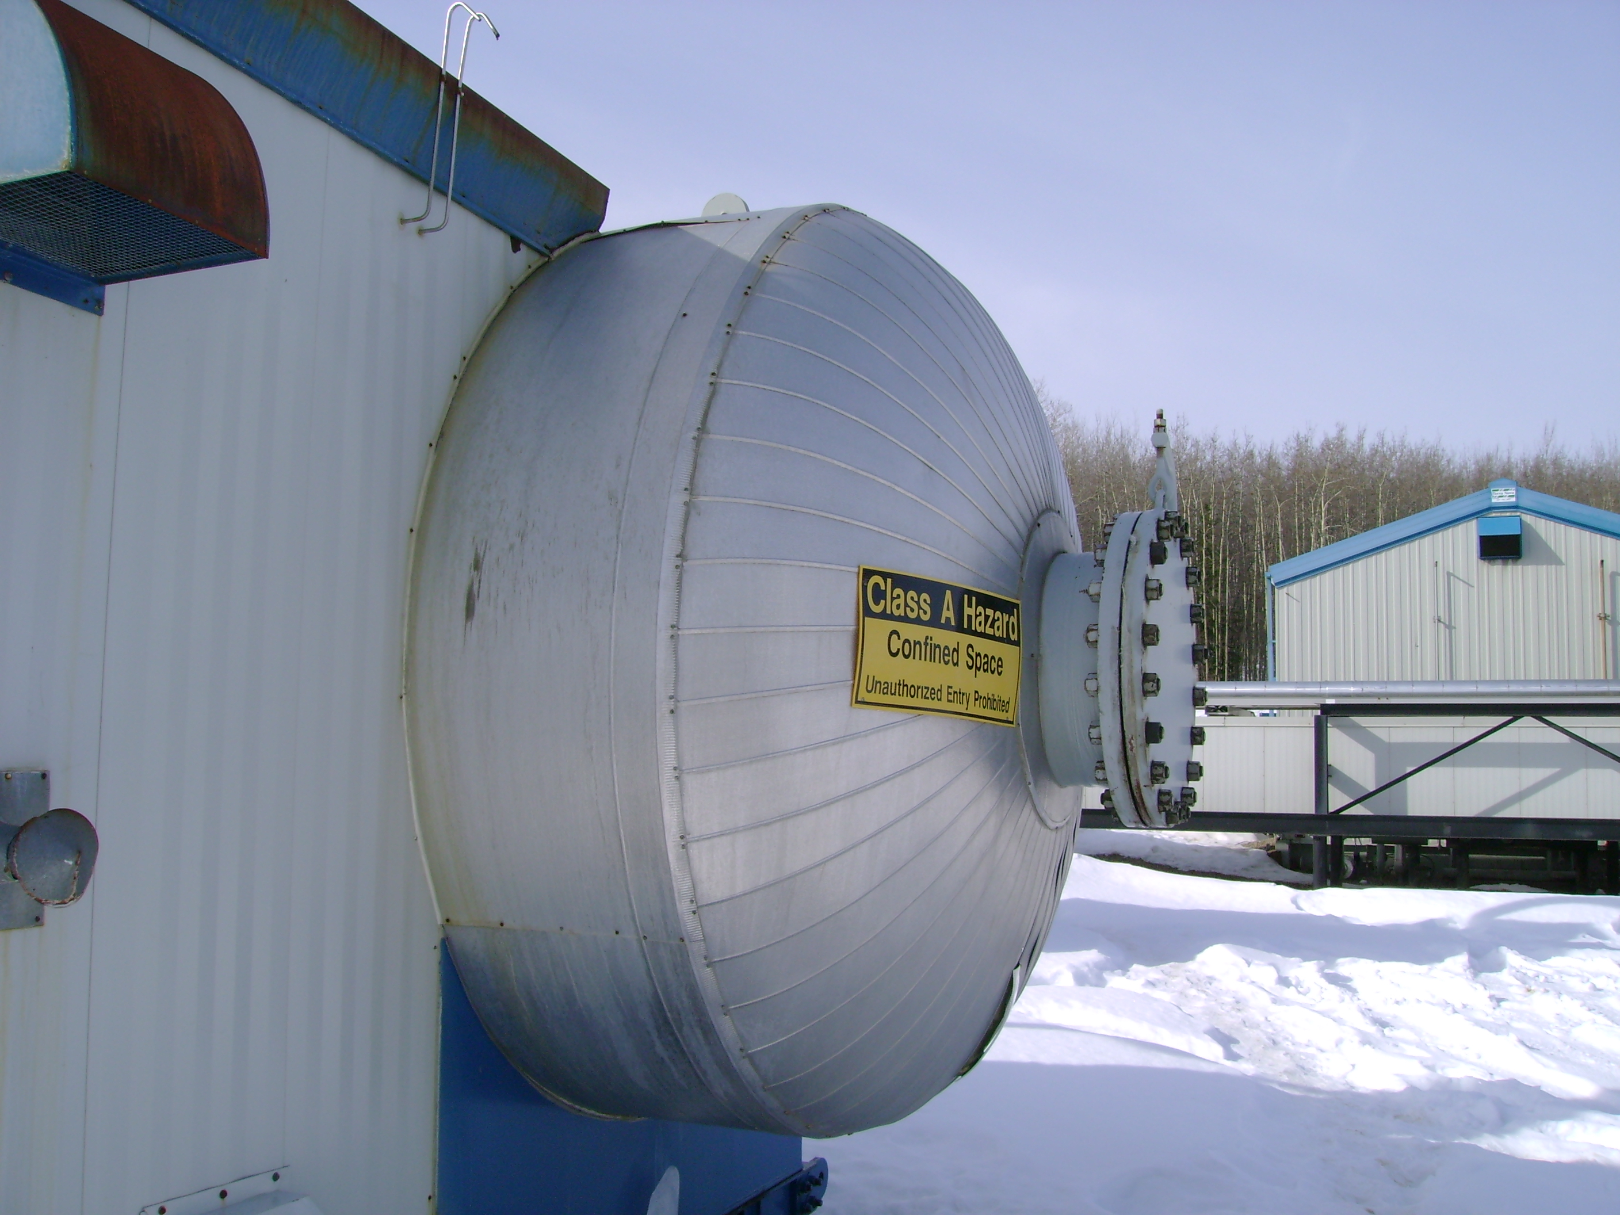
Data Plate | Over view
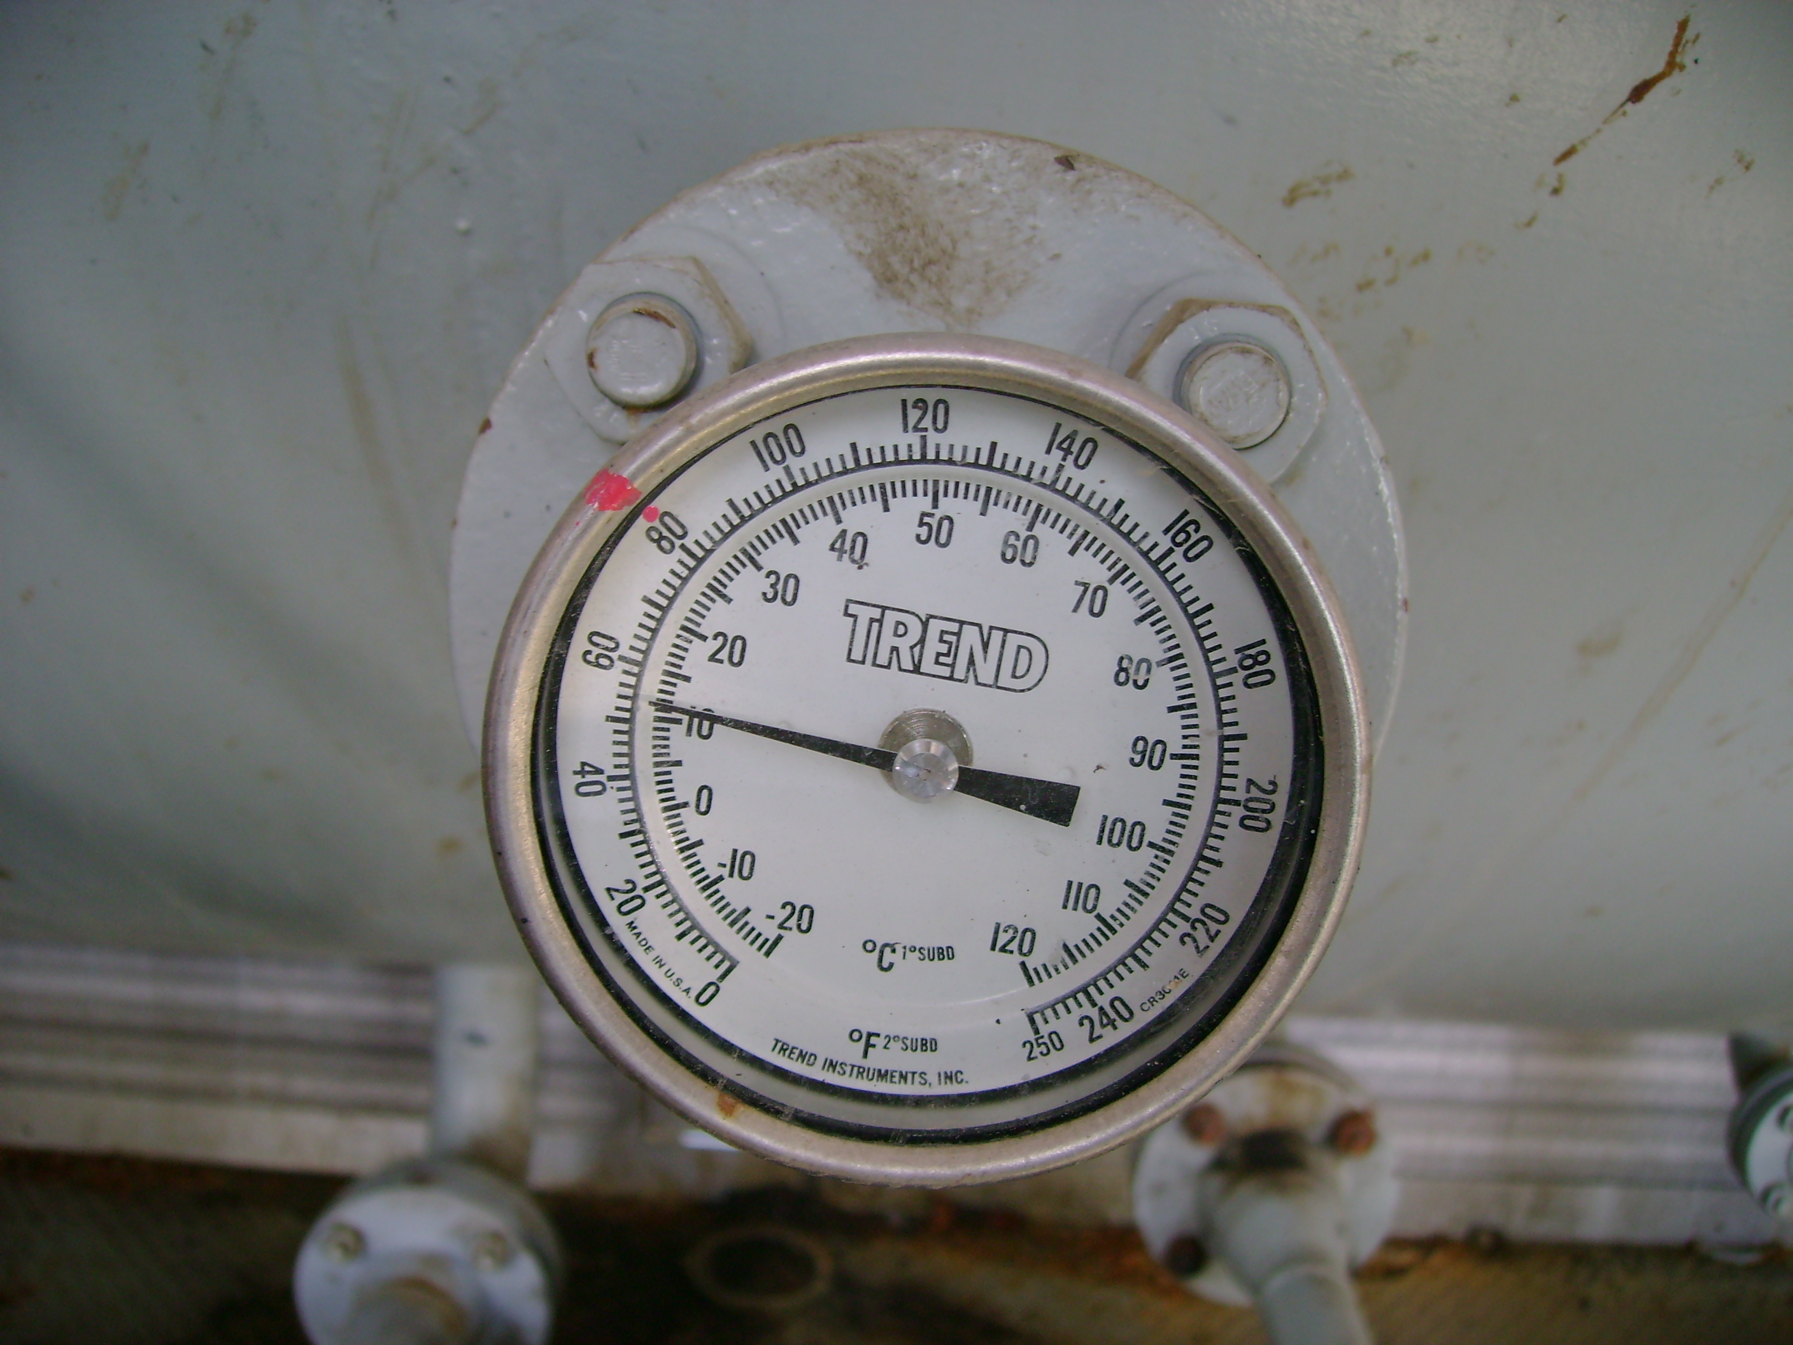 | 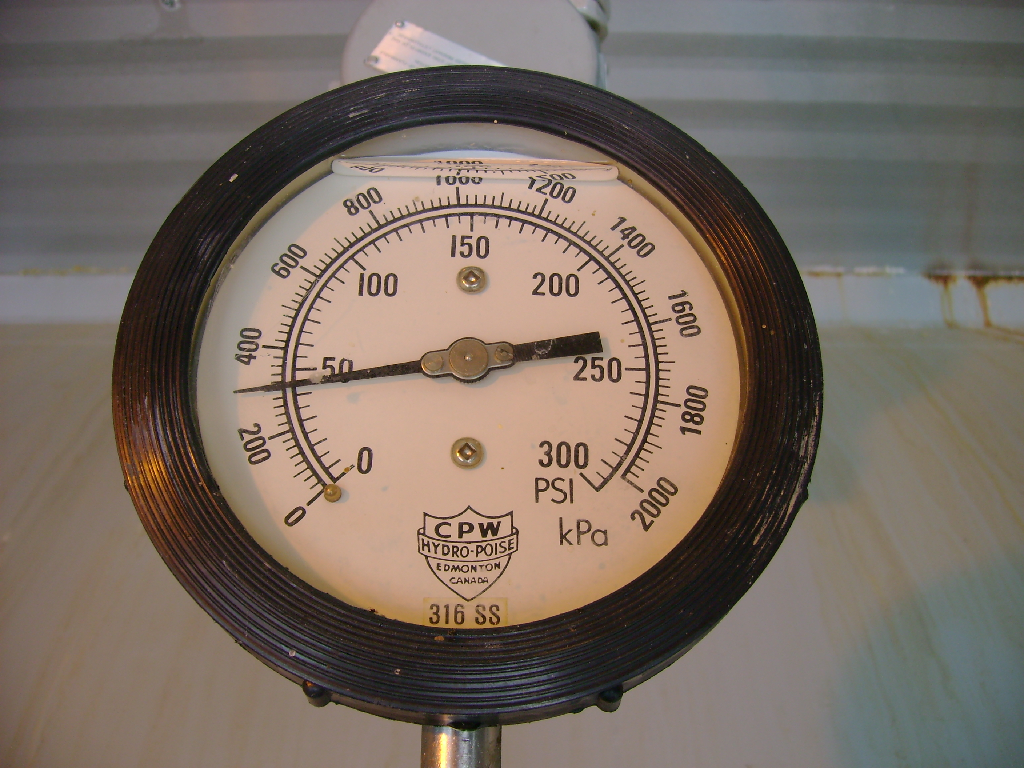
Temp gauge | Pressure gauge

