Canadian Natural Resources Limited

GENERAL PRESSURE VESSEL INFORMATION
District: Fort St. John, BC |  |  |  |  | Skid No.
Facility: Sikanni Compressor Station |  |  |  |  | Location (LSD): b-10-L / 94-G-03
Vessel Name Equipment Number: Two Phase Separator

Orientation: Vertical
Status: In Service |  |  |  |  | Regulatory Inspection
PRESSURE VESSEL NAMEPLATE DATA
“A” or “G” or “S” (Sask.) or BC Registration Number.  A 2907439 |  |  |  |  |  | CRN Number:  M-1440.2
Vessel serial number: 1670 |  |  |  |  |  | Size: 16 in. x 60 in.
Shell thickness: 21.4mm |  |  |  |  |  | Shell material: SA 106 B
Head thickness: 22.4mm |  |  |  |  |  | Head material: SA 516 70N
Tube wall thickness: |  |  |  |  |  | Tube material:
Tube diameter: |  |  |  |  |  | Tube length:
Channel thickness: |  |  |  |  |  | Channel material:
Design pressure | Shell: 8964 kPa |  |  |  |  | Operating pressure |  | Shell: 0-1500 PSI
 | Tubes: |  |  |  |  | 300PSI |  | Tubes:
Design Temp. | Shell: 38°C |  |  |  |  | Operating temperature |  | Shell: -2°C - 120°C
 | Tubes: |  |  |  |  |  |  | Tubes:
X-ray: RT2 |  |  |  |  |  | Heat treatment:
Code parameters: ASME VIII, Div 1 |  |  |  |  |  | Coated:
Manufacturer: Flo. Skid Manufacturing |  |  |  |  |  | Year built: 1994
Corrosion allowance: 1.6 mm |  |  |  |  |  | Manway: No

PRESSURE SAFETY VALVE NAMEPLATE DATA
PSV Tag # | Manufacture | Model # |  | Serial # |  |  | Set Pressure  (kPa) |  | Capacity  (scfm) |  | Service  Date
 | Mercer | 8112421117 | 14805 |  |  |  | 8964 |  | 4479 | 4/2002
CRN # | Service By | Block Valve | Location |  |  |  | Size |  | Code Stamp
OG0079.2 | Unified Valve | No | Upper shell |  |  |  | 1”x 1” |  | UV

SERVICE CONDITIONS-INDICATE ALL THAT APPLY
Sweet | Sour X |  |  | Oil |  |  |  | Gas X |  |  | Water X
Amine | LPG |  |  | Condensate |  |  |  | Air |  |  | Glycol
Other (Describe):

Inspection Interval ________________________________________PSV Service Interval_________________________________

(Determined by MIC in conjunction with Chief Inspector following guidelines of CNRL’s Owner-User Inspection Program)

Reports reviewed and accepted by:

Mechanical Integrity Coordinator________________________________________________Date__________________________

Fill out all forms as completely as possible. All information is important! Use back of sheets to record additional information or sketch if required.

Copy of report to be filed by MIC at site, and copy sent to Chief Inspector

External Inspection Items | G | F | P | N/A | Comments
Insulation Verify sealed around manways, nozzles, no damage present, and there is no egress of moisture. |  |  |  | X | Vessel not insulated
External Condition Assess paint condition, areas peeling, record any corrosion, damage, etc (record location, size and depth of corrosion or damage) | X |  |  |  | Paint is in good condition – no exposed metal.
Leakage Record any leakage at flanges, threaded joints, weep holes on repads, etc. | X |  |  |  | No leaks
Saddle Assess condition of paint, fire protection, and concrete. Look for corrosion, buckling, dents, etc. Look at vessel surface area near supports. Verify no signs of leakage at attachment to vessel and attachment welds are acceptable. Ground wire attached? | X |  |  |  | No distortion to skirt - Paint is in good condition - no corrosion at welds.  No leaks  Skid package is grounded.
Anchor Bolts Hammer tap to ensure secure. Look for cracking in treads or signs of deformation. |  |  |  | X | Skirt welded to skid deck.
Concrete foundation Check for cracks, spalling, etc. |  |  |  | X
Ladder / Platform Describe general condition, ensure support is secure to vessel, and describe any hazards. |  |  |  | X
Nozzle Assess paint, look for leakage, and ensure stud threads are fully engaged. Record any damage, deflection, etc. Are nozzles gusseted? | X |  |  |  | Paint in good condition – no exposed metal.  No leaks.  Stud threads are fully engaged to nuts.  No gussets.
Gauges Ensure gauges are visible, working, no leakage, and suitable for range of MAWP/ Temp. | X |  |  |  | Gauge are visible, working, no leaks and suitable for range of MAWP of vessel 0-1500PSI, temp. -20-120°C
External Piping Ensure pipe is well supported. All clamps, supports, shoes, etc. in place. Look for evidence of structural overload, deflection, etc. Paint condition, external corrosion? | X |  |  |  | Piping is well supported; all clamps, supports and shoes are in place.  Paint is in poor condition with 75% of paint peeling from piping
Valving Ensure no leaks are visible. Valves are properly supported and chained if necessary. | X |  |  |  | No leaks  Valves are properly supported  Paint peeling from valves
PSV Ensure PSV is set at pressure at or below that of vessel. | X |  |  |  | Located on upper shell - set at MAWP of vessel.
NDE methods Was UT/ MPI done on vessel  (MI coordinator to review results) | X |  |  |  | Ultrasonic thickness survey carried out – no metal thickness detected below nominal minus corrosion allowance.

Other

Recommendations or corrective actions : Vessel is Fit for Service or describe corrective actions required)
(MIC to review corrective actions with Operations, discuss with Chief Inspector where necessary, and get remedial action implemented)
Recommendations: 1. Repaint piping.
Summary: This Vessel is in good overall condition, ultrasonic thickness survey carried out – no metal thickness detected below nominal minus corrosion allowance.
Vessel is fit for service

Inspected By: Gerry Avery Date: Aug.10, 2006

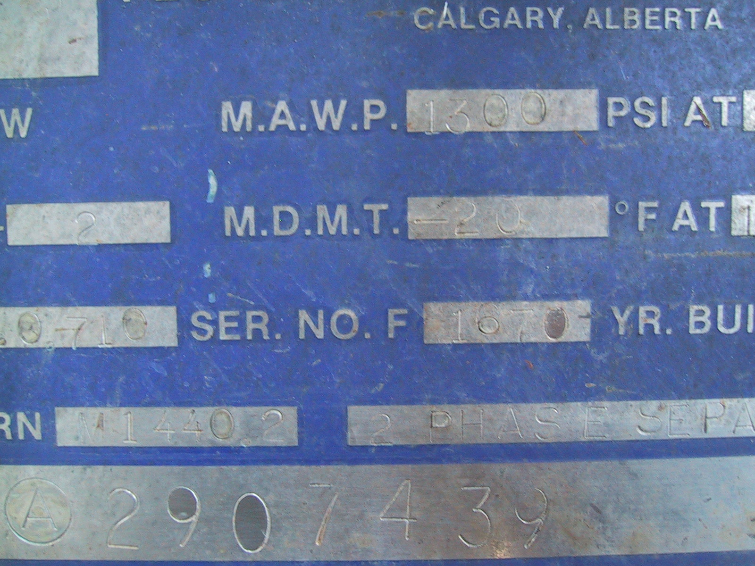 | 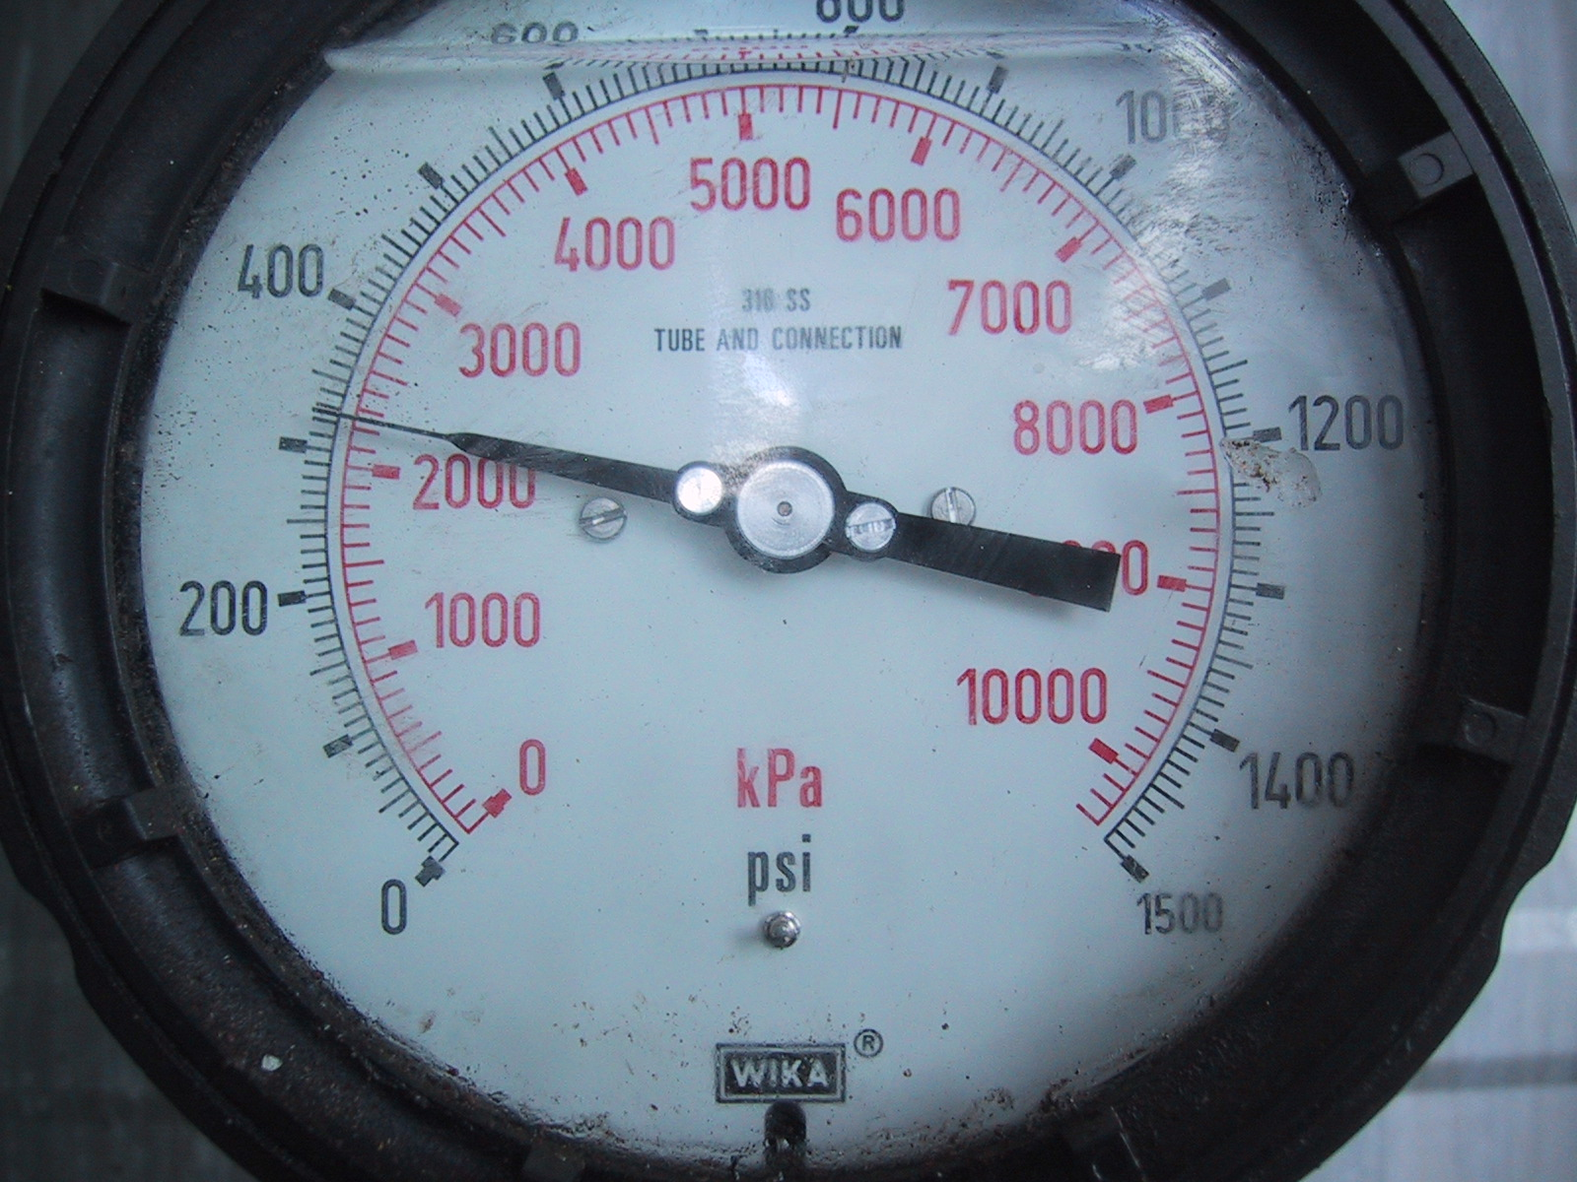
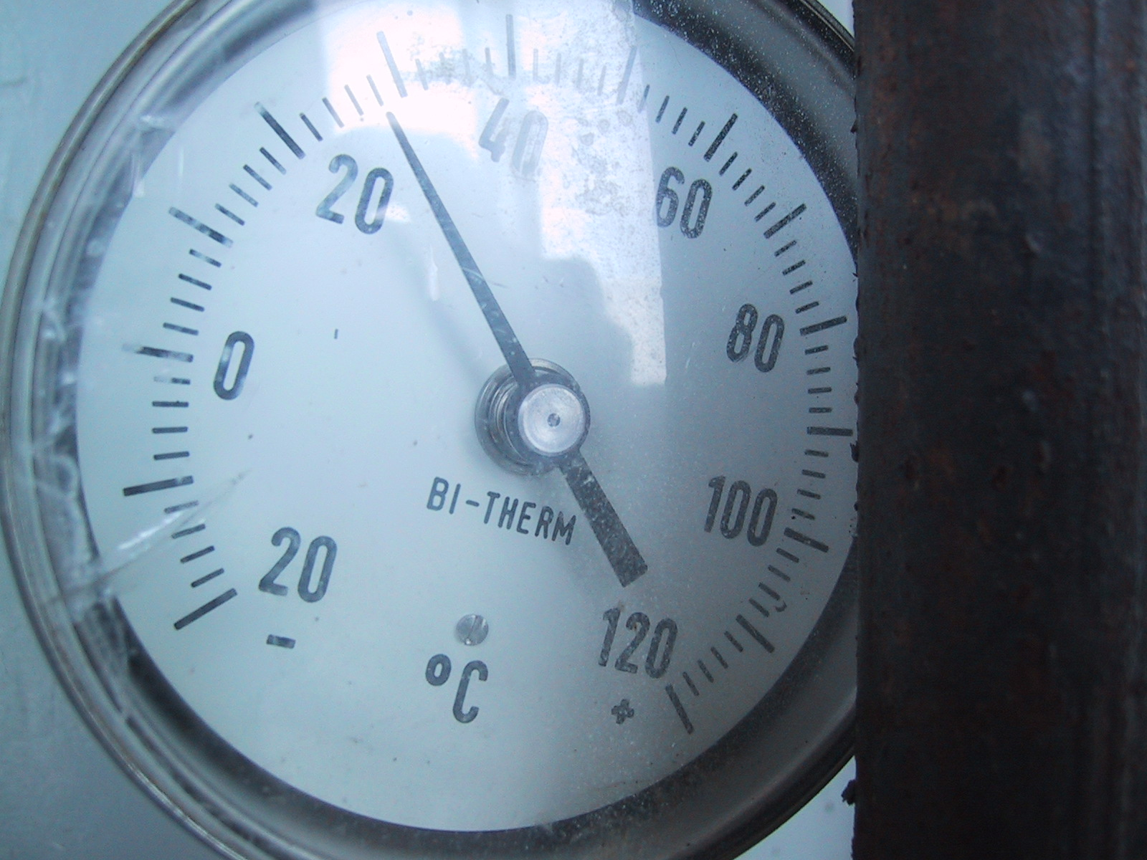 | 